Data Science and Machine learning

Spis treści

Python setup 5

Command Line Basics 5

Shortcuts 6

Python Object and Data Structure Basics 6

NUMPY 6

Introduction 6

NumPy Arrays 6

Atributes and Methods of Arrays 7

Indexing and Selecting 7

Pandas 9

Introduction 9

Series 9

DataFrames 10

Selecting columns 11

Selecting rows 12

Select subsets 13

Conditional selection 13

Index 14

Nested indexes 15

Missing data 15

Groupby 16

Operations 17

Pivot table 18

Merging, Joining, Concatenating 18

Data Input and Output 18

Pandas built-in Vizualization 18

Histogram – 3 solutions 19

Density – 2 solutions 20

Plots 21

Matplotlib 23

Introduction 23

Functional Method 23

Object oriented 23

Figure Size and DPI, saving file 25

Style 25

Seaborn 26

Introduction 26

Distribution plots 26

Distplot 26

Joinplot 27

Pairplot 28

Rugplots 29

Categorical plots 30

barplot 30

Countplot 31

Boxplot 31

Violinplot 32

Stripplot 33

Swarmplot 34

Catplot 35

Matrix plots 35

Heatmap 36

Clustermap 37

Grids 39

Regression plot 42

Style and color 44

Plotly and Cufflinks 45

Otherview 45

Code 45

Imports and setup 45

Code 45

Geographical plotting 52

Introduction 52

Code 52

Imports and setup 52

USA 52

World 55

Machine learning – general 58

Introduction 58

Superwised Learning 58

Machine learning Process 58

Evaluating Performance – classification error metrics – Classification 58

Evaluating performance – Regression Error Metrics 60

Machine learning with Python 61

Linear regression 61

Theory 61

Code 61

Imports and setup 61

Code 62

Bias variance trade-off 66

Logistic Regression 68

Overview 68

Code 70

Cleaning data 74

Train 76

K Nearest Neighbors 77

KNN Theory 77

Code 78

Decision trees and random forest 82

Introduction 82

Code 84

Support Vector Machines 86

Theory 86

Code 88

K Means Clustering 90

Theory 90

Code 92

Principal Component Analysis – Factor Analysis 94

Theory 94

Code 95

Recommender systems 97

Theory 97

Code 98

Natural Language Processing 106

Theory 106

Code 107

Neural Nests and Deep Learning 114

Introduction to Artificial Neural Networks 114

Perceptron Model 114

Neural Networks 116

Activation Function 119

Multi-Class Activation Function 121

Cost Functions and Gradient Descent 123

Backpropagation 128

TensorFlow vs Keras 130

TensorBoard 131

Code 131

TF Syntax Basics - Part One - Preparing the Data 131

TF Syntax Basics - Part Two - Creating and Training the Model 133

TF Syntax Basics - Part Three - Model Evaluation 135

Code - Housing 136

TF Regression Code Along - Exploratory Data Analysis 136

TF Regression Code Along - Exploratory Data Analysis - Continued 144

TF Regression Code Along - Data Preprocessing and Creating a Model 147

TF Regression Code Along - Model Evaluation and Predictions 148

TF Classification Code Along - EDA and Preprocessing 150

TF Classification - Dealing with Overfitting and Evaluation 155

Tensorboard 159

Code – Breast cancer 161

EDA 162

Train test split 164

Scaling data 164

Creating the Model 165

Example One: Choosing too many epochs and overfitting! 165

Example two: Early stopping 166

Example Three: DropOut Layers 167

Model evaluation 168

Code – Lending Club 168

Data overview 168

Exploratory data analysis 170

Data preprocessing – Missing data 175

Data preprocessing – Categorical variables and dummy variables 182

Train test split 184

Normalizing data 185

Creating model 185

Save model 185

Evaluating Model Performance 185

Big Data and Spark with Python 187

Overview 187

Spark 189

EC2 Instance Set-Up 192

Lambda Revision 192

PySpark Setup 192

RDD Transformations and Actions 193

My Notes 196

Clear Data – Fill Nulls 196

Feature scaling – MinMaxScaling and Standarization 196

Transform Categories 196

Saving Models 196

# Python setup

## Command Line Basics

|  |  |
| --- | --- |
| Command |  |
| cd | Current directory |
| dir | Contents of directory |
| Cd *foldername* | Go to folder |
| Cd .. | Go back |
| Tab | Hints |
| cls | Clear cmd |

## Shortcuts

|  |  |
| --- | --- |
| Shortcut | Description |
| Shift + Tab | Show signature of method |
|  |  |
|  |  |

# Python Object and Data Structure Basics

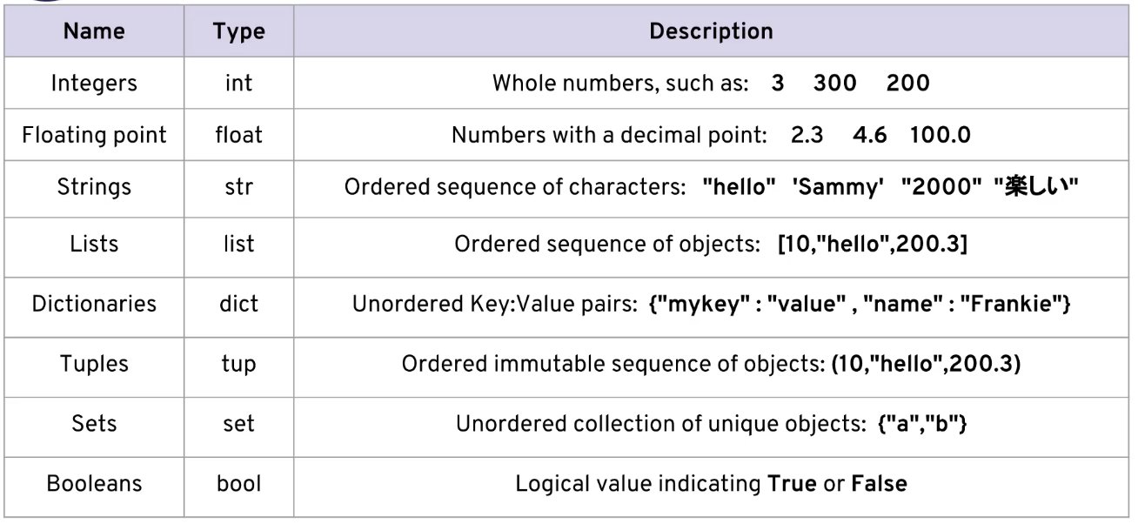

# NUMPY

## Introduction

Numpy is a Linear Algebra Library for Python. Almost all of the libraries in the PyData Ecosystem rely in NumPy as one of their main building blocks

It is increadibly fast as it has bindings to C libraries

2 flavors:

* Vectors – 1d array
* Marices – 2d array

## NumPy Arrays

my_mat=[[1,2,3], [4,5,6],[7,8,9]]  
mat=np.array(my_mat)  
mat

array([[1, 2, 3],

[4, 5, 6],

[7, 8, 9]])

*# similar to range() built in function*  
ara=np.arange(0,10,2) *# 10 is not included*  
ara

array([0, 2, 4, 6, 8])

np.zeros((2,3))

array([[0., 0., 0.],

[0., 0., 0.]])

np.ones(4)

array([1., 1., 1., 1.])

np.eye(4)

array([[1., 0., 0., 0.],

[0., 1., 0., 0.],

[0., 0., 1., 0.],

[0., 0., 0., 1.]])

arr=np.random.rand(2,3)  
arr

array([[-7.73100273e-01, -6.84540737e-01, 9.69670768e-01],

[-1.28685216e+00, -8.65607266e-01, 1.09698694e-03]])

arr=np.random.randint(-5,5, (2,3)) *#-5 inclusive, 5 - non-inclusive*  
arr

array([[-5, 0, 3],

[-1, -1, -4]])

## Atributes and Methods of Arrays

arr=np.arange(20)  
print(arr)  
print(arr.shape)  
  
arr45=arr.reshape(4,5)  
print(arr45)  
print(arr45.shape)

[ 0 1 2 3 4 5 6 7 8 9 10 11 12 13 14 15 16 17 18 19]

(20,)

[[ 0 1 2 3 4]

[ 5 6 7 8 9]

[10 11 12 13 14]

[15 16 17 18 19]]

(4, 5)

np.random.seed(101)  
  
ranarr=np.random.randint(0,50,10)  
ranarr  
  
maximum=ranarr.max()  
max_index=ranarr.argmax()  
  
print(f'Max {maximum} on {max_index} position')  
print(ranarr.dtype)

Max 47 on 6 position

int32

## Indexing and Selecting

arr=np.arange(0,11)  
arr

array([ 0, 1, 2, 3, 4, 5, 6, 7, 8, 9, 10])

arr[1:9:2]

array([1, 3, 5, 7])

slice_of_arr=arr[0:6]  
slice_of_arr

array([0, 1, 2, 3, 4, 5])

slice_of_arr[:4]=99  
print(slice_of_arr)  
print(arr) *# use copy!*

[99 99 99 99 4 5]

[99 99 99 99 4 5 6 7 8 9 10]

arr=np.arange(0,11)  
slice_of_arr=arr[0:6].copy() *# here is copy!*  
slice_of_arr[:4]=99  
print(slice_of_arr)  
print(arr)

[99 99 99 99 4 5]

[ 0 1 2 3 4 5 6 7 8 9 10]

arr_2d=np.array([[5,10,15], [20,25,30], [35,40,45]])  
arr_2d

array([[ 5, 10, 15],  
 [20, 25, 30],   
 [35, 40, 45]])

*# it is the same*  
print(arr_2d[0][1])  
print(arr_2d[0,1])

10

10

arr_2d[:2,1:]

array([[10, 15],

[25, 30]])

bool_arr=arr>5  
print(bool_arr)  
arr[bool_arr]

[False False False False False False True True True True True]

array([ 6, 7, 8, 9, 10])

arr[arr>5]

array([ 6, 7, 8, 9, 10])

arr_2d=np.arange(0,50).reshape(5,10)  
print(arr_2d)  
print('---------------------')  
print(arr_2d[1:4,1:9])

[[ 0 1 2 3 4 5 6 7 8 9]

[10 11 12 13 14 15 16 17 18 19]

[20 21 22 23 24 25 26 27 28 29]

[30 31 32 33 34 35 36 37 38 39]

[40 41 42 43 44 45 46 47 48 49]]

---------------------

[[11 12 13 14 15 16 17 18]

[21 22 23 24 25 26 27 28]

[31 32 33 34 35 36 37 38]]

NumPy Operations

arr =np.arange(0,11)  
arr

array([ 0, 1, 2, 3, 4, 5, 6, 7, 8, 9, 10])

arr+100

array([100, 101, 102, 103, 104, 105, 106, 107, 108, 109, 110])

arr**arr *# * - + / \*\**

array([ 1, 1, 4, 27, 256,

3125, 46656, 823543, 16777216, 387420489,

1410065408], dtype=int32)

arr/arr *# 0/0 - nan*

array([nan, 1., 1., 1., 1., 1., 1., 1., 1., 1., 1.])

1/arr *# 1/0 > inf (infinitive)*

array([ inf, 1. , 0.5 , 0.33333333, 0.25 ,

0.2 , 0.16666667, 0.14285714, 0.125 , 0.11111111,

0.1 ])

np.sqrt(arr) *# sqrt, log, exp, sin, cos…*

array([0. , 1. , 1.41421356, 1.73205081, 2. ,

2.23606798, 2.44948974, 2.64575131, 2.82842712, 3. ,

3.16227766])

print(np.max(arr))  
print(arr.max())

10

10

# Pandas

## Introduction

* It is an open source library built on top of NumPy
* It allows for fast analysis and data cleaning and preparation
* It excels in performance and productivity
* It also has built-in visualization features
* It can work with data from a wide variety of sources

## Series

labels=['a', 'b', 'c']  
my_data=[11,22,33]  
arr=np.array(my_data)  
d={'A':10, 'B':20, 'C':30}  
pd.Series(data=my_data)

0 11

1 22

2 33

dtype: int64

pd.Series(data=my_data, index=labels ) *# or without data= , index= - correct order!*

a 11

b 22

c 33

dtype: int64

pd.Series(arr, labels)

a 11

b 22

c 33

dtype: int32

pd.Series(data=d)

A 10

B 20

C 30

dtype: int64

pd.Series(data=labels)

0 a

1 b

2 c

dtype: object

pd.Series(data=[sum, print, len])

0 <built-in function sum>

1 <built-in function print>

2 <built-in function len>

dtype: object

ser1=pd.Series([1,2,3,4], index=['USA', 'Germany', 'Poland', 'Japan'])  
ser1

USA 1

Germany 2

Poland 3

Japan 4

dtype: int64

ser2=pd.Series([5,6,7,8], index=['USA', 'Germany', 'Italy', 'China'])  
ser2

USA 5

Germany 6

Italy 7

China 8

dtype: int64

ser1['USA']

1

ser1[0]

1

ser1+ser2 *#integer converted to float automatically - to don't lose data*

China NaN

Germany 8.0

Italy NaN

Japan NaN

Poland NaN

USA 6.0

dtype: float64

## DataFrames

DataFrame’s columns and rows are Pandas series

from numpy.random import randn  
np.random.seed(101)  
df=pd.DataFrame(randn(5,4), ['A', 'B', 'C', 'D', 'E'], ['W', 'X', 'Y', 'Z'])  
df

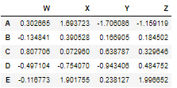

print(type(df['W']))  
df['W']

<class 'pandas.core.series.Series'>

A 0.302665

B -0.134841

C 0.807706

D -0.497104

E -0.116773

Name: W, dtype: float64

df.W *# not recommended*

A 0.302665

B -0.134841

C 0.807706

D -0.497104

E -0.116773

Name: W, dtype: float64

### Selecting columns

df[['W', 'Y']]

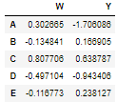

df['new']=df['W']+df['Y']  
df

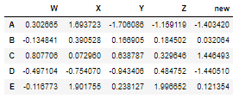

df.drop('new', axis=1) *# default axis = 0 -> index row - default it remove row, not column*

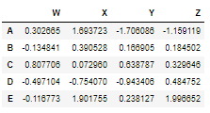

df *# it didn't take place inplace, to remove for forever*

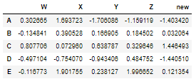

df.drop('new', axis=1, inplace=True)  
df

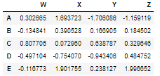

df.drop('E')

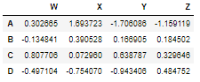

df

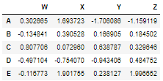

df.shape

(5, 4)

### Selecting rows

df.loc['A']

W 0.302665

X 1.693723

Y -1.706086

Z -1.159119

Name: A, dtype: float64

df.iloc[0]

W 0.302665

X 1.693723

Y -1.706086

Z -1.159119

Name: A, dtype: float64

### Select subsets

df.loc['B', 'Y']df.loc['B', 'Y']

0.16690463609281317

df.loc[['A', 'B'], ['W', 'Y']]

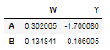

### Conditional selection

df

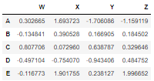

df>0

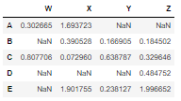

df[df>0]

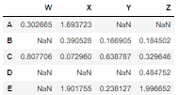

df['W']>0

A True

B False

C True

D False

E False

Name: W, dtype: bool

df[df['W']>0]

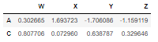

df[df['W']>0]['X']

A 1.693723

C 0.072960

Name: X, dtype: float64

df[df['W']>0][['X', 'Y']]

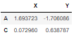

df[(df['W']<0) & (df['Y']<0)] *# and -> & and () parenhesis*

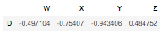

df[(df['W']<0) | (df['Y']<0)] *# or -> | and () parenhesis*

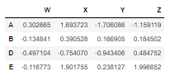

### Index

df.reset_index() *# inplace=True if you want it permament*

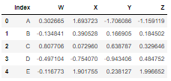

new_index='CA NY WY OR CO'.split()  
df['States']=new_index  
df

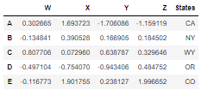

df.set_index('States') *# inplace - if you want it permamently*

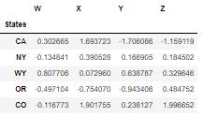

### Nested indexes

More in the notebook

*# Index Levels*  
outside = ['G1','G1','G1','G2','G2','G2']  
inside = [1,2,3,1,2,3]  
hier_index = list(zip(outside,inside))  
hier_index = pd.MultiIndex.from_tuples(hier_index)  
list(zip(outside,inside))

[('G1', 1), ('G1', 2), ('G1', 3), ('G2', 1), ('G2', 2), ('G2', 3)]

hier_index

MultiIndex([('G1', 1),

('G1', 2),

('G1', 3),

('G2', 1),

('G2', 2),

('G2', 3)],

)

df=pd.DataFrame(randn(6,2), hier_index, ['A', 'B'])  
df

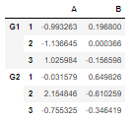

df.loc['G1'].loc[2]

A -1.136645

B 0.000366

Name: 2, dtype: float64

df.index.names=['Groups', 'Num']  
df.loc['G2'].loc[2]['B']

-0.6102588558227414

*# xs lets get inside*  
df.xs(1, level='Num')

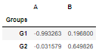

### Missing data

More in the notebook

d={'A': [1,2,np.nan], 'B':[5,np.nan, np.nan], 'C':[7,8,9]}  
df=pd.DataFrame(d)  
df

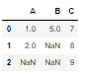

df.dropna(axis=1) *#drop columns without non-value values*

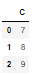

df.dropna(thresh=2) *# drop rows with less than 2 empty*

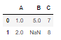

df['A'].fillna(value=df['A'].mean())

0 1.0

1 2.0

2 1.5

Name: A, dtype: float64

### Groupby

More in the notebook

data = {'Company':['GOOG','GOOG','MSFT','MSFT','FB','FB'],  
 'Person':['Sam','Charlie','Amy','Vanessa','Carl','Sarah'],  
 'Sales':[200,120,340,124,243,350]}  
  
df=pd.DataFrame(data)  
df

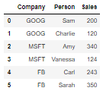

df.groupby('Company').sum().loc['FB'] *# sum(), mean(), count(), max(), min() ….*

Sales 593

Name: FB, dtype: int64

df.groupby('Company').describe().transpose()

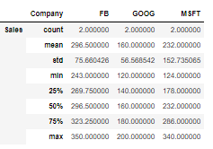

### Operations

df = pd.DataFrame({'col1':[1,2,3,4], 'col2':[444,555,666,444],'col3':['abc','def','ghi','xyz']})  
df

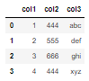

df['col2'].unique()

array([444, 555, 666], dtype=int64)

df['col2'].nunique() *# or len(df['col2'].unique())*

3

df['col2'].value_counts()

444 2

555 1

666 1

Name: col2, dtype: int64

df.apply(lambda x: x*2)

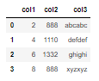

df.columns

Index(['col1', 'col2', 'col3'], dtype='object')

df.index

RangeIndex(start=0, stop=4, step=1)

df.sort_values('col2') *# indexes stay attached to rows*

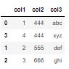

df.isnull()

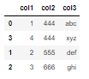

### Pivot table

data = {'A':['foo','foo','foo','bar','bar','bar'],  
 'B':['one','one','two','two','one','one'],  
 'C':['x','y','x','y','x','y'],  
 'D':[1,3,2,5,4,1]}  
  
df = pd.DataFrame(data)  
df

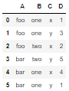

df.pivot_table(values='D', index=['B', 'A'], columns=['C'])

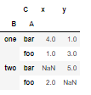

## Merging, Joining, Concatenating

More in the notebook

## Data Input and Output

More in the notebook

## Pandas built-in Vizualization

df1=pd.read_csv(path+'df1', index_col=0)  
df1

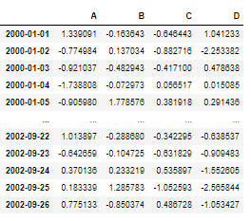

df2=pd.read_csv(path+'df2')  
df2

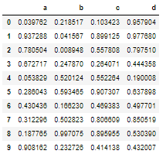

### Histogram – 3 solutions

df1['A'].hist(bins=30)

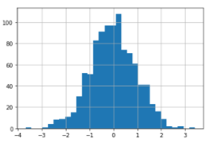

df1['A'].plot(kind='hist', bins=30)

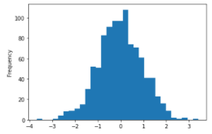

df1['A'].plot.hist()

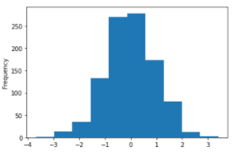

### Density – 2 solutions

df2.plot.density()

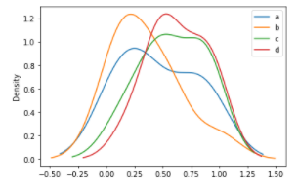

df2.plot.kde()

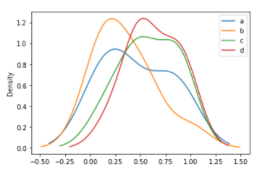

### Plots

df2.plot.area(alpha=0.5)

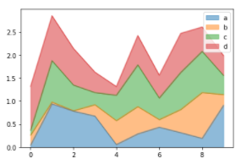

df2.plot.bar()

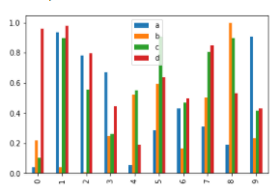

df2.plot.bar(stacked=True)

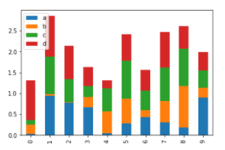

df1.plot.line(y='B', figsize=(12,3), lw=1, marker='o')

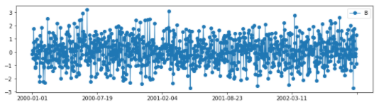

df1.plot.scatter(x='A', y='B', c='C', s=df1['D']*50, cmap='plasma')

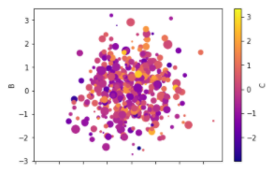

df2.plot.box()

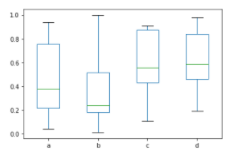

df=pd.DataFrame(np.random.randn(100,2), columns=['a', 'b'])  
df

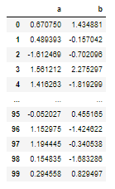

df.plot.hexbin(x='a', y='b', gridsize=20) *# darker -> more points*

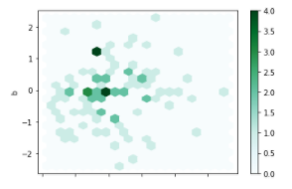

# Matplotlib

## Introduction

* Matplotlib is the most popular plotting library for Python
* It gives the control over every aspect of a figure
* It was designed to have a similar feel to MatLab’s graphical plotting

Good reference: <http://www.loria.fr/~rougier/teaching/matplotlib>

### Functional Method

x =np.linspace(0,5,11)  
y=x**2  
plt.plot(x,y, 'r')  
plt.xlabel('X')  
plt.ylabel('Y')  
plt.title('y=x**2')  
plt.legend('y')

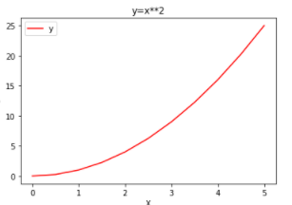

plt.subplot(1,2,1)  
plt.plot(x,y, 'r')  
  
plt.subplot(1,2,2)  
plt.plot(y,x, 'g')

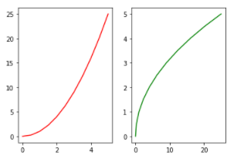

### Object oriented

fig=plt.figure()  
  
axes=fig.add_axes([0.1,0.1,0.8,0.8]) *# left, bottom, width, height*   
axes.plot(x,y)  
axes.set_xlabel('X')  
axes.set_ylabel('Y')  
axes.set_title('y = x**2')  
  
axes2=fig.add_axes([0,0.5,0.4,0.4])  
axes2.plot(y,x, 'r')

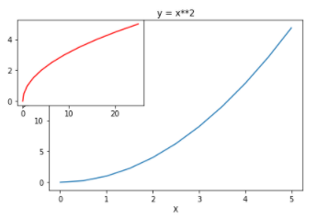

fig, axes=plt.subplots(nrows=1, ncols=2)  
  
*# axes are iterable, for a in axes: ...*  
  
axes[0].plot(x,x,'r', label='y=x')  
  
  
axes[1].plot(x,y,'b', label='y=x**2')  
axes[1].plot(x,y*2,'g', label='y=2*(x**2)')  
  
axes[0].legend(loc=(0.2,0.8))  
axes[1].legend(loc='center') *# location codes in documentation*  
  
  
plt.tight_layout()

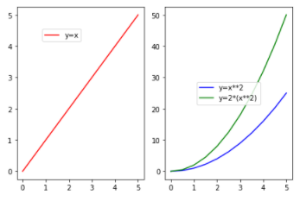

### Figure Size and DPI, saving file

fig=plt.figure(figsize=(3,2), dpi=100)  
ax=fig.add_axes([0,0,1,1])  
ax.plot(x,y)

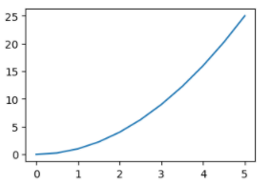

fig.savefig('my_pict.jpg') *# .jpg, .png, .pdf ...*

### Style

fig=plt.figure(figsize=(10,6))  
  
ax=fig.add_axes([0,0,1,1])  
  
  
ax.plot(x,x+1,color='#cc1b97', lw=5)  
ax.plot(x,x+2,color='orange', marker='o', markersize=30, markerfacecolor='#cc1b97', markeredgewidth=5, markeredgecolor='#461282')  
ax.plot(x,x+3, color='purple', linestyle='dotted')  
ax.plot(x,x+4, color='blue', ls='--', lw=10)  
  
ax.plot(x,-x+10,color='#32a893', linewidth=60, alpha=0.7)  
  
ax.set_xlim([1,5])  
ax.set_ylim([1,10])

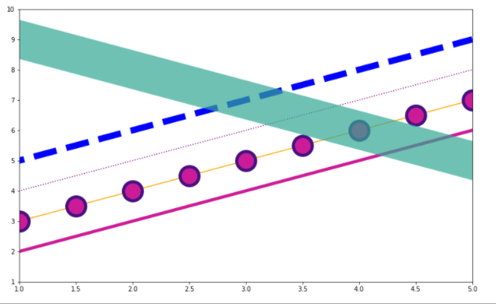

plt.scatter(x,y)

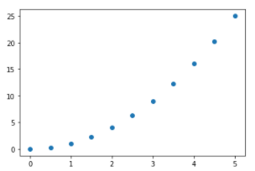

# Seaborn

## Introduction

* Seaborn Is a statistical plotting library
* Beautiful default styles
* It is designed to work well with pandas dataframe objects

## Distribution plots

*# built-in data*  
tips=sns.load_dataset('tips')  
tips

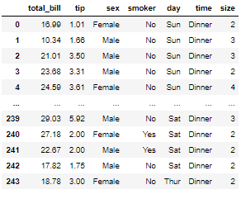

### Distplot

sns.histplot(tips['total_bill'], kde=True, bins=20)  
*#kde default True*

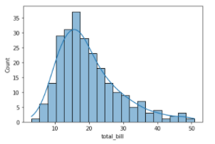

### Joinplot

*# jointplot - allows to show 2 distplots*   
sns.jointplot(x='total_bill',y='tip',data=tips) *#default kin='scatter'*

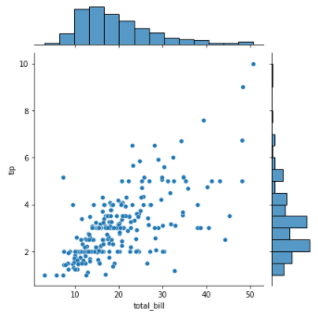

*# jointplot - allows to show 2 distplots*   
sns.jointplot(x='total_bill',y='tip',data=tips, kind='hex') *#more points - darker hexagon*

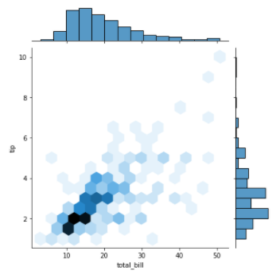

*# jointplot - allows to show 2 distplots*   
sns.jointplot(x='total_bill',y='tip',data=tips, kind='reg')

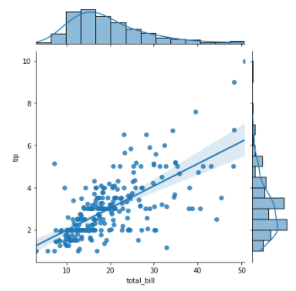

*# jointplot - allows to show 2 distplots*   
sns.jointplot(x='total_bill',y='tip',data=tips, kind='kde')

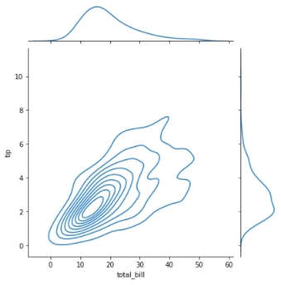

### Pairplot

*#plot pairwise relationship across an entire data frame at least for the numeical columns*  
sns.pairplot(tips)

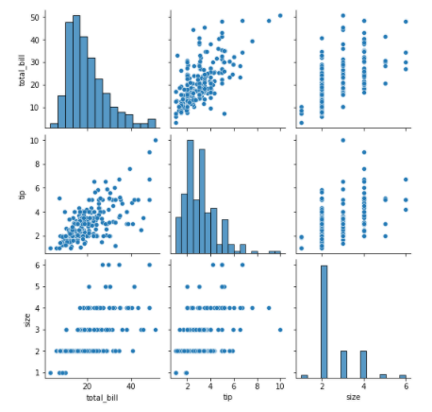

sns.pairplot(tips, hue='sex', palette='Set2')

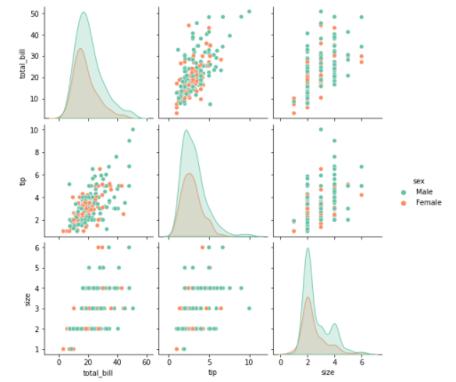

### Rugplots

sns.rugplot(tips['total_bill'])

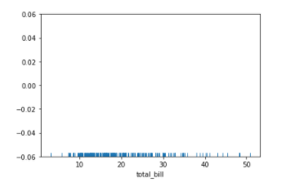

sns.kdeplot(tips['total_bill'])

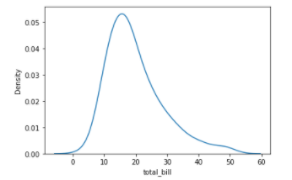

KDE – Kernel density estimation

|  |  |
| --- | --- |
|  |  |

## Categorical plots

### barplot

sns.barplot(x='sex', y='total_bill', data=tips) *#default mean()*

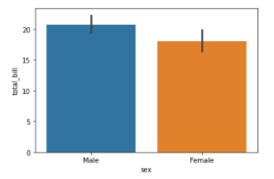

sns.barplot(x='sex', y='total_bill', data=tips, estimator=np.std)

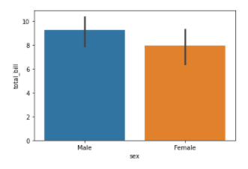

### Countplot

sns.countplot(x='sex', data=tips)

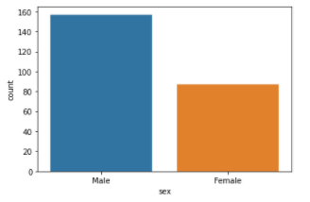

### Boxplot

sns.boxplot(x='day', y='total_bill', data=tips)

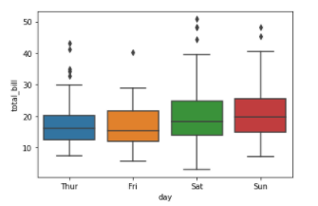

sns.boxplot(x='day', y='total_bill', data=tips, hue='smoker')

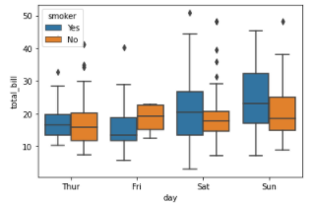

### Violinplot

sns.violinplot(x='day', y='total_bill', data=tips)

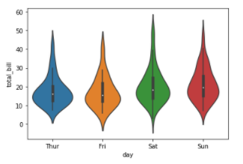

sns.violinplot(x='day', y='total_bill', data=tips, hue='smoker')

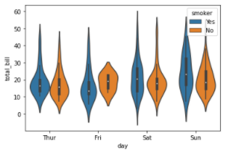

sns.violinplot(x='day', y='total_bill',data=tips,hue='smoker', split=True)

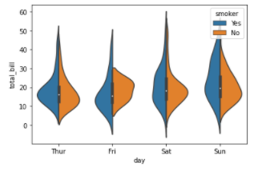

### Stripplot

sns.stripplot(x='day',y='total_bill', data=tips)

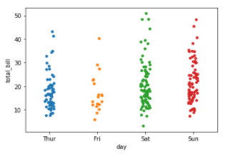

sns.stripplot(x='day',y='total_bill', data=tips, jitter=False)

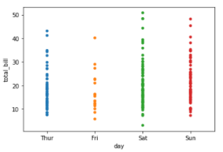

sns.stripplot(x='day',y='total_bill', data=tips, hue='sex', dodge=True) *#split -> dodge*

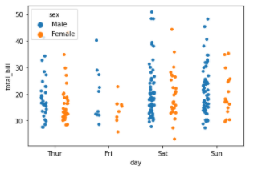

### Swarmplot

*# swarmplot is a combination of stripplot and violin plot*  
sns.swarmplot(x='day', y='total_bill', data=tips)

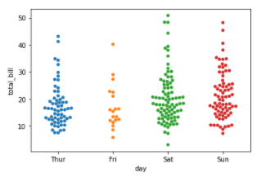

sns.violinplot(x='day', y='total_bill', data=tips, color='black')  
sns.swarmplot(x='day', y='total_bill', data=tips)

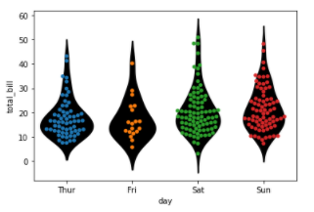

### Catplot

sns.catplot(x='day', y='total_bill', data=tips, kind='bar') *#factorplot -> catplot*  
  
*# catplot is a general plot and kind is declared inside*

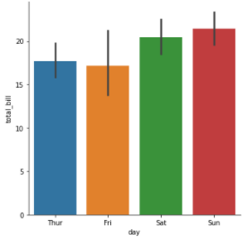

## Matrix plots

flights=sns.load_dataset('flights')  
flights

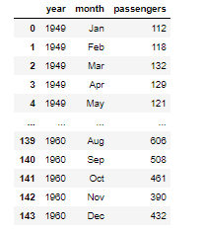

### Heatmap

tips.corr()

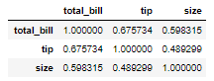

sns.heatmap(tips.corr())

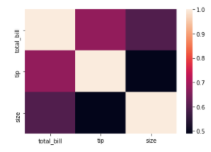

sns.heatmap(tips.corr(), annot=True, cmap='coolwarm')

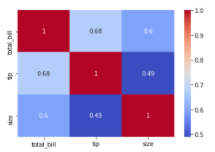

flights_pivot=flights.pivot_table(index='month', columns='year', values='passengers')  
flights_pivot

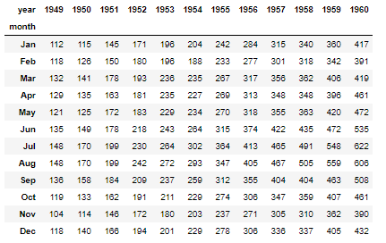

sns.heatmap(flights_pivot)

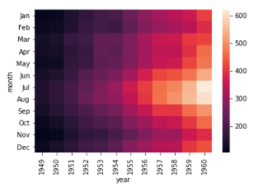

sns.heatmap(flights_pivot, linecolor='white', lw=1, cmap='magma')

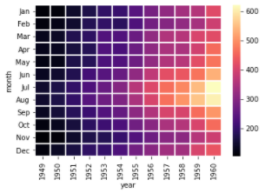

### Clustermap

sns.clustermap(flights_pivot)

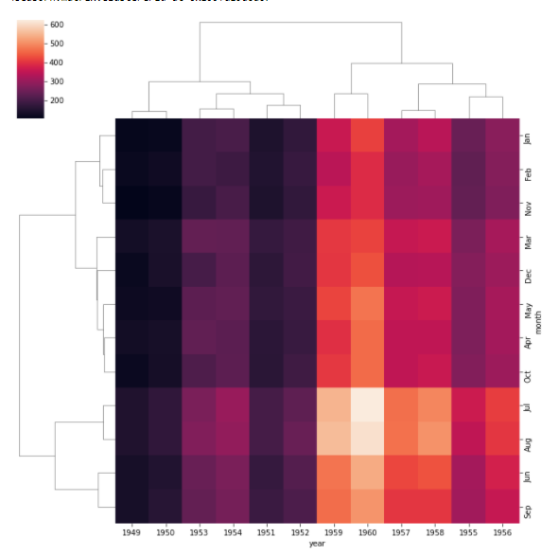

sns.clustermap(flights_pivot, standard_scale=1)

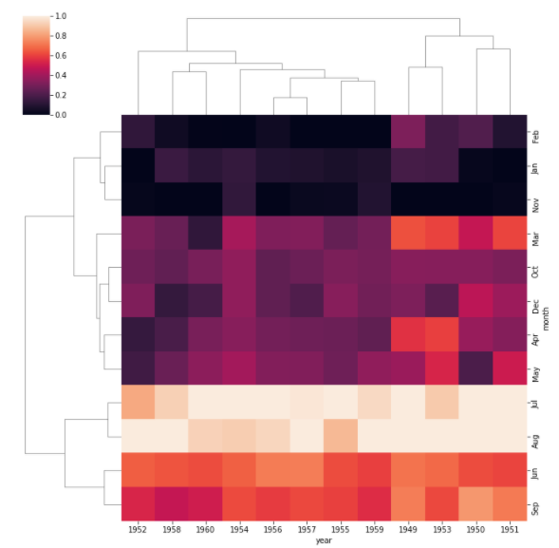

## Grids

iris=sns.load_dataset('iris')  
iris

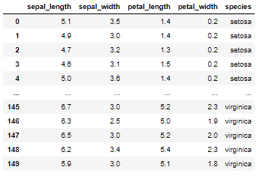

iris['species'].unique()

array(['setosa', 'versicolor', 'virginica'], dtype=object)

sns.pairplot(iris)

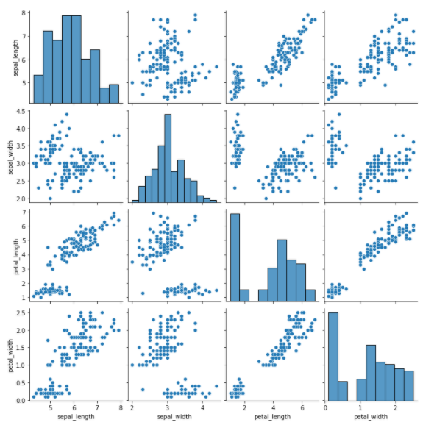

sns.PairGrid(iris) *# PairGrid gives much more controle than pairplot*

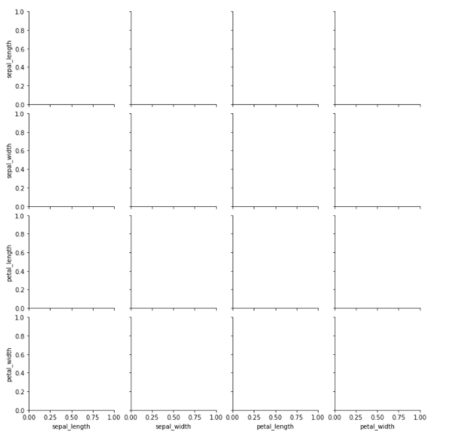

g=sns.PairGrid(iris)  
g.map(plt.scatter)

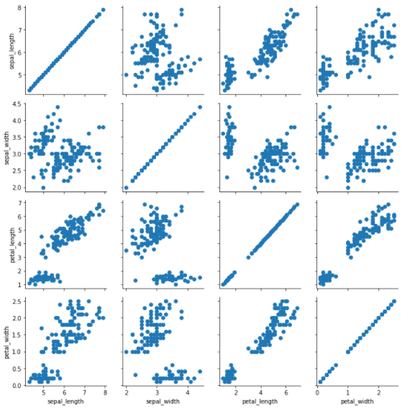

g=sns.PairGrid(iris)  
g.map_diag(sns.histplot)  
g.map_upper(plt.scatter)  
g.map_lower(sns.kdeplot)

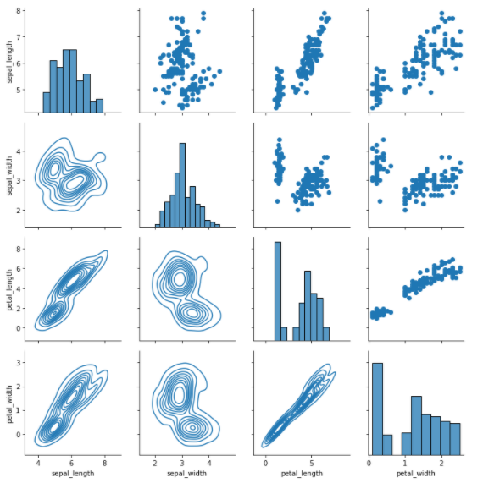

g=sns.FacetGrid(data=tips, col='time', row='smoker')  
g.map(sns.histplot, 'total_bill')

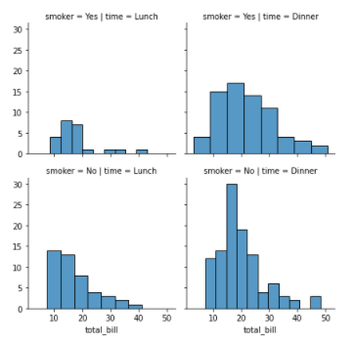

g=sns.FacetGrid(data=tips, col='time', row='smoker')  
g.map(plt.scatter, 'total_bill', 'tip')

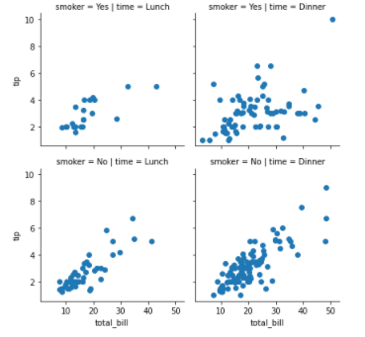

## Regression plot

sns.lmplot(x='total_bill', y='tip', data=tips)

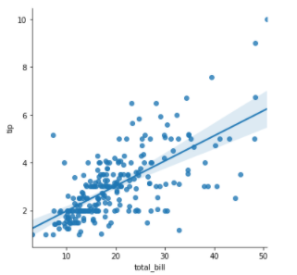

*#scatter_kws - matplotlib argument - dictioary - size :100*  
  
sns.lmplot(x='total_bill', y='tip', data=tips, hue='sex', markers=['o', 'v'], scatter_kws={'s':100})

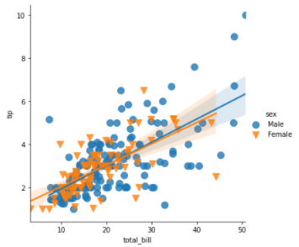

sns.lmplot(x='total_bill', y='tip', data=tips, col='time', row='smoker', hue='sex', aspect=0.6, height=8)

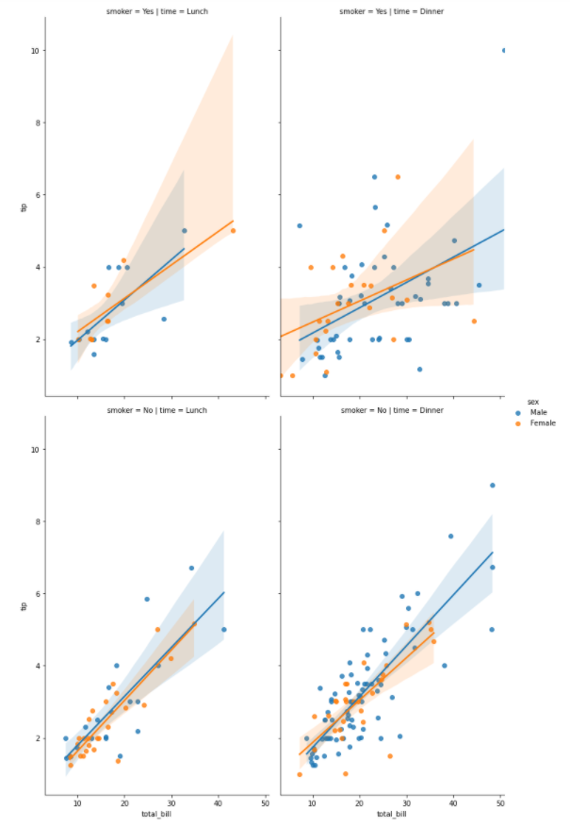

## Style and color

sns.set_style('whitegrid')  
  
  
sns.countplot(x='sex', data=tips)  
  
sns.despine(left=True) *# remove right and top spine (for remove left and bottom add as parameters)*

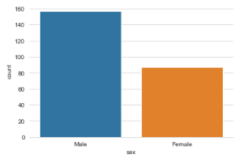

plt.figure(figsize=(6,3))  
sns.countplot(x='sex', data=tips)

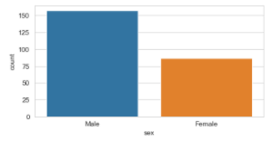

sns.set_context('talk', font_scale=2) *# contex: {paper, notebook, talk, poster}*  
sns.countplot(x='sex', data=tips)

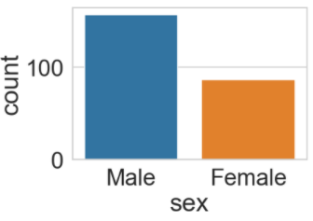

sns.set_context('paper', font_scale=2) *# contex: {paper, notebook, talk, poster}*  
sns.lmplot(x='total_bill', y='tip', data=tips, hue='sex', palette='PiYG')

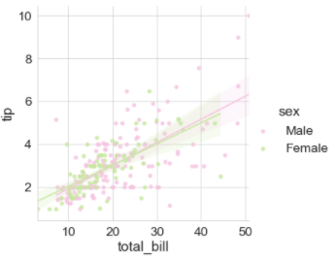

# Plotly and Cufflinks

## Otherview

* Plotly is an interactive visualization library
* Cufflinks connects plotly with pandas

## Code

### Imports and setup

import chart_studio.plotly as py  
import pandas as pd  
import numpy as np  
from plotly import __version__  
import cufflinks as cf  
  
from plotly.offline import download_plotlyjs, init_notebook_mode, plot, iplot  
init_notebook_mode(connected=True)   
cf.go_offline()  
%matplotlib inline

### Code

*# Data*  
df=pd.DataFrame(np.random.randn(100,4), columns='A B C D'.split())  
df

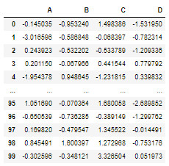

df.iplot()

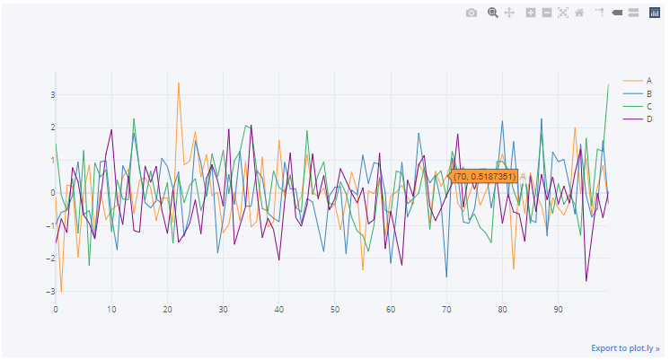

df.iplot(kind='scatter', x='A', y='B', mode='markers', size=20)

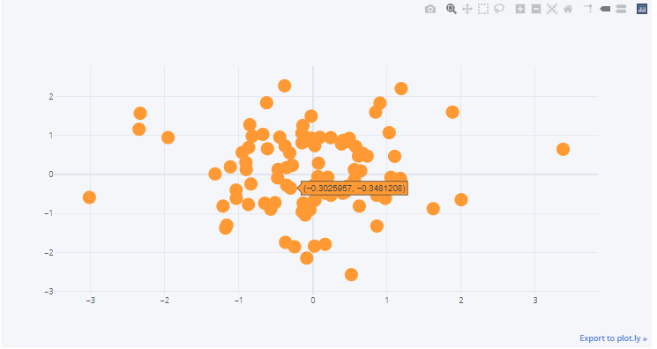

df2.iplot(kind='bar', x='Category', y="Values")

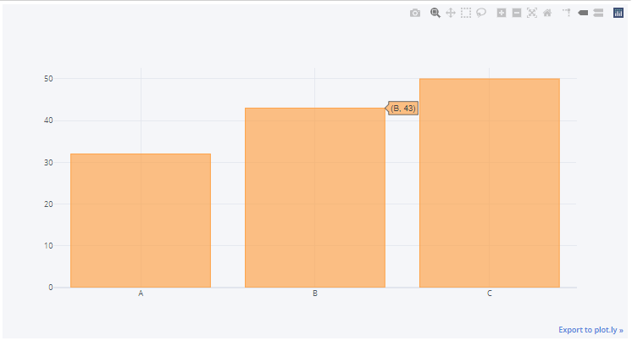

df.mean().iplot(kind='bar')

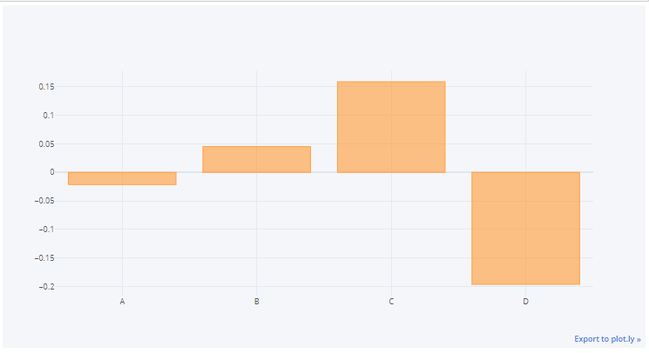

df.iplot('box')

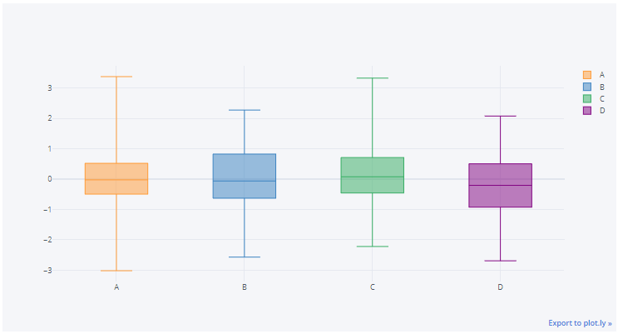

df3=pd.DataFrame({'x':[1,2,3,4,5], 'y':[10,20,30,20,10], 'z':[500,400,300,200,100]})  
df3

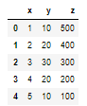

df3.iplot(kind='surface')

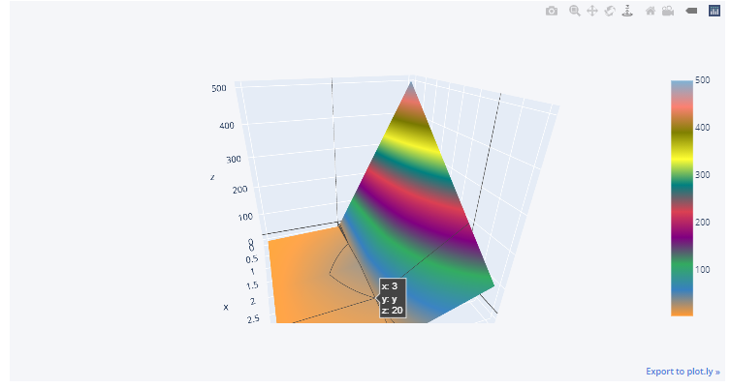

df3=pd.DataFrame({'x':[1,2,3,4,5], 'y':[10,20,30,20,10], 'z':[5,4,3,2,1]})  
df3

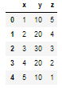

df3.iplot(kind='surface', colorscale='rdylbu')

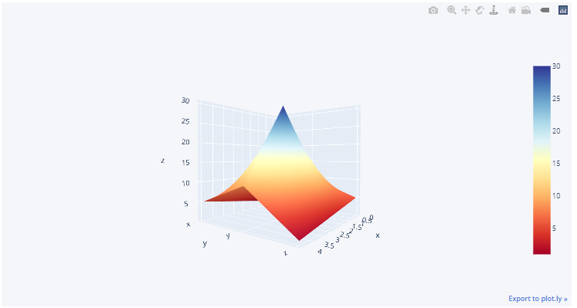

df['A'].iplot(kind='hist', bins=25)

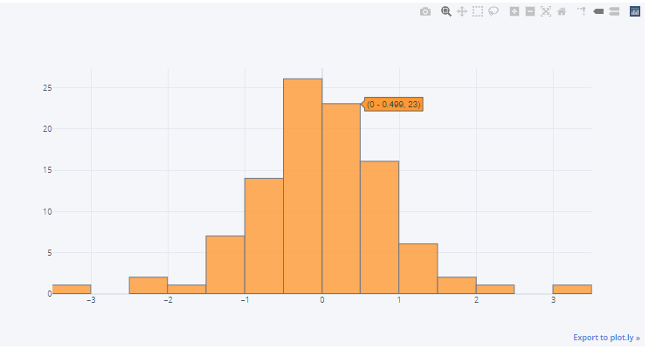

df.iplot(kind='hist')

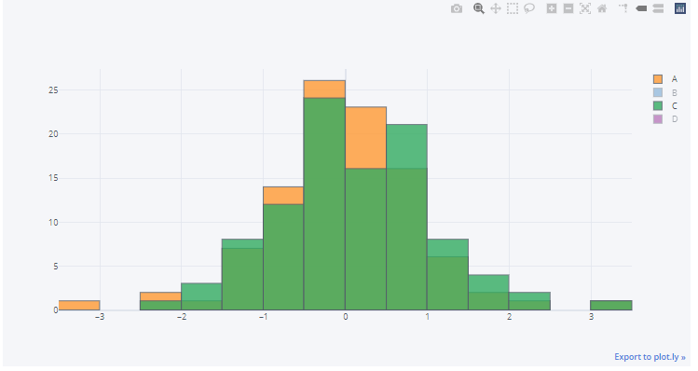

df[['A', 'B']].iplot(kind='spread')

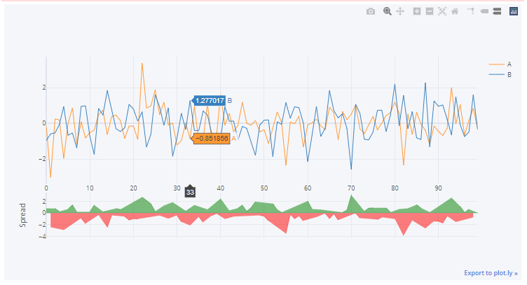

df.iplot(kind='bubble', x='A', y='B', size='C', color='pink')

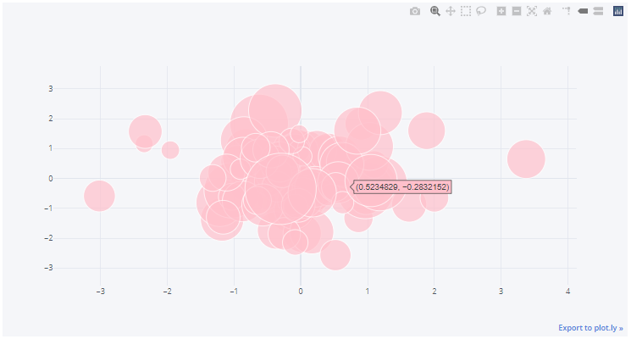

df.scatter_matrix()

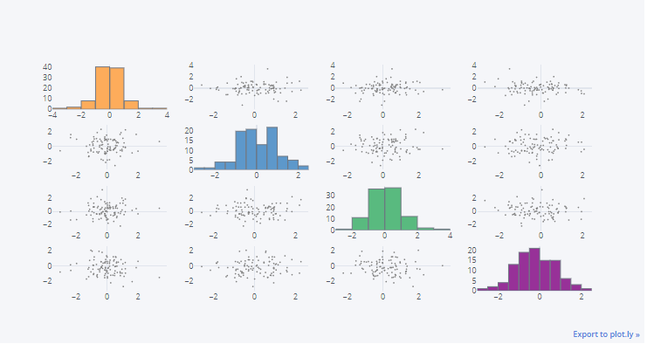

# Geographical plotting

## Introduction

* Challenging to due the various formats the data can come in
* Plotly
* Matplotlib – extension basemap

## Code

### Imports and setup

import plotly as py  
from plotly.offline import download_plotlyjs, init_notebook_mode, plot, iplot  
import plotly.graph_objs as go  
  
init_notebook_mode(connected=True)

### USA

*# colorscale : Portland, Jet, Green, Red ...*  
  
data=dict(type='choropleth',  
 locations=['AZ', 'CA', 'NY'],  
 locationmode='USA-states',  
 colorscale='Portland',  
 text=['Arizona', 'Cali', 'New York'],  
 z=[1.0,2.0,3.0],  
 colorbar={'title':'Colorbar Title Gooes Here'})  
data

{'type': 'choropleth',

'locations': ['AZ', 'CA', 'NY'],

'locationmode': 'USA-states',

'colorscale': 'Portland',

'text': ['Arizona', 'Cali', 'New York'],

'z': [1.0, 2.0, 3.0],

'colorbar': {'title': 'Colorbar Title Gooes Here'}}

layout=dict(geo={'scope':'usa'})  
choromap=go.Figure(data=[data], layout=layout)  
iplot(choromap)

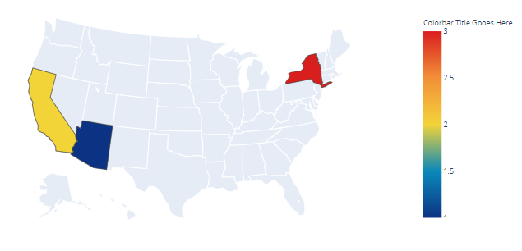

plot(choromap) *#it open map in new window*

df=pd.read_csv(path+'2011_US_AGRI_Exports')  
df

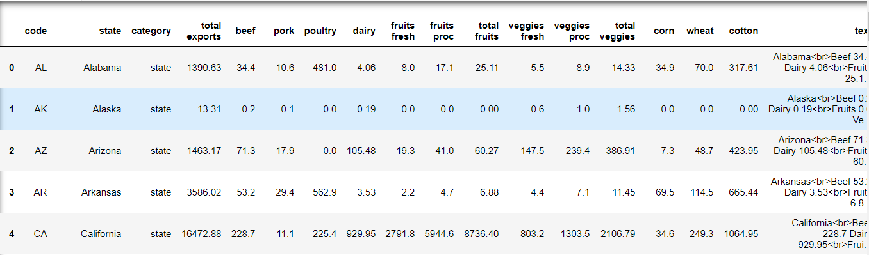

data=dict(type='choropleth',  
 colorscale='YlOrRd',  
 locations=df['code'],  
 locationmode='USA-states',  
 z=df['total exports'],  
 text=df['text'],  
 marker=dict(line=dict(color='rgb(255,255,255)', width=2)),  
 colorbar={'title':'Milions USD'})

layout=dict(title='2011 US Agriculture Exports by State',   
 geo=dict(scope='usa', showlakes=True, lakecolor='rgb(85,173,240)'))

choromap2=go.Figure(data=[data], layout=layout)  
iplot(choromap2)

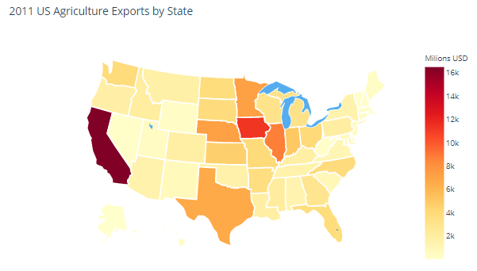

df=pd.read_csv(path+'2012_Election_Data')  
df.head(5)

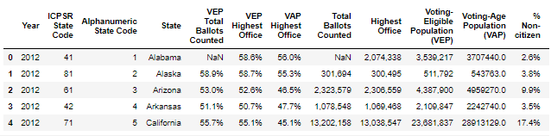

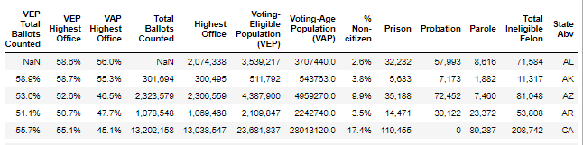

data=dict(type='choropleth',   
 locations=df['State Abv'],   
 colorscale='fall',  
 reversescale=True,  
 locationmode='USA-states',  
 z=df['Voting-Age Population (VAP)'],   
 text=df['State'],  
 colorbar={'title':'Voting-Age Population (VAP)'})  
  
layout=dict(title='2012 Election - Voting-Age Population (VAP)',  
 geo=dict(showframe=False,  
 scope='usa',  
 showlakes=True, lakecolor='rgb(90,170,240)'))

*#+str(df['Voting-Age Population (VAP)']*

choropleth5=go.Figure(data=[data], layout=layout)  
iplot(choropleth5)

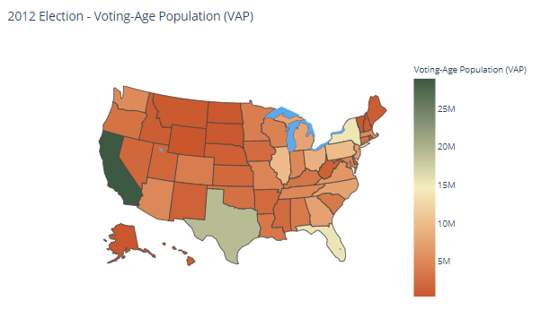

### World

df=pd.read_csv(path+'2014_World_GDP')  
df

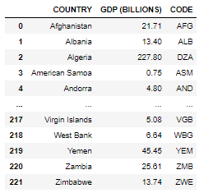

data=dict(type='choropleth',  
 locations=df['CODE'],  
 locationmode='ISO-3',  
 z=df['GDP (BILLIONS)'],  
 text=df['COUNTRY'],  
 colorbar={'title':'GDP (bilions)'})  
  
layout=dict(title='2014 Global GDP',  
 geo=dict(showframe=False,  
 projection={'type':'natural earth'}))

choromap3=go.Figure(data=[data], layout=layout)  
iplot(choromap3)

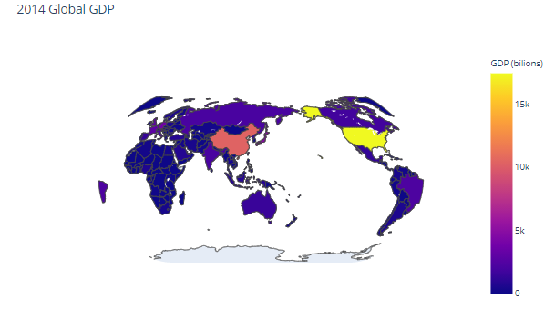

df=pd.read_csv(path+'2014_World_Power_Consumption')  
df

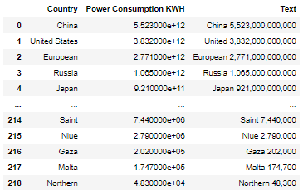

data=dict(type='choropleth',   
 locations=df['Country'],   
 z=df['Power Consumption KWH'],   
 colorscale='Viridis',  
 reversescale=True,  
 text=df['Text'],   
 locationmode='country names',  
 colorbar={'title':'Power Consumption KWH'}  
 )  
  
layout=dict(title='2014 World Power Consumption',  
 geo=dict(showframe=False,  
 projection={'type':'natural earth'}))

choropleth4=go.Figure(data=[data], layout=layout)  
iplot(choropleth4)

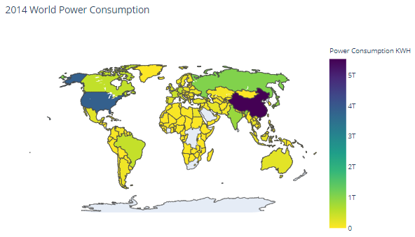

Machine learning

# Machine learning – general

## Introduction

### Superwised Learning

* **Supervised learning** algorithms are trained using **labeled** examples, such as an input where the desire output is known.
* For example, a segment of text could have a category label, such as:
  + Spam vs. Legitimate Email
  + Positive vs. Negative Movie Review
* The network receives a set of inputs along with the corresponding correct outputs, and the algorithm learns by comparing its actual output with correct outputs to find errors.
* It then modifies the model accordingly.
* Supervised learning is commonly used in applications where historical data predicts likely future events.

### Machine learning Process

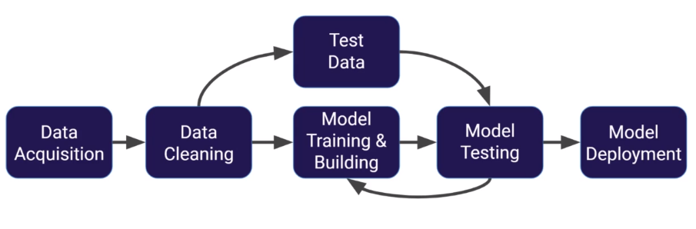

Splitting data:

* 1
  + Training data ~70%
  + Test data- over and over again to adjust the model
* 2
  + Training data – used to train model parameters
  + Validation data – used to determine what model hyperparameters to adjust
  + Test data – Used to get some final performance metric, the model has never seen it before, after we see the result on the final test set we don’t get to go back and adjust any model parameters! The final measure is what we label the true performance of the model to be.

## Evaluating Performance – classification error metrics – Classification

* After machine learning process is complete, we will use performance metrics to evaluate how the model did,
* The key classification metrics we need to understand are:
  + **Accuracy** – accurancy in classification problems is the **number of correct predictions** made by the model divided by the **total number of predictions**
 $$acurancy=\frac{number of correct predictions}{total number of predictions}$$

   - Is useful when target classes are well balanced
  + **Recall** – ability of a model to find all the relevant cases within a dataset. This is the number of true positives divided by the number of true positives plus the number of false negatives

* + **Precision** – ability of classification model to identify only the relevant data points. This is a number of true positives divided by the number of true positives plus the number of false positives
 $$precision=\frac{number of true positives}{number of true positives+number of false positives}$$

 + **F1-Score** – combination of recall and precision, uses in cases where we want to find an optimal blend of precision and recall we can combine the two metrics using what is called the F1 score. It is the harmonic mean of recall and precision taking both metrics into account in the following equation
$$F_{1}=2*\frac{recall*precision}{recal+precision}$$

* Recall and precision
  + Often there are a trade-off between Recall and Precision
  + While recall expresses the ability to find all relevant instances in a dataset, precision expresses the proportion of the data points out model says was relevant actually were relevant
* Typically in any classification task model can only achieve two result:
  + Either model was **correct** in prediction
  + Model was **incorrect** in its prediction
* Fortunately incorrect vs correct expands to situations where you have multiple classes
* For the purposes of explaining the metrics, let’s imagine a binary classification situation, where only have two available classes
* **Confusion matrix**

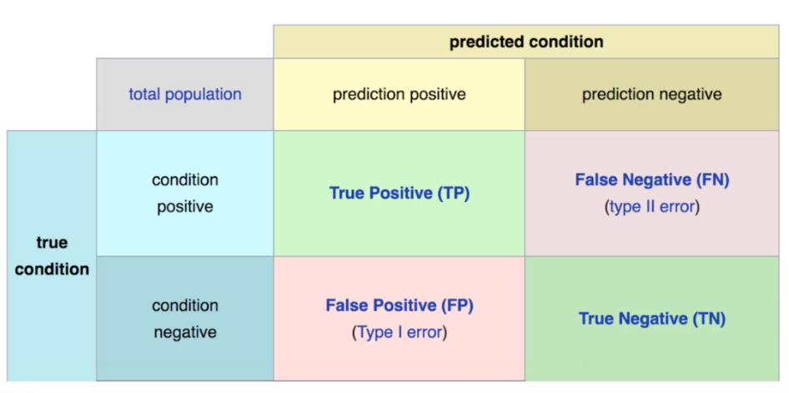

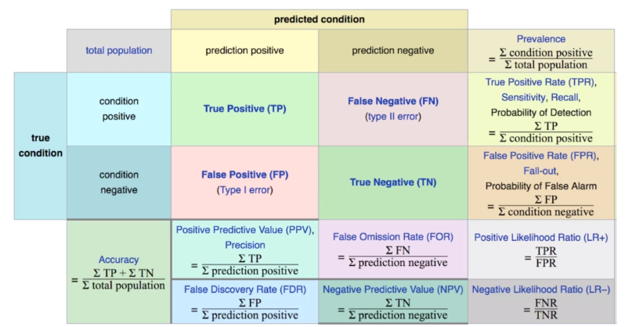

* + The main point to remember with the confusion matrix and the various calculated metrics is that they are all fundamentally ways of comparing the predicted values versus the true values
  + What constitutes ‘good’ metrics, will really depend on the specific situation!

## Evaluating performance – Regression Error Metrics

* Regression is a task when a model attempts to predict continuous values (unlike categorical values, which is classification)
* These sort of metrics aren’t useful for regression problems, we need metrics designed for **continuous** values
* Most common evaluation metrics for regression:
  + Mean Absolute Error (MEA)
    - This is the mean of the absolute value of errors
    - Easy to understand
 $$\frac{1}{n}\sum_{i=1^{\left|y_{i}-{\hat{y}}_{i}\right|}}^{n}{ }$$

   - MEA won’t punish large errors however

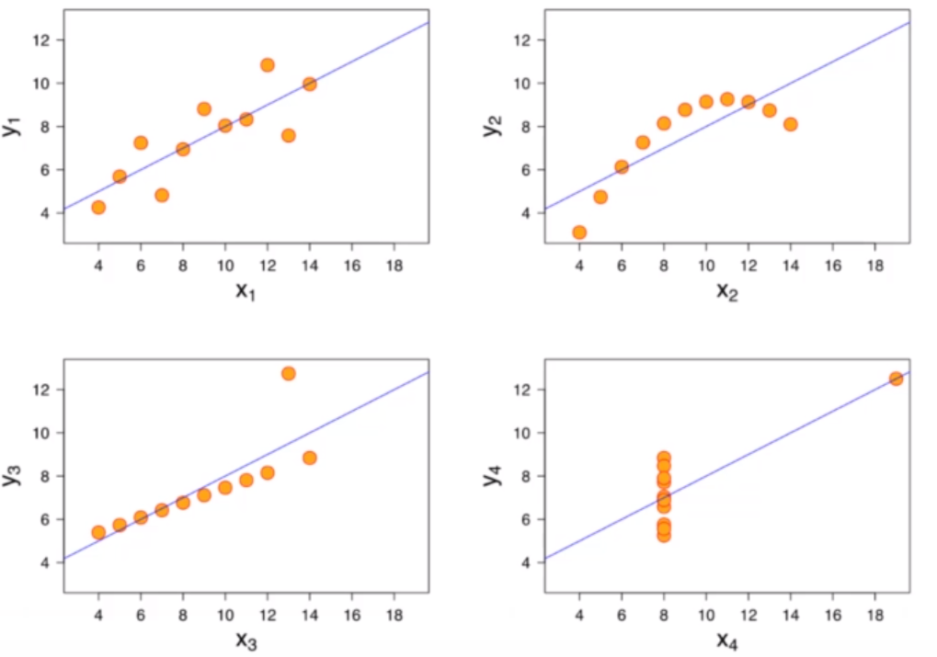

* + Mean Squared Error (MSA)
    - This is the mean of the squared errors
    - Large errors are noted more than with MAE, making MSE more popular
 $$\frac{1}{n}\sum_{i=1^{{\left(y_{i}-{\hat{y}}_{i}\right)}^{2}}}^{n}{ }$$

 + Root Mean Square Error
    - This is the root of the mean of the squared errors
    - Has the same unit as y
 $$\sqrt{\frac{1}{n}\sum_{i=1^{{\left(y_{i}-{\hat{y}}_{i}\right)}^{2}}}^{n}{ } }$$

 + Is this value of RMSE good? – Depends on context!
  + Compare error metric to the average value of the label into data set to try to get an intuition of its overall performance

## Machine learning with Python

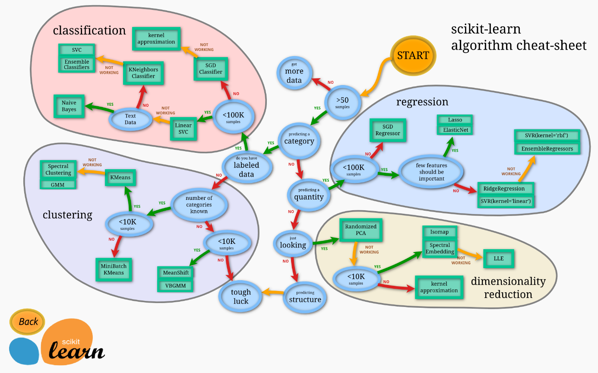

# Linear regression

## Theory

* 1800s, Francis Galton – he was studying the relationship between parents and children. In particular, he investigated the relationship between the heights of fathers and their sons.
  + Man’s son tended to be roughly as tall as his father
  + Son’s height tended to be closer to the overall average height of all people

## Code

### Imports and setup

import pandas as pd  
import numpy as np  
import matplotlib.pyplot as plt  
import seaborn as sns  
%matplotlib inline  
  
from sklearn.model_selection import train_test_split  
from sklearn.linear_model import LinearRegression  
from sklearn import metrics

### Code

path='C:\\Users\\HP\\Desktop\\Python\\DS_ML_Bootcamp\\@Source\\11-Linear-Regression\\'  
df=pd.read_csv(path+'USA_Housing.csv')  
df

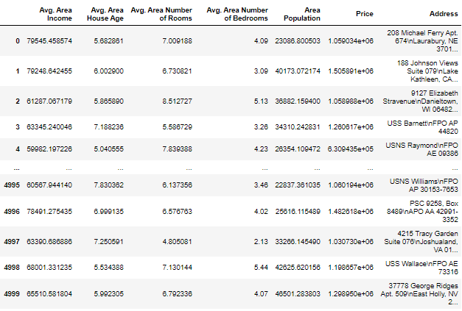

df.info()

<class 'pandas.core.frame.DataFrame'>

RangeIndex: 5000 entries, 0 to 4999

Data columns (total 7 columns):

# Column Non-Null Count Dtype

--- ------ -------------- -----

0 Avg. Area Income 5000 non-null float64

1 Avg. Area House Age 5000 non-null float64

2 Avg. Area Number of Rooms 5000 non-null float64

3 Avg. Area Number of Bedrooms 5000 non-null float64

4 Area Population 5000 non-null float64

5 Price 5000 non-null float64

6 Address 5000 non-null object

dtypes: float64(6), object(1)

memory usage: 273.6+ KB

df.describe()

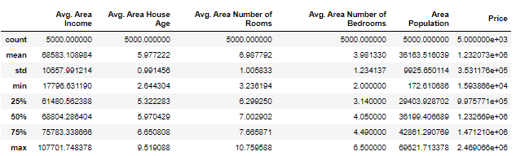

sns.pairplot(df)

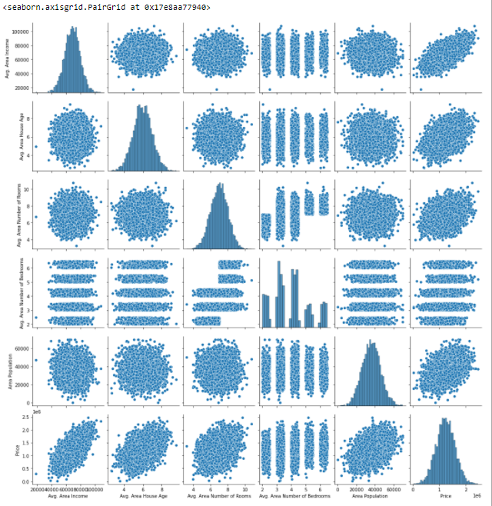

sns.histplot(df['Price'], kde=True)

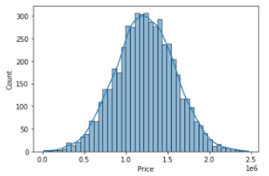

sns.heatmap(df.corr(), annot=True, cmap='coolwarm')

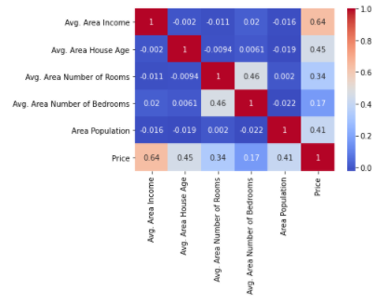

*# set sets data*  
X=df[['Avg. Area Income', 'Avg. Area House Age', 'Avg. Area Number of Rooms',  
 'Avg. Area Number of Bedrooms', 'Area Population']]  
  
y=df['Price']  
from sklearn.model_selection import train_test_split  
*# split the data*  
X_train, X_test, y_train, y_test=train_test_split(X, y, test_size=0.4, random_state=101)  
from sklearn.linear_model import LinearRegression  
lm=LinearRegression()  
lm.fit(X_train, y_train)   
print(lm.intercept_)  
cdf=pd.DataFrame(lm.coef_, X.columns, columns=['Coeff'])  
cdf

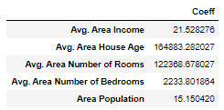

predictions=lm.predict(X_test)  
predictions

array([1260960.70567626, 827588.75560352, 1742421.24254328, ...,

372191.40626952, 1365217.15140895, 1914519.54178824])

y_test

1718 1.251689e+06

2511 8.730483e+05

345 1.696978e+06

2521 1.063964e+06

54 9.487883e+05

...

1776 1.489520e+06

4269 7.777336e+05

1661 1.515271e+05

2410 1.343824e+06

2302 1.906025e+06

Name: Price, Length: 2000, dtype: float64

plt.scatter(y_test, predictions)

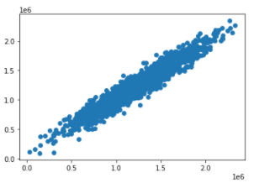

sns.histplot((y_test-predictions))

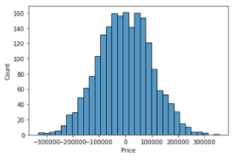

from sklearn import metrics  
  
print('MAE: ', metrics.mean_absolute_error(y_test, predictions))  
print('MSE: ', metrics.mean_squared_error(y_test, predictions))  
print('RMSE: ', metrics.mean_squared_error(y_test, predictions)**0.5)

MAE: 82288.22251914957

MSE: 10460958907.209501

RMSE: 102278.82922291153

# Bias variance trade-off

* The bias variance trade-off is the point where we are adding just noise by adding model complexity (flexibility)
* The training errors goes down as it has to, but the test error is starting go to up
* The model after the bias trade-off begins to overfit

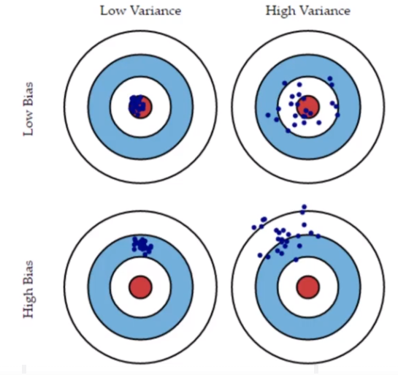

* A common temptation is to continually add complexity to a model until it fits the training set very well

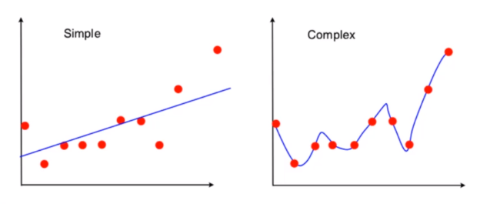

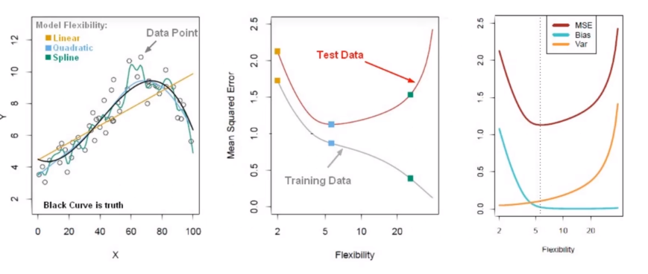

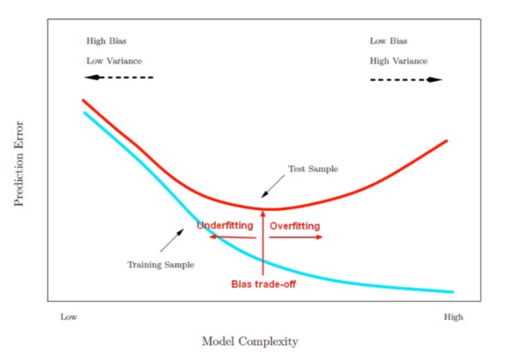

# Logistic Regression

## Overview

* Binary classification – yes/no, categories
* Allows to solve classification problems, where we are trying to predict discrete categories
* The convention for binary classification is to have two classes 0 and 1
* We can’t use a normal linear regression model on binary groups, It won’t lead to a good fit

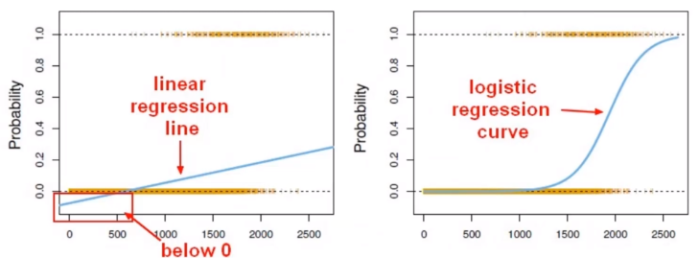

* The Sigmoid (aka Logistic) Function takes in any value and outputs is to be between 0 and 1

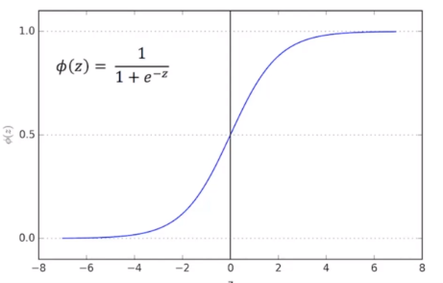

* This means we can take out Linear Regression Solution and place it into the Sigmoid Function

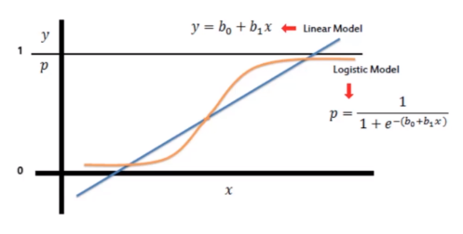

* This result in a probability from 0 to 1 of belonging in the 1 class. We can set set a **cutoff** point at 0.5, anything below it results in class 0, anything above is class 1. We use the logistic function to output a value ranging from 0 to 1. Based off of this probability we assign a class

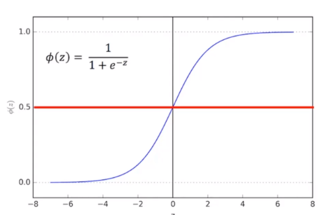

## Code

train=pd.read_csv(path+'titanic_train.csv')  
train

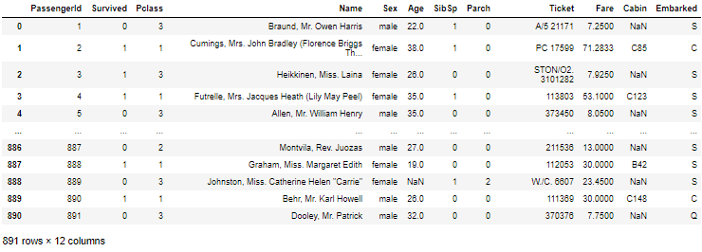

sns.heatmap(train.isnull(), yticklabels=False, cbar=False, cmap='viridis')

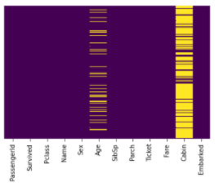

sns.countplot(x='Survived', data=train, hue='Sex', palette='RdBu_r')

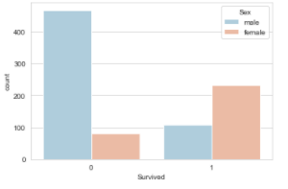

sns.countplot(x='Survived', data=train, hue='Pclass')

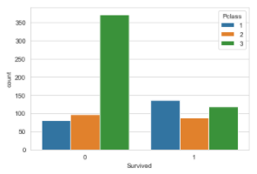

sns.histplot(train['Age'].dropna())

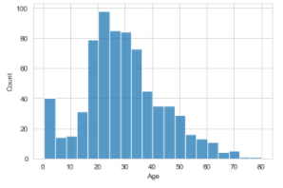

train['Age'].plot.hist()

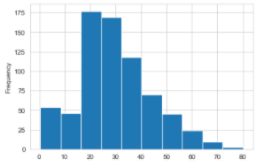

train.info()

<class 'pandas.core.frame.DataFrame'>

RangeIndex: 891 entries, 0 to 890

Data columns (total 12 columns):

# Column Non-Null Count Dtype

--- ------ -------------- -----

0 PassengerId 891 non-null int64

1 Survived 891 non-null int64

2 Pclass 891 non-null int64

3 Name 891 non-null object

4 Sex 891 non-null object

5 Age 714 non-null float64

6 SibSp 891 non-null int64

7 Parch 891 non-null int64

8 Ticket 891 non-null object

9 Fare 891 non-null float64

10 Cabin 204 non-null object

11 Embarked 889 non-null object

dtypes: float64(2), int64(5), object(5)

memory usage: 83.7+ KB

sns.countplot(x='SibSp', data=train)

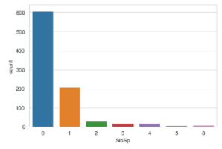

train['Fare'].hist(bins=40, figsize=(12,5))

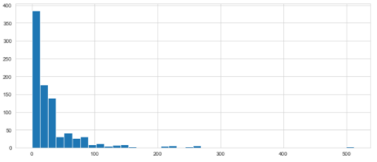

import cufflinks as cf  
cf.go_offline()  
train['Fare'].iplot(kind='hist', bins=40)

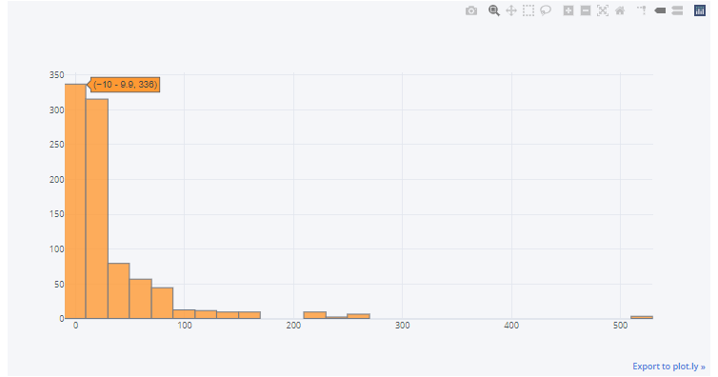

plt.figure(figsize=(10,5))  
sns.boxplot(x='Pclass', y='Age', data=train)

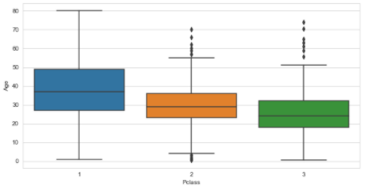

round(train[train['Pclass']==1]['Age'].mean(),0)

38.0

def impute_age(cols):  
 Age=cols[0]  
 Pclass=cols[1]  
   
 if pd.isnull(Age):  
 return round(train[train['Pclass']==Pclass]['Age'].mean(), 0)  
 else:  
 return Age

train['Age']=train[['Age', 'Pclass']].apply(impute_age, axis=1)  
train

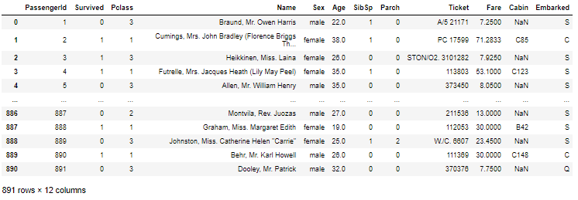

sns.heatmap(train.isnull(), yticklabels=False, cbar=False)

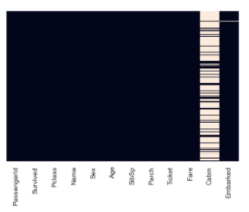

train.drop('Cabin', axis=1, inplace=True)  
train  
train.dropna(inplace=True)  
sns.heatmap(train.isnull(), yticklabels=False, cbar=False)

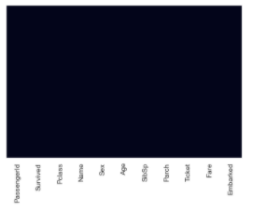

### Cleaning data

*# Creating Dummy variable*  
pd.get_dummies(train['Sex'])

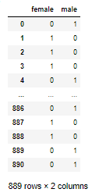

*# Creating Dummy variable*  
  
sex=pd.get_dummies(train['Sex'], drop_first=True)  
embark=pd.get_dummies(train['Embarked'], drop_first=True)  
sex

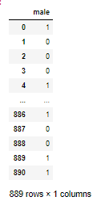

train=pd.concat([train, sex, embark], axis=1)  
train

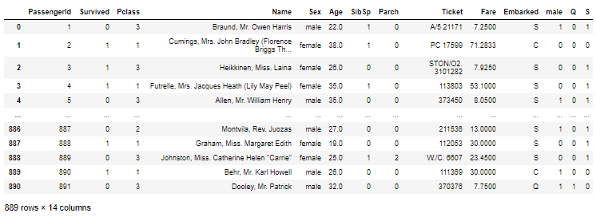

train.drop(['Sex', 'Embarked', 'Name', 'Ticket', 'PassengerId'], inplace=True, axis=1)  
train

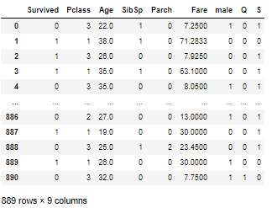

### Train

X=train.drop('Survived', axis=1)  
y=train['Survived']  
  
from sklearn.model_selection import train_test_split  
  
X_train, X_test, y_train, y_test = train_test_split(X, y, test_size=0.3, random_state=101)  
from sklearn.linear_model import LogisticRegression  
  
logmodel=LogisticRegression(max_iter=1000)  
logmodel.fit(X_train, y_train)  
  
predictions=logmodel.predict(X_test)  
from sklearn.metrics import classification_report  
print(classification_report(y_test, predictions))

precision recall f1-score support

0 0.83 0.92 0.87 163

1 0.85 0.70 0.77 104

accuracy 0.84 267

macro avg 0.84 0.81 0.82 267

weighted avg 0.84 0.84 0.83 267

from sklearn.metrics import confusion_matrix  
print(confusion_matrix(y_test, predictions))

[[150 13]

[ 31 73]]

# K Nearest Neighbors

## KNN Theory

* It is a classification algorithm that operates on a very simple principle
* Prediction algorithm
  + Calculate the distance from x to all points in your data
  + Sort the points in data by increasing distance from x
  + Predict the majority label of the ‘k’ closest points

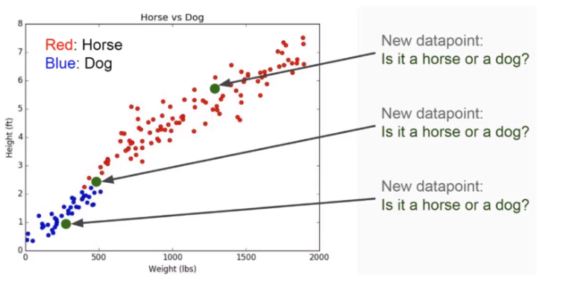 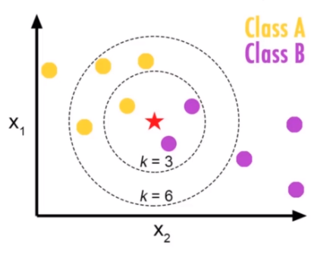

* Choosing a K will affect what class a new point is assigned to

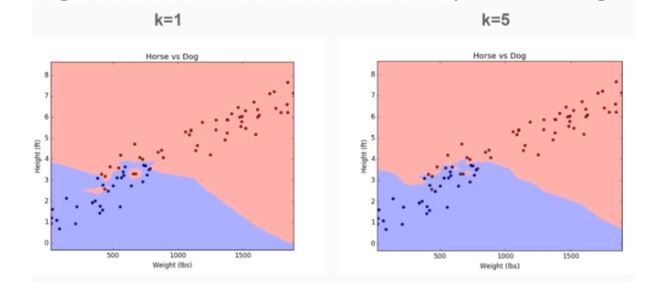

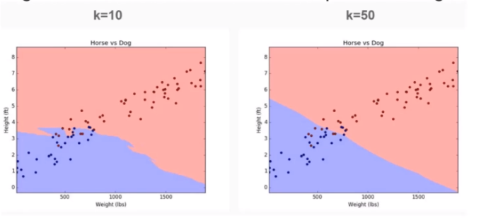

* Pros
  + Very simple
  + Training is trivial
  + Works with any number of classes
  + Easy to add new data
  + Few parameters
    - K
    - Distance Metric
* Cons
  + High Prediction Cost (worse for large data sets)
  + Not good with high dimensional data
  + Categorical Features don’t work well

## Code

path='C:\\Users\\HP\\Desktop\\Python\\DS_ML_Bootcamp\\@Source\\14-K-Nearest-Neighbors\\'  
df=pd.read_csv(path+'Classified Data', index_col=0)  
df

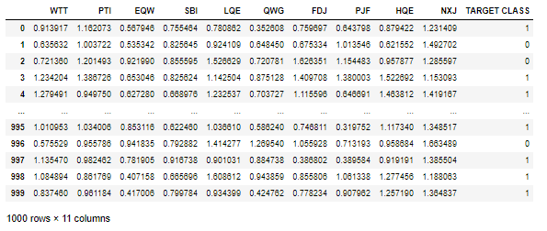

sns.pairplot(df, hue='TARGET CLASS')

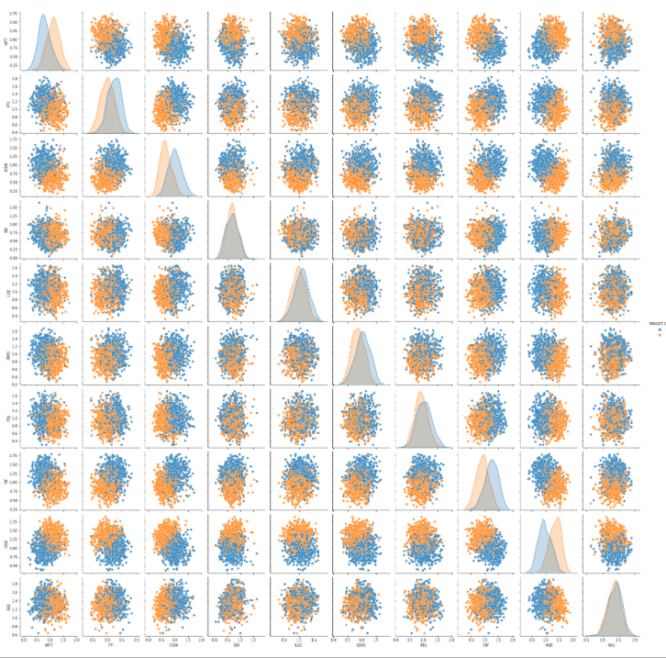

*# biger scale have much more impact than numbers in small scale - you have to standarize*  
from sklearn.preprocessing import StandardScaler  
scaler=StandardScaler()  
scaler.fit(df.drop('TARGET CLASS', axis=1))  
  
scaled_features=scaler.transform(df.drop('TARGET CLASS', axis=1))  
scaled_features

array([[-0.12354188, 0.18590747, -0.91343069, ..., -1.48236813,

-0.9497194 , -0.64331425],

[-1.08483602, -0.43034845, -1.02531333, ..., -0.20224031,

-1.82805088, 0.63675862],

[-0.78870217, 0.33931821, 0.30151137, ..., 0.28570652,

-0.68249379, -0.37784986],

...,

[ 0.64177714, -0.51308341, -0.17920486, ..., -2.36249443,

-0.81426092, 0.11159651],

[ 0.46707241, -0.98278576, -1.46519359, ..., -0.03677699,

0.40602453, -0.85567 ],

[-0.38765353, -0.59589427, -1.4313981 , ..., -0.56778932,

0.3369971 , 0.01034996]])

df_feat=pd.DataFrame(scaled_features, columns=df.columns[:-1])  
df_feat

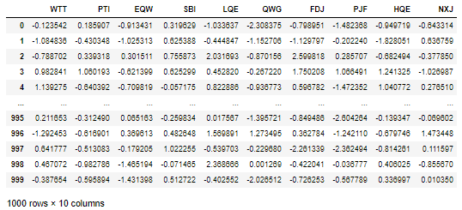

df_feat2=pd.concat([df_feat, df['TARGET CLASS']], axis=1)  
df_feat2

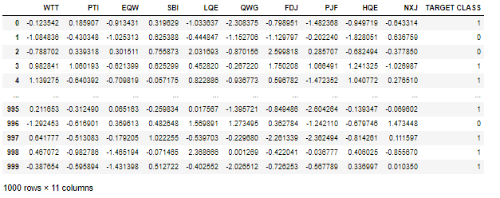

from sklearn.model_selection import train_test_split  
X=df_feat2.drop('TARGET CLASS', axis=1)  
y=df_feat2['TARGET CLASS']  
  
X_train, X_test, y_train, y_test = train_test_split(X, y, test_size=0.3, random_state=101)  
  
from sklearn.neighbors import KNeighborsClassifier  
knn=KNeighborsClassifier(n_neighbors=1)  
knn.fit(X_train, y_train)  
predictions=knn.predict(X_test)  
  
from sklearn.metrics import classification_report, confusion_matrix  
print(confusion_matrix(y_test, predictions))  
print(classification_report(y_test, predictions))

[[151 8]

[ 15 126]]

precision recall f1-score support

0 0.91 0.95 0.93 159

1 0.94 0.89 0.92 141

accuracy 0.92 300

macro avg 0.92 0.92 0.92 300

weighted avg 0.92 0.92 0.92 300

error_rate=[]  
for i in range(1, 40):  
 knn=KNeighborsClassifier(n_neighbors=i)  
 knn.fit(X_train, y_train)  
 pred_i=knn.predict(X_test)  
   
 error_rate.append(np.mean(pred_i!=y_test)) *#average error rate*

plt.figure(figsize=(10,6))  
plt.plot(range(1,40), error_rate, color='blue', linestyle='dashed', marker='o', markerfacecolor='red', markersize=10)  
plt.xlabel('K')  
plt.ylabel('Error rate')  
plt.grid(True)

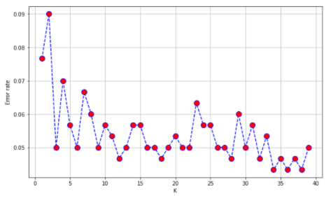

*#17 - the bes score - minimum iteration and minimum error rate*  
  
knn=KNeighborsClassifier(n_neighbors=17)  
knn.fit(X_train, y_train)  
predictions=knn.predict(X_test)  
  
  
print(confusion_matrix(y_test, predictions))  
print(classification_report(y_test, predictions))

[[153 6]

[ 9 132]]

precision recall f1-score support

0 0.94 0.96 0.95 159

1 0.96 0.94 0.95 141

accuracy 0.95 300

macro avg 0.95 0.95 0.95 300

weighted avg 0.95 0.95 0.95 300

# Decision trees and random forest

## Introduction



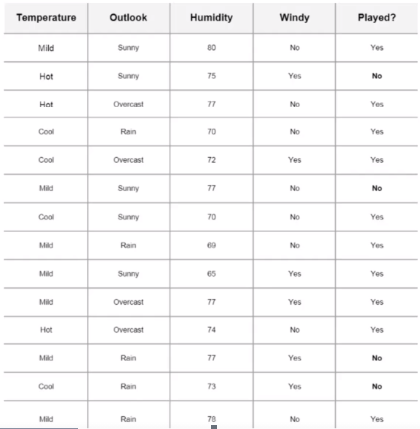

* Decision tree
  + Nodes – split for the value of the certain attribute (outlook, humidity, windy
  + Edges – outcome of a split to next node
  + Root – the node that perform the first split (here – outlook)
  + Leaves – terminal nodes that predict outcome

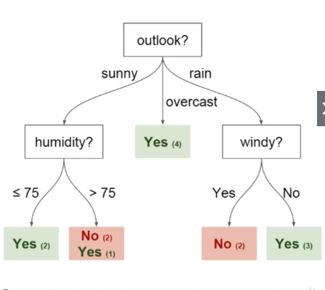

* Entropy and Information Gain are the Mathematical methods of choosing the best split

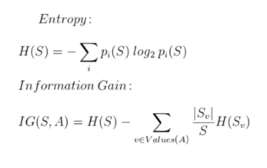

* To improve performance, we can use many trees wits a random sample of features chosen as the split
  + A new random sample of features is chosen for **every single tree at every single split**
  + For **classification**, m is typically chosen to be the square root of p
* What is the point?
  + Suppose there is one very strong feature in the data set. When using ‘bagged’ trees, most of trees will use that feature as the top split, resulting in an ensemble of similar trees that are **highly corelated**
  + Averaging highly corelated quantities does not significantly reduce variance
  + By randomly leaving out candidate feature from each split, **Random Forest ‘decorrelates’ the trees**, such that the averaging process can reduce the variance of the resulting model.

## Code

path='C:\\Users\\HP\\Desktop\\Python\\DS_ML_Bootcamp\\@Source\\15-Decision-Trees-and-Random-Forests\\'  
df=pd.read_csv(path+'kyphosis.csv')  
df

*#Age in months*

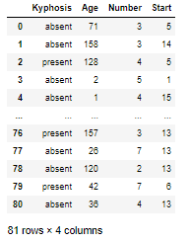

df.info()

<class 'pandas.core.frame.DataFrame'>

RangeIndex: 81 entries, 0 to 80

Data columns (total 4 columns):

# Column Non-Null Count Dtype

--- ------ -------------- -----

0 Kyphosis 81 non-null object

1 Age 81 non-null int64

2 Number 81 non-null int64

3 Start 81 non-null int64

dtypes: int64(3), object(1)

memory usage: 2.7+ KB

sns.pairplot(df, hue="Kyphosis")

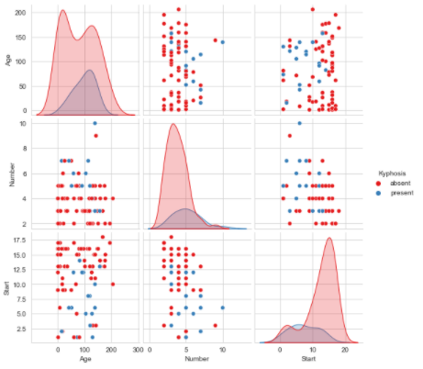

from sklearn.model_selection import train_test_split  
X=df.drop('Kyphosis', axis=1)  
y=df['Kyphosis']  
  
X_train, X_test, y_train, y_test = train_test_split(X, y, test_size=0.3)  
from sklearn.tree import DecisionTreeClassifier  
dtree=DecisionTreeClassifier()  
dtree.fit(X_train, y_train)  
  
predictions=dtree.predict(X_test)  
from sklearn.metrics import classification_report, confusion_matrix  
  
print(classification_report(y_test, predictions))  
print('\n')  
print(confusion_matrix(y_test, predictions))

precision recall f1-score support

absent 0.81 0.81 0.81 21

present 0.00 0.00 0.00 4

accuracy 0.68 25

macro avg 0.40 0.40 0.40 25

weighted avg 0.68 0.68 0.68 25

[[17 4]

[ 4 0]]

from sklearn.ensemble import RandomForestClassifier  
rfc=RandomForestClassifier(n_estimators=200)  
  
rfc.fit(X_train, y_train)  
rfc_predictions=rfc.predict(X_test)  
print(classification_report(y_test, rfc_predictions))  
print(confusion_matrix(y_test, rfc_predictions))

precision recall f1-score support

absent 0.87 0.95 0.91 21

present 0.50 0.25 0.33 4

accuracy 0.84 25

macro avg 0.68 0.60 0.62 25

weighted avg 0.81 0.84 0.82 25

[[20 1]

[ 3 1]]

# Support Vector Machines

## Theory

* Support vector machines (SVMs) are supervised learning models with associated learning algorithms that analyze data and recognize patterns, used for classification and regression analysis
* Given a set of training examples, each marked for belonging to one of two categories, an SVM training algorithm builds a model that assigns new examples into one category or the other, making it a non-probabilistic binary linear classifier
* An SVM model is a representation of the examples as points in space, mapped so that the examples of the separate categories are divided by a clear gap that is as wide as possible
* New examples are then mapped into that same space and predicted to belong to a category based on which side of the gap they fall on

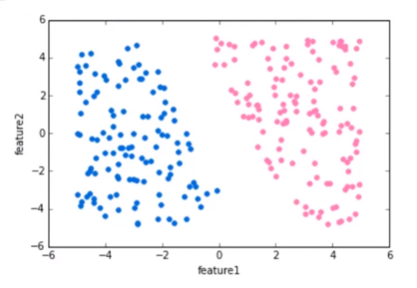

* We can draw separating ‘hyperplane between the classes, but we have many options of hyperplanes that separate perfectly

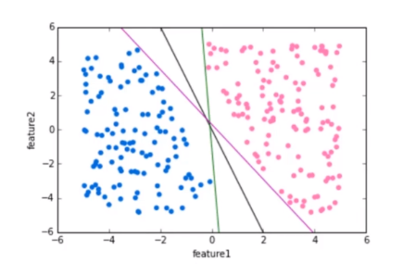

* We would like to choose a hyperplane that maximizes the margin between classes. The vector points that the margin lines touch are known as Support Vectors

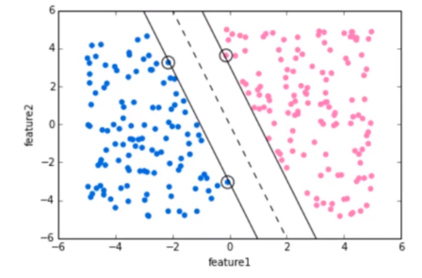

* We can expand this idea to non-linearly separable data through the ‘kernel trick’

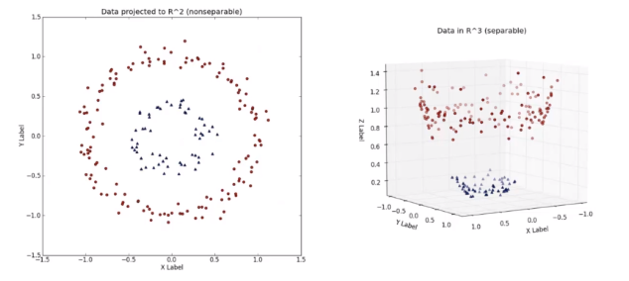

## Code

from sklearn.datasets import load_breast_cancer  
cancer=load_breast_cancer()  
cancer.keys()

dict_keys(['data', 'target', 'frame', 'target_names', 'DESCR', 'feature_names', 'filename'])

df_feat=pd.DataFrame(cancer['data'], columns=cancer['feature_names'])  
df_feat

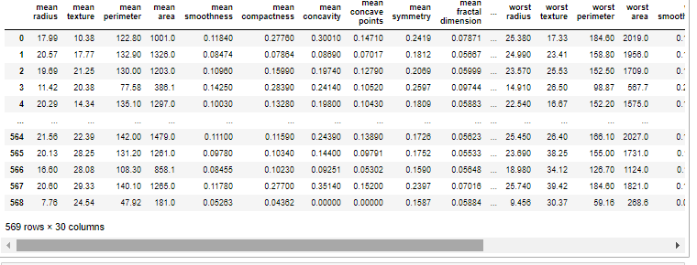

cancer['target']

array([0, 0, 0, 0, 0, 0, 0, 0, 0, 0, 0, 0, 0, 0, 0, 0, 0, 0, 0, 1, 1, 1,

0, 0, 0, 0, 0, 0, 0, 0, 0, 0, 0, 0, 0, 0, 0, 1, 0, 0, 0, 0, 0, 0,

...

1, 1, 1, 1, 1, 1, 1, 1, 1, 1, 1, 1, 0, 0, 0, 0, 0, 0, 1])

cancer['target_names']

array(['malignant', 'benign'], dtype='<U9')

from sklearn.model_selection import train_test_split  
X=df_feat  
y=cancer['target']  
  
X_train, X_test, y_train, y_test = train_test_split(X, y, test_size=0.3, random_state=101)  
from sklearn.svm import SVC  
model=SVC()  
model.fit(X_train, y_train)  
  
predictions=model.predict(X_test)  
from sklearn.metrics import classification_report, confusion_matrix  
  
print(classification_report(y_test, predictions))  
print(confusion_matrix(y_test, predictions))

precision recall f1-score support

0 0.95 0.85 0.90 66

1 0.91 0.97 0.94 105

accuracy 0.92 171

macro avg 0.93 0.91 0.92 171

weighted avg 0.93 0.92 0.92 171

[[ 56 10]

[ 3 102]]

from sklearn.model_selection import GridSearchCV

'''  
SVC(  
 *,  
 C=1.0,  
 kernel='rbf',  
 degree=3,  
 gamma='scale',  
 coef0=0.0,  
 shrinking=True,  
 probability=False,  
 tol=0.001,  
 cache_size=200,  
 class_weight=None,  
 verbose=False,  
 max_iter=-1,  
 decision_function_shape='ovr',  
 break_ties=False,  
 random_state=None,  
)  
'''

param_grid={'C':[0.1, 1, 10, 100, 1000], 'gamma':[1,0.1,0.01,0.001,0.0001]}  
grid=GridSearchCV(SVC(), param_grid, verbose=3)  
grid.fit(X_train, y_train)

Fitting 5 folds for each of 25 candidates, totalling 125 fits

[CV] C=0.1, gamma=1 ..................................................

[CV] ...................... C=0.1, gamma=1, score=0.637, total= 0.0s

[CV] C=0.1, gamma=1 ..................................................

[CV] ...................... C=0.1, gamma=1, score=0.637, total= 0.0s

…

[CV] ................ C=1000, gamma=0.0001, score=0.962, total= 0.0s

[Parallel(n_jobs=1)]: Done 125 out of 125 | elapsed: 2.4s finished

Out[22]:

GridSearchCV(estimator=SVC(),

param_grid={'C': [0.1, 1, 10, 100, 1000],

'gamma': [1, 0.1, 0.01, 0.001, 0.0001]},

verbose=3)

grid.best_params_

'C': 1, 'gamma': 0.0001}

grid.best_estimator_

SVC(C=1, gamma=0.0001)

grid.best_estimator_

SVC(C=1, gamma=0.0001)

grid_predictions=grid.predict(X_test)  
print(confusion_matrix(y_test, grid_predictions))  
print(classification_report(y_test, predictions))

[[ 59 7]

[ 4 101]]

precision recall f1-score support

0 0.95 0.85 0.90 66

1 0.91 0.97 0.94 105

accuracy 0.92 171

macro avg 0.93 0.91 0.92 171

weighted avg 0.93 0.92 0.92 171

# K Means Clustering

## Theory

* K Means Clustering is an unsupervised learning algorithm that will attempt to group similar clusters together in your data.
* Typical clustering problems:
  + Cluster Similar Documents
  + Cluster Customers based on Features
  + Market Segmentation
  + Identify similar physical groups
* The overall goal is to divide data into distinct groups such that observations within each group are similar

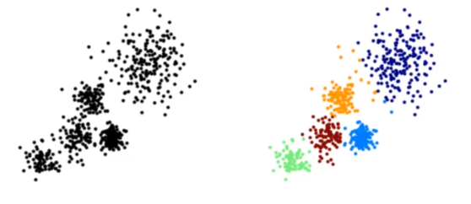

* The K Means Algorithm:
  + Choose a number of Clusters ‘K’
  + Randomly assign each point to a cluster
  + Until clusters stop changing repeat the following:
    - For each cluster, compute the cluster centroid by taking a mean vector of points in the cluster
    - Assign each data point to the cluster for which the centroid is the closest

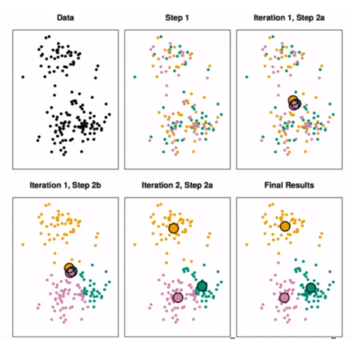

* Choosing K value
  + There is no easy answer for choosing a ‘best’ K value
  + One way is the elbow method

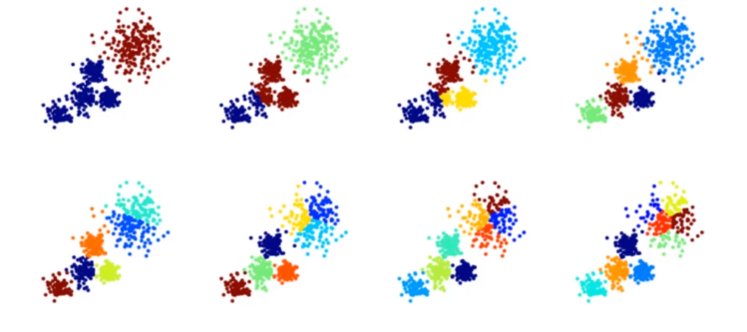

* Elbow Method
  + First of all, compute the sum of squared error (SSE) for some values of k (for example 2,4,6,8 …)
  + The SSE is defined as the sum of the squared distance between each member of the cluster and its centroid
  + If you plot k against the SSE, you will see that **the error decreases as k gets larger**, this is because when the number of clusters increases, they should be smaller, so distortion is also smaller
  + The idea of the elbow method is to choose the k which the SSE decreases abruptly
  + This produces as ‘elbow effect’ in the graph, as you can see following picture

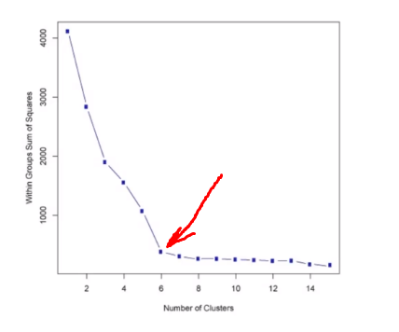

## Code

from sklearn.datasets import make_blobs  
data=make_blobs(n_samples=200, n_features=2, centers=4, cluster_std=1.8, random_state=101)  
data

(array([[-6.42884095e+00, 1.01411174e+01],

[ 5.86867888e+00, 5.20110356e+00],

[-3.76109375e-01, 3.26427943e+00],

...

[ 2.17474403e+00, 1.13147551e+00]]),

array([3, 2, 0, 2, 2, 1, 2, 0, 2, 0, 3, 0, 2, 2, 3, 0, 2, 0, 1, 3, 1, 0,

0, 1, 3, 1, 1, 0, 2, 2, 3, 1, 2, 0, 0, 3, 1, 1, 1, 2, 1, 3, 3, 3,

...

1, 0]))

plt.scatter(data[0][:,0], data[0][:,1], c=data[1], cmap='Set2')

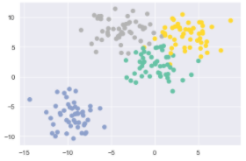

data[1]

array([3, 2, 0, 2, 2, 1, 2, 0, 2, 0, 3, 0, 2, 2, 3, 0, 2, 0, 1, 3, 1, 0,

0, 1, 3, 1, 1, 0, 2, 2, 3, 1, 2, 0, 0, 3, 1, 1, 1, 2, 1, 3, 3, 3,

0, 3, 3, 0, 1, 2, 0, 3, 2, 0, 1, 3, 0, 0, 3, 2, 1, 2, 1, 3, 2, 0,

1, 2, 2, 1, 2, 0, 1, 3, 1, 2, 2, 0, 3, 0, 0, 1, 2, 1, 0, 0, 0, 3,

2, 1, 1, 1, 1, 3, 0, 1, 2, 3, 1, 2, 0, 1, 0, 0, 2, 0, 1, 2, 1, 1,

0, 3, 3, 2, 1, 2, 3, 3, 2, 3, 0, 3, 0, 3, 0, 2, 3, 0, 1, 3, 3, 3,

0, 1, 1, 3, 2, 3, 2, 0, 1, 2, 1, 3, 3, 2, 0, 1, 3, 3, 3, 3, 0, 2,

0, 3, 2, 2, 2, 0, 2, 0, 0, 3, 1, 3, 0, 2, 3, 0, 2, 0, 3, 3, 0, 3,

2, 2, 1, 2, 3, 1, 1, 3, 1, 1, 1, 1, 1, 0, 1, 2, 2, 3, 1, 0, 2, 2,

1, 0])

from sklearn.cluster import KMeans  
kmeans=KMeans(n_clusters=4)  
kmeans.fit(data[0])

KMeans(n_clusters=4)

kmeans.cluster_centers_

array([[-9.46941837, -6.56081545],

[-0.0123077 , 2.13407664],

[-4.13591321, 7.95389851],

[ 3.71749226, 7.01388735]])

kmeans.labels_

array([2, 3, 1, 3, 3, 0, 3, 1, 3, 1, 2, 1, 3, 3, 2, 1, 3, 1, 0, 2, 0, 1,

1, 0, 2, 0, 0, 1, 3, 3, 2, 0, 3, 1, 1, 2, 0, 0, 0, 1, 0, 2, 2, 2,

1, 3, 2, 1, 0, 1, 1, 2, 3, 1, 0, 2, 1, 1, 2, 3, 0, 3, 0, 2, 3, 1,

0, 3, 3, 0, 3, 1, 0, 1, 0, 3, 3, 1, 2, 1, 1, 0, 3, 0, 1, 1, 1, 2,

1, 0, 0, 0, 0, 1, 1, 0, 3, 2, 0, 3, 1, 0, 1, 1, 3, 1, 0, 3, 0, 0,

3, 2, 2, 3, 0, 3, 2, 2, 3, 2, 1, 2, 1, 2, 1, 3, 2, 1, 0, 2, 2, 2,

1, 0, 0, 2, 3, 2, 3, 1, 0, 3, 0, 2, 2, 3, 1, 0, 2, 2, 2, 2, 1, 3,

1, 2, 3, 3, 3, 1, 3, 1, 1, 2, 0, 2, 1, 3, 2, 1, 3, 1, 2, 3, 1, 2,

3, 3, 0, 3, 2, 0, 0, 2, 0, 0, 0, 0, 0, 1, 0, 3, 3, 2, 0, 1, 3, 3,

0, 1])

fig, (ax1, ax2)=plt.subplots(1,2,sharey=True, figsize=(10,6))  
  
ax1.set_title('K Means')  
ax1.scatter(data[0][:,0], data[0][:,1], c=kmeans.labels_, cmap='Set2')  
  
ax2.set_title('Original')  
ax2.scatter(data[0][:,0], data[0][:,1], c=data[1], cmap='Set2')

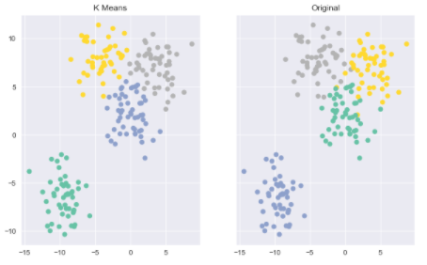

# Principal Component Analysis – Factor Analysis

## Theory

* Principal component analysis is an unsupervised statistical technique used to examine the interrelations among a set of variables in order to identify the underlying structure of those variables
* It is also known sometimes as a general **factor analysis**
* Where regression determines a line of best fit to a data set, factor analysis determines several orthogonal lines of best fit to the data set
* Orthogonal means ‘at right angles’
  + Actually the lines are perpendicular to each other in n-dimensional space.
* N-Dimensional Space is the variable sample space
  + There are as many dimensions as there are variables, so in a data set with 4 variables the sample space is 4-dimensional
* Here we have some data plotted along two features, x and y
  + We can add orthogonal line
  + Now we can begin to understand the components
  + Components are a linear transformation that chooses a variable system for the data set such that the greatest variance of the data set comes to lie on the first axis
  + The second greatest variance on the second axis, and so on…
  + This process allows us to reduce the number of variables used in an analysis
  + Note that components are uncorrelated since in the sample space they are orthogonal to each other
  + We can continue this analysis into higher dimensions

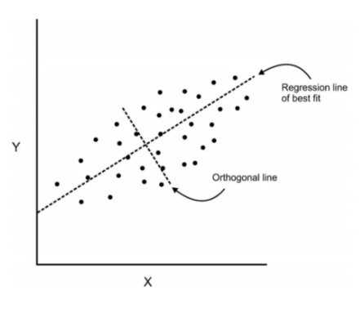

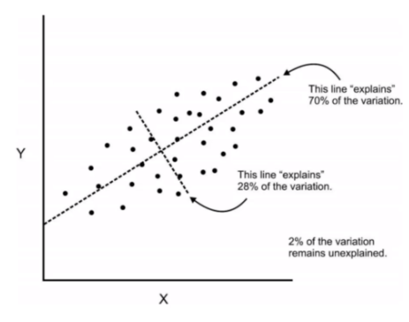

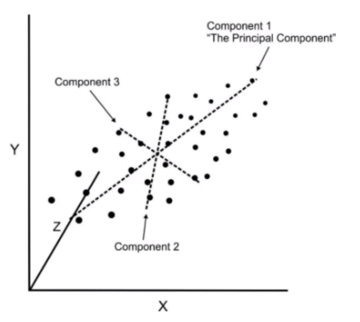

* If we use this technique on a data set with a large number of variables, we can compress the amount of explained variation to just a few components
* The most challenging part of PCA is interpreting the components

## Code

from sklearn.datasets import load_breast_cancer  
cancer=load_breast_cancer()  
cancer

{...

'target': array([0, 0, 0, 0, 0, 0, 0, 0, 0, 0, 0, 0, 0, 0, 0, 0, 0, 0, 0, 1, 1, 1,

0, 0, 0, 0, 0, 0, 0, 0, 0, 0, 0, 0, 0, 0, 0, 1, 0, 0, 0, 0, 0, 0,

...

1, 1, 1, 1, 1, 1, 1, 1, 1, 1, 1, 1, 0, 0, 0, 0, 0, 0, 1]),

...

df=pd.DataFrame(cancer.data, columns=cancer.feature_names)  
df

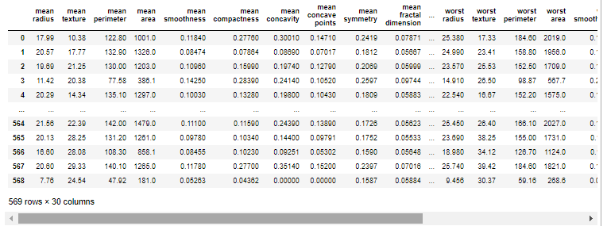

from sklearn.preprocessing import StandardScaler  
  
scaler=StandardScaler()  
scaler.fit(df)  
  
scaled_data=scaler.transform(df)  
scaled_data

array([[ 1.09706398, -2.07333501, 1.26993369, ..., 2.29607613,

2.75062224, 1.93701461],

[ 1.82982061, -0.35363241, 1.68595471, ..., 1.0870843 ,

-0.24388967, 0.28118999],

[ 1.57988811, 0.45618695, 1.56650313, ..., 1.95500035,

1.152255 , 0.20139121],

...,

[ 0.70228425, 2.0455738 , 0.67267578, ..., 0.41406869,

-1.10454895, -0.31840916],

[ 1.83834103, 2.33645719, 1.98252415, ..., 2.28998549,

1.91908301, 2.21963528],

[-1.80840125, 1.22179204, -1.81438851, ..., -1.74506282,

-0.04813821, -0.75120669]])

*#PCA*  
  
from sklearn.decomposition import PCA  
pca=PCA(n_components=2)  
  
pca.fit(scaled_data)  
  
x_pca=pca.transform(scaled_data)  
  
print(scaled_data.shape)  
print(x_pca.shape)

(569, 30)

(569, 2)

plt.figure(figsize=(12,6))  
  
plt.scatter(x_pca[:,0], x_pca[:,1], c=cancer.target)  
  
plt.xlabel('First Principal Component')  
plt.ylabel('Second Principal Component')

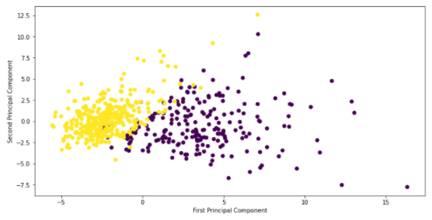

pca.components_

array([[ 0.21890244, 0.10372458, 0.22753729, 0.22099499, 0.14258969,

0.23928535, 0.25840048, 0.26085376, 0.13816696, 0.06436335,

0.20597878, 0.01742803, 0.21132592, 0.20286964, 0.01453145,

0.17039345, 0.15358979, 0.1834174 , 0.04249842, 0.10256832,

0.22799663, 0.10446933, 0.23663968, 0.22487053, 0.12795256,

0.21009588, 0.22876753, 0.25088597, 0.12290456, 0.13178394],

[-0.23385713, -0.05970609, -0.21518136, -0.23107671, 0.18611302,

0.15189161, 0.06016536, -0.0347675 , 0.19034877, 0.36657547,

-0.10555215, 0.08997968, -0.08945723, -0.15229263, 0.20443045,

0.2327159 , 0.19720728, 0.13032156, 0.183848 , 0.28009203,

-0.21986638, -0.0454673 , -0.19987843, -0.21935186, 0.17230435,

0.14359317, 0.09796411, -0.00825724, 0.14188335, 0.27533947]])

df_comp=pd.DataFrame(pca.components_, columns=cancer.feature_names)  
df_comp

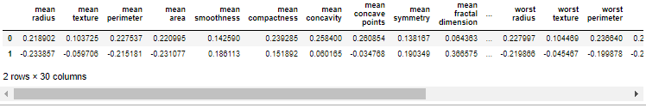

plt.figure(figsize=(18,6))  
  
sns.heatmap(df_comp, cmap='plasma')

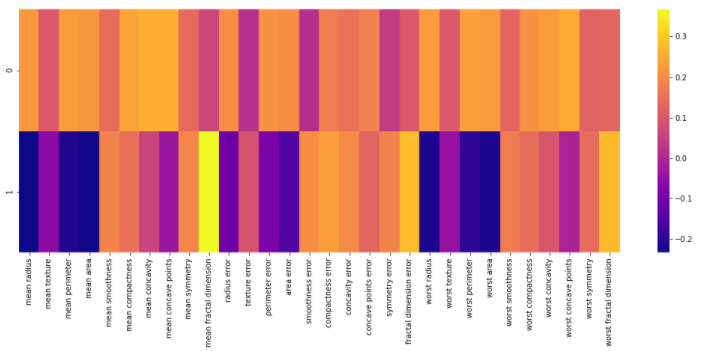

# Recommender systems

## Theory

* Textbook: Recommender Systems by Jannach and Zanker
* The two most common types of recommender systems are **Content-Based** and **Collaborative Filtering (CF)**
  + Collaborative filtering produces recommendations based on the knowledge of users’ attitude to items, that is it uses the ‘wisdom of the crowd’ to recommend items
  + Content-based recommender systems focus on the attributes of the items and give you recommendations based on the similarity between them
* In general, Collaborative filtering (CF) is more commonly used than content-based system because it usually gives better results and is relatively easy to understand (from an overall implementation perspective)
* The algorithm has the ability to do feature learning on its own, which means that it can start to learn for itself what features to use
* CF can be divided into **Memory-Based Collaborative Filtering** and **Mode-Based Collaborative filtering**

## Code

columns_name=['User_id', 'item_id', 'rating', 'timestamp']  
path='C:\\Users\\HP\\Desktop\\Python\\DS_ML_Bootcamp\\@Source\\19-Recommender-Systems\\'  
df_scoring=pd.read_csv(path+'u.data', sep='\t', names=columns_name)  
df_scoring

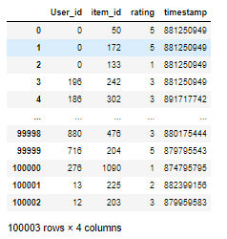

movie_titles=pd.read_csv(path+'Movie_Id_Titles')  
movie_titles

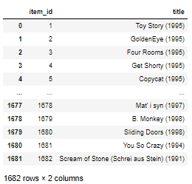

df=pd.merge(df_scoring, movie_titles, on='item_id')  
df

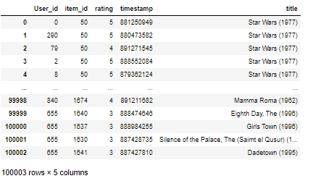

df.groupby('title')['rating'].mean().sort_values(ascending=False)

title

Marlene Dietrich: Shadow and Light (1996) 5.0

Prefontaine (1997) 5.0

Santa with Muscles (1996) 5.0

Star Kid (1997) 5.0

Someone Else's America (1995) 5.0

...

Touki Bouki (Journey of the Hyena) (1973) 1.0

JLG/JLG - autoportrait de décembre (1994) 1.0

Daens (1992) 1.0

Butterfly Kiss (1995) 1.0

Eye of Vichy, The (Oeil de Vichy, L') (1993) 1.0

Name: rating, Length: 1664, dtype: float64

df.groupby('title')['User_id'].count().sort_values(ascending=False)

title

Star Wars (1977) 584

Contact (1997) 509

Fargo (1996) 508

Return of the Jedi (1983) 507

Liar Liar (1997) 485

...

Man from Down Under, The (1943) 1

Marlene Dietrich: Shadow and Light (1996) 1

Mat' i syn (1997) 1

Mille bolle blu (1993) 1

Á köldum klaka (Cold Fever) (1994) 1

Name: User_id, Length: 1664, dtype: int64

ratings=pd.DataFrame(df.groupby('title')['rating'].mean())  
ratings

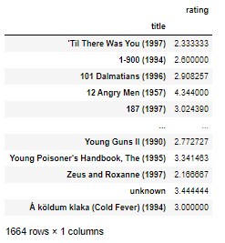

ratings['num of ratings']=df.groupby('title')['User_id'].count()  
ratings

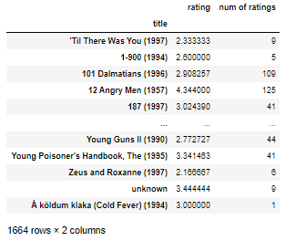

ratings['num of ratings'].hist(bins=70)

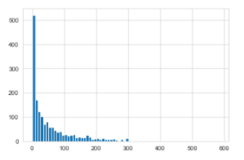

ratings['rating'].hist(bins=70)

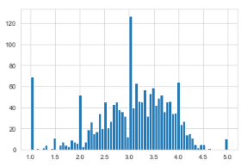

sns.jointplot(data=ratings, x='rating', y='num of ratings')

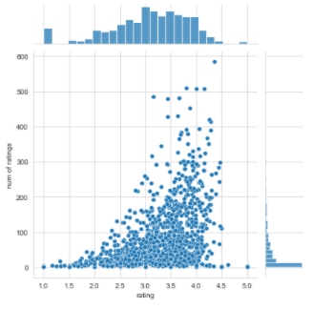

moviemat=df.pivot_table(index='User_id', columns='title', values='rating')  
moviemat

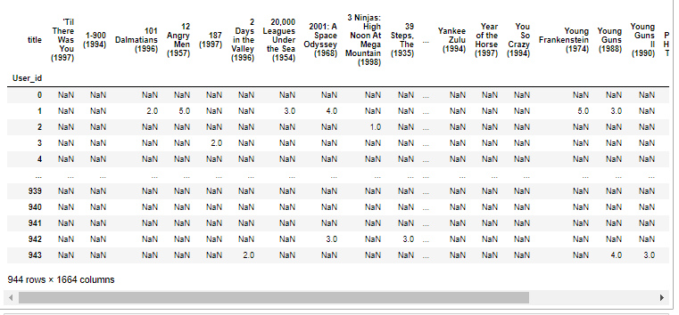

ratings.sort_values('num of ratings', ascending=False)

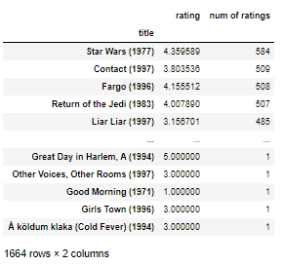

*# Star Wars (1977) - Science Fiction*  
*# Liar Liar (1997) - Comedy*  
starwars_user_ratings=moviemat['Star Wars (1977)']  
liarliar_user_rating=moviemat['Liar Liar (1997)']  
  
starwars_user_ratings

User_id

0 5.0

1 5.0

2 5.0

3 NaN

4 5.0

...

939 NaN

940 4.0

941 NaN

942 5.0

943 4.0

Name: Star Wars (1977), Length: 944, dtype: float64

similar_to_starwars=moviemat.corrwith(starwars_user_ratings)  
similar_to_starwars

title

'Til There Was You (1997) 0.872872

1-900 (1994) -0.645497

101 Dalmatians (1996) 0.211132

12 Angry Men (1957) 0.184289

187 (1997) 0.027398

...

Young Guns II (1990) 0.228615

Young Poisoner's Handbook, The (1995) -0.007374

Zeus and Roxanne (1997) 0.818182

unknown 0.723123

Á köldum klaka (Cold Fever) (1994) NaN

Length: 1664, dtype: float64

similar_to_liarliar=moviemat.corrwith(liarliar_user_rating)  
similar_to_liarliar

title

'Til There Was You (1997) 0.118913

1-900 (1994) NaN

101 Dalmatians (1996) 0.469765

12 Angry Men (1957) 0.066272

187 (1997) 0.175145

...

Young Guns II (1990) 0.352174

Young Poisoner's Handbook, The (1995) 0.445016

Zeus and Roxanne (1997) -0.500000

unknown 0.870388

Á köldum klaka (Cold Fever) (1994) NaN

Length: 1664, dtype: float64

corr_starwars=pd.DataFrame(similar_to_starwars, columns=['correlation'])  
corr_starwars.dropna(inplace=True)  
corr_starwars

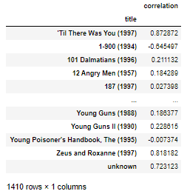

corr_liarliar=pd.DataFrame(similar_to_liarliar, columns=['correlation'])  
corr_liarliar.dropna(inplace=True)  
corr_liarliar

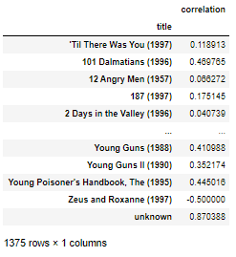

*# without sense*  
  
*# perfect correlation because that film was seen by only 1 person, who give the same rating Star Wars*  
  
corr_starwars.sort_values('correlation', ascending=False)

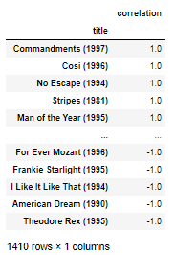

corr_starwars=corr_starwars.join(ratings['num of ratings'])  
corr_starwars

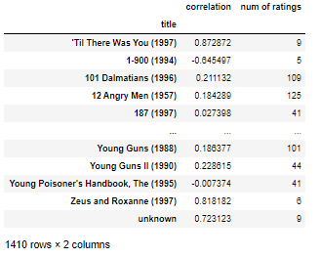

corr_liarliar=corr_liarliar.join(ratings['num of ratings'])  
corr_liarliar

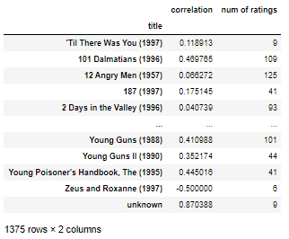

corr_starwars=corr_starwars[corr_starwars['num of ratings']>100].sort_values('correlation', ascending=False)  
corr_starwars

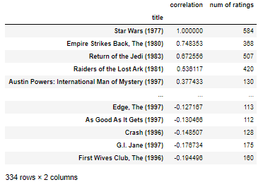

corr_liarliar=corr_liarliar[corr_liarliar['num of ratings']>100].sort_values('correlation', ascending=False)  
corr_liarliar

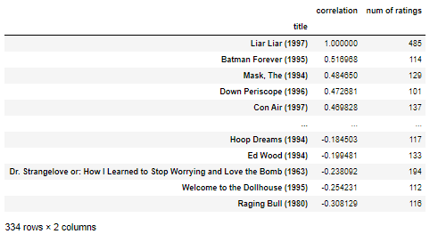

# Natural Language Processing

## Theory

We will want to:

* Compile Documents
* Featurize Them
* Compare their features

Example

* You have 2 documents
  + ‘Blue House’
  + ‘Red House’
* Featurize based on word count
  + ‘Blue House’ → (red, blue, house) → (0,1,1)
  + ‘Red House’ → (red, blue, house) → (1,0,1)
* A document represented as a vector of word counts is called ‘Bag of Words’
  + ‘Blue House’ → (red, blue, house) → (0,1,1)
  + ‘Red House’ → (red, blue, house) → (1,0,1)
* You can use cosine similarity on the vectors made to determine similarity

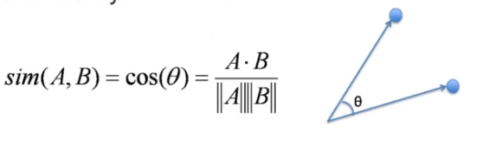

* We can improve on Bag of Words by adjusting word counts based on their frequency in corpus (the group of all the document)
* We can use TF-IDF (Term Frequency-Inverse Document Frequency)
  + **Term Frequency (TF)** – Importance of the term within that document
    - TF(d,t) – Number of occurences of term t in document d
  + **Inverse Document Frequency (IDF)** – Importance of the term in the corpus
    - IDF(t)=log(D/t) where:
      * D = total number of documents
      * t = number of documents with the term

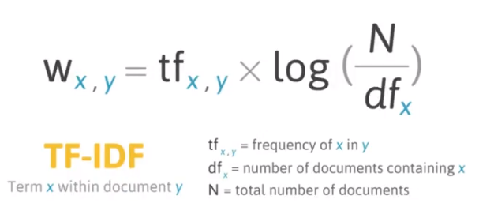

## Code

import nltk  
nltk.download_shell()

NLTK Downloader

---------------------------------------------------------------------------

d) Download l) List u) Update c) Config h) Help q) Quit

---------------------------------------------------------------------------

Downloader> l

...

path='C:\\Users\\HP\\Desktop\\Python\\DS_ML_Bootcamp\\@Source\\20-Natural-Language-Processing\\smsspamcollection\\SMSSpamCollection'  
messages=[line.rstrip() for line in open(path, encoding='utf8')]  
  
print(len(messages))

5574

messages[1]

'ham\tOk lar... Joking wif u oni...'

for mess_no, message in enumerate(messages[:5]):  
 print(mess_no, message)  
 print('\n')

0 ham Go until jurong point, crazy.. Available only in bugis n great world la e buffet... Cine there got amore wat...

1 ham Ok lar... Joking wif u oni...

2 spam Free entry in 2 a wkly comp to win FA Cup final tkts 21st May 2005. Text FA to 87121 to receive entry question(std txt rate)T&C's apply 08452810075over18's

3 ham U dun say so early hor... U c already then say...

4 ham Nah I don't think he goes to usf, he lives around here though

messages=pd.read_csv(path, sep='\t', names=['label', 'message'])  
messages

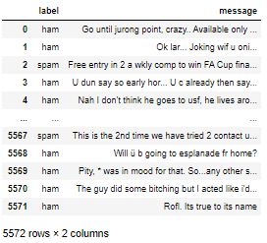

messages.describe()

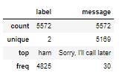

messages.groupby('label').describe().transpose()

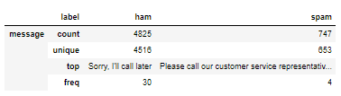

messages['length']=messages['message'].apply(len)  
messages

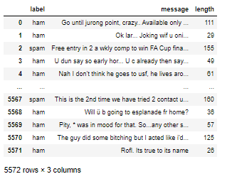

messages['length'].plot.hist(bins=100)

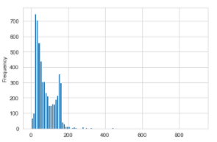

messages['length'].describe()

count 5572.000000

mean 80.489950

std 59.942907

min 2.000000

25% 36.000000

50% 62.000000

75% 122.000000

max 910.000000

Name: length, dtype: float64

messages[messages['length']==910]['message'].iloc[0]

"For me the love should start with attraction.i should feel that I need her every time around me.she should be the first thing which comes in my thoughts.I would start the day and end it with her.she should be there every time I dream.love will be then when my every breath has her name.my life should happen around her.my life will be named to her.I would cry for her.will give all my happiness and take all her sorrows.I will be ready to fight with anyone for her.I will be in love when I will be doing the craziest things for her.love will be when I don't have to proove anyone that my girl is the most beautiful lady on the whole planet.I will always be singing praises for her.love will be when I start up making chicken curry and end up makiing sambar.life will be the most beautiful then.will get every morning and thank god for the day because she is with me.I would like to say a lot..will tell later.."

messages.hist(column='length', by='label', bins=50, figsize=(16,8))

#plt.xlim((0,1000))

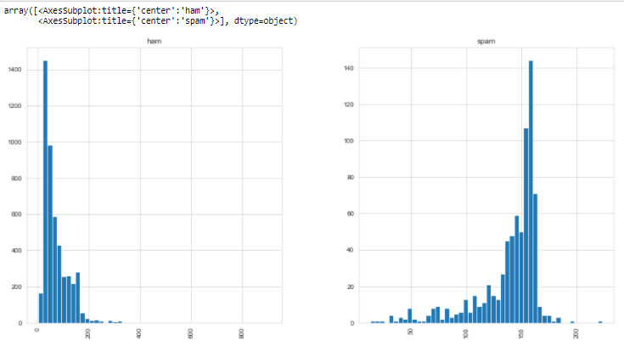

import string  
mess='Sample message! Notice: it has punctuation.'  
string.punctuation

'!"#$%&\'()*+,-./:;<=>?@[\\]^_`{|}~'

nopunc=[c for c in mess if c not in string.punctuation]  
nopunc

['S',

'a',

'm',

'p',

'l',

'e',

' ',

'm',

'e',

's',

's',

'a',

'g',

'e',

' ',

'N',

'o',

't',

'i',

'c',

'e',

' ',

'i',

't',

' ',

'h',

'a',

's',

' ',

'p',

'u',

'n',

'c',

't',

'u',

'a',

't',

'i',

'o',

'n']

nopunc=''.join(nopunc)  
nopunc

'Sample message Notice it has punctuation'

from nltk.corpus import stopwords  
stopwords.words('english')

['i',

'me',

'my',

'myself',

'we',

'our',

...

"wouldn't"]

nopunc.split()

['Sample', 'message', 'Notice', 'it', 'has', 'punctuation']

clean_mess=[word for word in nopunc.split() if word.lower() not in stopwords.words('english')]  
clean_mess

['Sample', 'message', 'Notice', 'punctuation']

def text_process(mess):  
 """  
 1. Remove punctuation  
 2. Remove stop words  
 3. return list of clean text words  
 """  
   
 nopunc=[char for char in mess if char not in string.punctuation]  
   
 nopunc=''.join(nopunc)  
   
 return [word for word in nopunc.split() if word.lower() not in stopwords.words('english')]  
  
messages['message'].head(5).apply(text_process)

0 [Go, jurong, point, crazy, Available, bugis, n...

1 [Ok, lar, Joking, wif, u, oni]

2 [Free, entry, 2, wkly, comp, win, FA, Cup, fin...

3 [U, dun, say, early, hor, U, c, already, say]

4 [Nah, dont, think, goes, usf, lives, around, t...

Name: message, dtype: object

*# 1. Count how many times does a word occur in each message (known as term frequency)*  
*# 2. Weigh the counts, so that frequent tokens get lower weight (inverse document frequency)*  
*# 3. Normalize the vector lenght, to abstract from the original text length (L2 norm)*  
from sklearn.feature_extraction.text import CountVectorizer  
bow_transformer=CountVectorizer(analyzer=text_process).fit(messages['message'])  
print(len(bow_transformer.vocabulary_))

11425

mess4=messages['message'][3]  
mess4

'U dun say so early hor... U c already then say...'

bow4=bow_transformer.transform([mess4])  
print(bow4)

(0, 4068) 2

(0, 4629) 1

(0, 5261) 1

(0, 6204) 1

(0, 6222) 1

(0, 7186) 1

(0, 9554) 2

print(bow4.shape)

(1, 11425)

bow_transformer.get_feature_names()[9554]

'say'

messages_bow=bow_transformer.transform(messages['message'])  
print('Shape of Sparse Matric: ',messages_bow.shape)

Shape of Sparse Matric: (5572, 11425)

messages_bow.nnz *#non zeros*

50548

*# how many zeros*  
  
sparsity = (100.0 * messages_bow.nnz / (messages_bow.shape[0] * messages_bow.shape[1]))  
print('sparsity: {}'.format(sparsity))

sparsity: 0.07940295412668218

sparsity = (100.0 * messages_bow.nnz / (messages_bow.shape[0] * messages_bow.shape[1]))  
print('sparsity: {}'.format(round(sparsity)))

sparsity: 0

from sklearn.feature_extraction.text import TfidfTransformer  
tfidf_transformer=TfidfTransformer().fit(messages_bow)  
tfidf4=tfidf_transformer.transform(bow4)  
print(tfidf4) *# 'weights' of words for this document*

(0, 9554) 0.5385626262927564

(0, 7186) 0.4389365653379857

(0, 6222) 0.3187216892949149

(0, 6204) 0.29953799723697416

(0, 5261) 0.29729957405868723

(0, 4629) 0.26619801906087187

(0, 4068) 0.40832589933384067

tfidf_transformer.idf_[bow_transformer.vocabulary_['university']] *#inverse word frequency*

8.527076498901426

messages_tfidf=tfidf_transformer.transform(messages_bow)  
from sklearn.naive_bayes import MultinomialNB  
spam_detect_model=MultinomialNB().fit(messages_tfidf, messages['label'])  
spam_detect_model.predict(tfidf4)[0]

'ham'

messages['label'][3]

'ham'

all_pred=spam_detect_model.predict(messages_tfidf)  
all_pred

array(['ham', 'ham', 'spam', ..., 'ham', 'ham', 'ham'], dtype='<U4')

from sklearn.model_selection import train_test_split  
msg_train, msg_test, label_train, label_test=train_test_split(messages['message'], messages['label'],test_size=0.3)  
bow_transformer=CountVectorizer(analyzer=text_process).fit(msg_train)  
messages_bow=bow_transformer.transform(msg_train)  
  
  
messages_tfidf=tfidf_transformer.transform(messages_bow)  
  
spam_detect_model=MultinomialNB().fit(messages_tfidf, label_train)  
  
  
all_pred=spam_detect_model.predict(messages_tfidf)  
*# Pipeline*  
  
from sklearn.pipeline import Pipeline  
pipeline=Pipeline([  
 ('bow', CountVectorizer(analyzer=text_process)),  
 ('tfidf', TfidfTransformer()),  
 ('classifier', MultinomialNB())  
])  
pipeline.fit(msg_train, label_train)

Pipeline(steps=[('bow',

CountVectorizer(analyzer=<function text_process at 0x00000277A0FBAD30>)),

('tfidf', TfidfTransformer()),

('classifier', MultinomialNB())])

predictions =pipeline.predict(msg_test)  
from sklearn.metrics import classification_report, confusion_matrix  
  
print(classification_report(label_test, predictions))  
print(confusion_matrix(label_test, predictions))

precision recall f1-score support

ham 0.96 1.00 0.98 1460

spam 1.00 0.72 0.84 212

accuracy 0.96 1672

macro avg 0.98 0.86 0.91 1672

weighted avg 0.97 0.96 0.96 1672

[[1460 0]

[ 60 152]]

*# use classiefier hich you want*  
  
from sklearn.ensemble import RandomForestClassifier  
  
  
pipeline=Pipeline([  
 ('bow', CountVectorizer(analyzer=text_process)),  
 ('tfidf', TfidfTransformer()),  
 ('classifier', RandomForestClassifier())  
])  
  
pipeline.fit(msg_train, label_train)  
predictions =pipeline.predict(msg_test)  
  
print(classification_report(label_test, predictions))  
print(confusion_matrix(label_test, predictions))

precision recall f1-score support

ham 0.97 1.00 0.98 1460

spam 1.00 0.77 0.87 212

accuracy 0.97 1672

macro avg 0.98 0.89 0.93 1672

weighted avg 0.97 0.97 0.97 1672

[[1460 0]

[ 48 164]]

# Neural Nests and Deep Learning

## Introduction to Artificial Neural Networks

* Theory Topics
  + Perceptron Model to Neural Networks
  + Activation Function
  + Cost Function
  + Feed Forward Networks
  + BackPropagation

## Perceptron Model

* To begin understanding deep learning, we will built up our model abstractions:
  + Single Biological Neuron
  + Perceptron
  + Multi-layer Perceptron Model
  + Deep Learning Neural Network
* As we learn about more complex models, we’ll also introduce concepts, such as:
  + Activation Functions
  + Gradient Descent
  + BackPropagation
* If the whole idea behind deep learning is to have computers artificially mimic biological natural intelligence, we should probably build a general understanding of how biological neurons work
* Stained Neurons in cerebral cortex



* Illustration of biological neurons

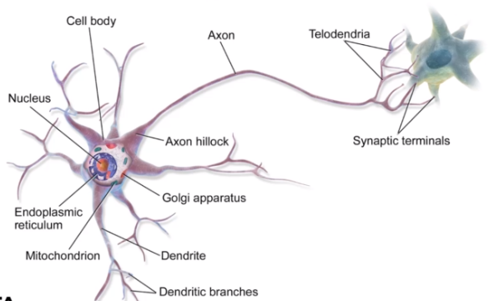

* Simplify Biological Neuron model
  + Dendrites – input
  + Nucleus – calculations
  + Axon - output



* A perceptron was a form of neural network introduced in 1958 by Frank Rosenblatt
* Amazingly, even back then he saw huge potential
  + ‘…perceptron may eventually be able to learn, make decision, and translate languages’
* However, in 1969 Marvin Minsky and Seymour Papert’s published their book **Perceptrons**
* It suggested that there were severe limitations to what perceptrons could do
* This marked the beginning of what is known as the AI Winter, with little funding into AI and Neural Networks in the 1970s
* Fortunately for us, we now know the amazing power of neural networks, which all stem from the simple perceptron model, so let’s head back and convert out simple biological neuron model into the perceptron model
* Example:
  + If f(x) is just a sum, then y=x1+x2
  + Realistically, we would to be able to adjust some parameter in order to ‘learn’
  + Let’s add an adjustable weight we multiply against x
  + Now y=x1w1+x2w2
  + We could update the **weights** to effect **y**
  + But what if an x is zero? W won’t change anything!
  + Let’s add in a **bias** term **b** to the inputs
  + y=(x1w1 + b) + (x2w2 + b)
  + We can expand this to a generalization

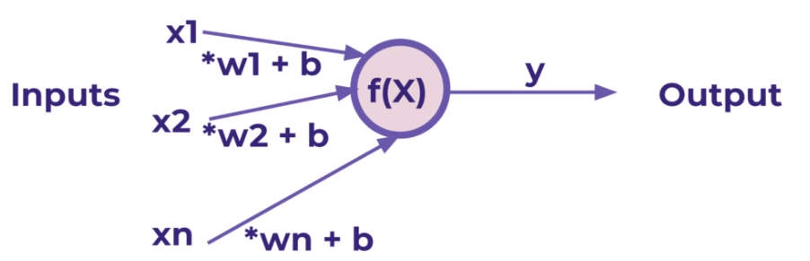

* We’ve been able to model a biological neuron as a simple perceptron! Mathematically our generalization was:

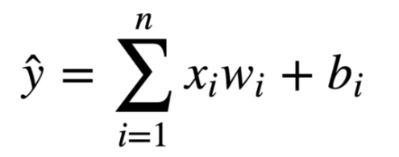

* Later on we will se how we can expand this model to nave X be a **tensor** of information (an n-dimensional matrix)

## Neural Networks

* A single perceptron won’t be enough to learn complicated systems
* Fortunately, we can expand on the idea of a single perceptron, to create a multi-layer perceptron model
* To build a network of perceptrons, we can connect layers of perceptrons, we can connect layers of perceptrons, using a **multi-layer perceptron model**

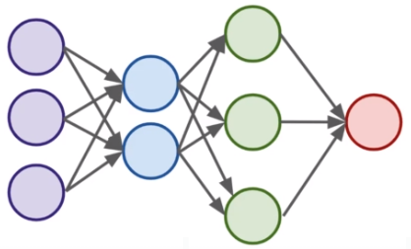

* ↑ - **fully connected layer** – every neuron is connected to every neuron in the next layer
* The outputs of one perceptron are directly fed into as inputs to another layer
* **Neuron = perceptron**
* This allows the network as a whole to learn about interactions and relationship between features
* The first layer is a **input layer** – it receives a data

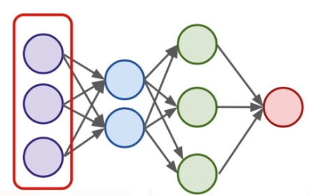

* Layers between the input and output layers are the **hidden layers** – hidden layers are difficult to interpret, due to their high interconnectivity and distance away from known input or output values

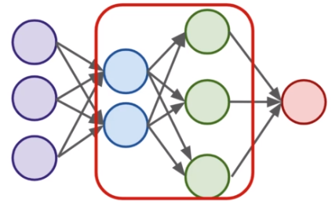

* The last layer is the **output layer** – Note: this last layer can be more than one neuron

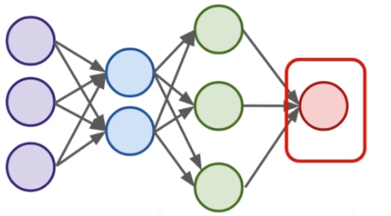

* Neural Networks become **“deep neural networks”** if then contain 2 or more hidden layers

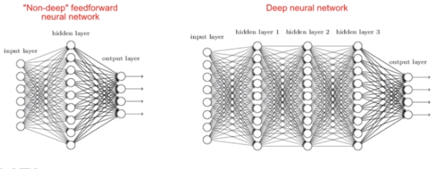

* Terminology
  + Input Layer – First Layer that directly accepts real data values
  + Hidden Layers - Any layer between input and output layers
  + Output Layer – The final estimate of the output
* What is incredible about the neural network framework is that it can be used to approximate any function
* Zhou Lu and later in Boris Hanin proved mathematically that Neural Networks can approximate any convex continuous function (“Universal Approximation Theorem”)
* Previously in our simple model we saw that the perceptron itself contained a very simple summation function f(x)
* For most use cases however that won’t be useful, we’ll want to be able to set constraints to our output values, especially in classification tasks
* In a classification tasks, it would be useful to have all outputs fall between 0 and 1
* These values can then present probability assignments for each class
* In the next lecture, we’ll explore how to use **activation functions** to set boundaries to output values from the neuron

## Activation Function

* Recall that inputs **x** have a weight **w** and a bias term **b** attached to them in the perceptron model
* Which means we have: **x*w + b**
  + Clearly **w** implies how much weight or strength to give the incoming input
  + We can thing of **b** as an offset value, making **x*w** have to reach a certain threshold before having an effect
  + For example if **b=-10**
    - Then the effects of **x*w** won’t really start to overcome the bias until their product surpasses 10
    - After that, then the effect is solely based on the value **w**
    - Thus the term ‘bias’
  + Next we want to set boundaries for the overall output value of **x*w+b**
    - We can state **z=x*w+b**
    - And then pass **z** through some activation function to limit its value
* A lot of research has been done into activation functions and heir effectiveness
* Let’s explore some common activations functions
* Recall our simple perceptron has an f(x)
  + If we had a binary classification problem we would want an output of either 0 or 1

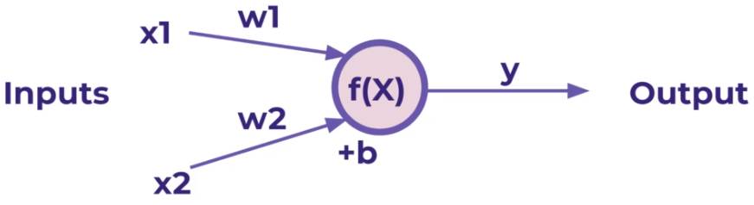

* Note:
  + To avoid confusion, let’s define the total inputs as a variable **z**, where **z=x*w+b**
  + In this context, we’ll then refer to activation functions as **f(z)**
  + Keep in mind, you will often see these variables capitalized **f(Z)** or **X** to denote a tensor input consisting of multiple values
* Activation functions
  + The most simple networks rely on basic **step function** that outputs 0 or 1
    - Regardless of the values, this always outputs 0 or 1
    - This sort of function could be useful for classification (0 or 1 class)
    - However, this is very ‘strong’ function, since small changes aren’t reflected
    - There is just an immediate cut off that splits between 0 and 1

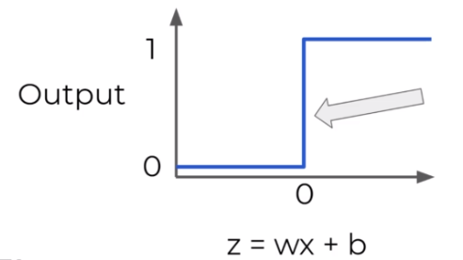

* + **Sigmoid function/Logistic function**
    - It would be nice if we could have a more dynamic function, for example the red line
    - Lucky for us, this is the sigmoid function! Also known as a logistic function
    - Changing the activation function used can be beneficial depending on the task
    - This still works for classification, and will be more sensitive to small changes

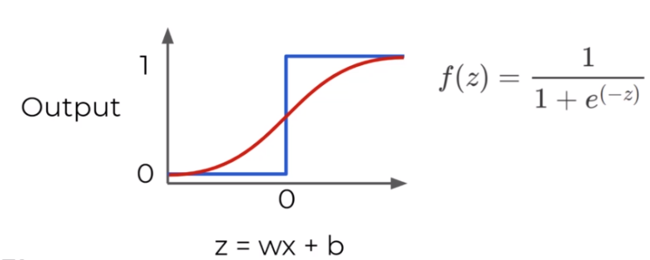

* + **Hyperbolic Tangent: tanh(z)**
    - Output between -1 and 1 instead of 0 to 1

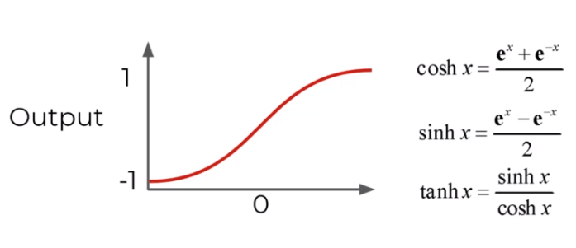

* + **Rectified Linear Unit (ReLU)**
    - This is actually a relatively simple function: max(0, z)
    - ReTU has been found to have very good performance, especially when dealing with the issue of **vanish gradient**
    - We’ll often default ReLU to its overall good performance

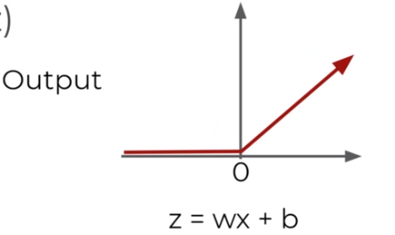

* + More: <https://en.wikipedia.org/wiki/Activation_function>

## Multi-Class Activation Function

* Notice all activation functions make sense for a single output, either a continuous label or trying to predict a binary classification (either a 0 or 1)
* But what should we do if we have a multi-class situation?
* There are 2 main types of multi-class situations
  + **Non-Exclusive Classes**
    - A data point can have multiple classes/categories assigned to it
    - Photos can have multiple tags (e.g. beach, family, vacation… etc.)
  + **Mutually Exclusive Classes**
    - Only one class/category assigned to it
    - Photos can be categorized as being in grayscale or full color photos. A phptp can not be both at the same time
* Organizing Multiple Classes
  + The easiest way to organize multiple classes is to simply have 1 output node per class
  + The single node could output a continuous regression value or binary classification (0 or 1) 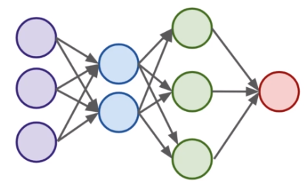
  + Let’s expand this output layer to work for the case of multi-classification
    - This means we will need to organize categories for this output layer
    - We can’t just have categories like ’red’, ‘blue’, ‘green’, etc…
    - Instead we use **one-hot encoding -** mutually exclusive classes

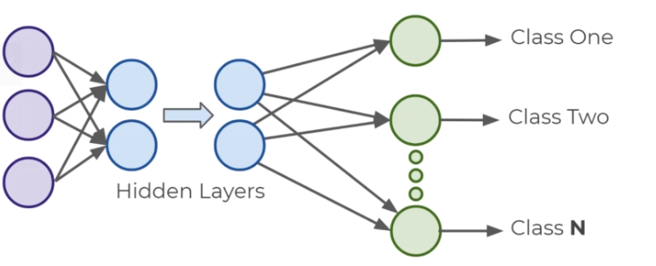

* **Mutually exclusive classes – One-hot encoding – Create dummy variables**

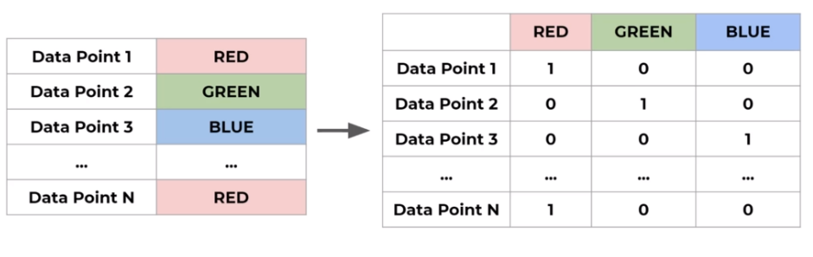

* Non-Exclusive Classes

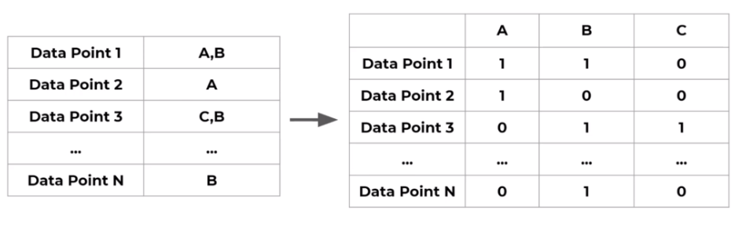

* Now that we have our data correctly organized, we just need to choose the correct classification activation function that the last output layer should have
  + Non-exclusive
    - Sigmoid function
      * Each neuron will output a value between 0 and 1, indicating the probability of having that class assigned to it
      * Sigmoid function for Non-Exclusive Classes

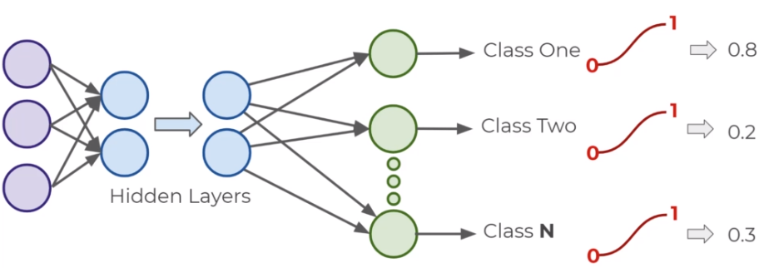

* + - * Keep in mind this allows each neuron to output independent of other classes, allowing for a single data point fed into the function to have multiple classes assigned to it
  + Mutually Exclusive Classes
    - But what we do when each data point can only have a single class assigned to it?
    - We can use the **softmax function** for this
    - Softmax Activation Function

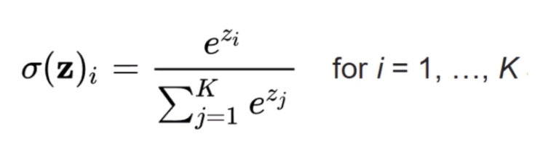

* + - * Softmax function calculates the probabilities distribution of the event over **K** different events
      * This function will calculate the probabilities of each target class over all possible target classes
      * The range will be 0 to 1, and **the sum of all the probabilities will be equal to one**
      * The model returns the probabilities of each class and the target class chosen will have the highest probability
      * He main thing to keep in mind is that if you use softmax for multi-class problems you get this sort of outputs

[Red, Green , Blue]

[0.1, 0.6, 0.3 ]

* + - * The probability for each class all sum up to 1. We choose the highest probability as our assignment

## Cost Functions and Gradient Descent

* We now understand that neural networks take in inputs, multiply them by weights, and add biases to them
* Then this result is passed through an activation function which at the end of all the layers leads to some output
* This output **ŷ** is the model’s estimation of what it predicts the label to be
* So after the network creates its prediction, how do we evaluate it?
* And after the evaluation how can we update the networks weights and biases?
* We need to take the estimated outputs of the network and then compare them to the real values of the label
* Keep in mind this is using the training data set during the fitting/training of the model
* The cost function (often referred to as a loss function) must be an average so it can output a single value
* We can keep track of our loss/cost during training to monitor network performance
* Variables:
  + We’ll use the following variables:
    - y to represent the true value
    - a to represent neuron’s prediction
  + In terms of weights and bias:
    - w*x+b=z
    - Pass z into activation function σ(Z)=a
  + One very common cost function is the quadratic cost function
  + We simply calculate the difference between the real values y(x) against our predicted values a(x)
  + Note: The notation shown here corresponds to vector inputs and outputs, since we will be dealing with a **batch** of training points and predictions
  + Notice how squaring this does 2 useful things for us, keeps everything positive and **punishes** large errors

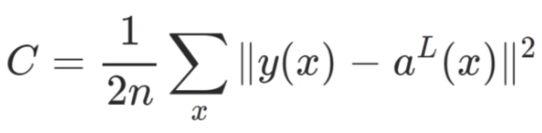

* + We can thing of the cost function as:

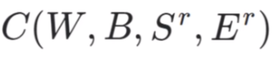

* + **W** is our neural network's weights, **B** is our neural network's biases, **Sr** is the input of a single training sample, and **Er** is the desired output of that training sample.
  + Notice how that information was all encoded in our simplified notation
  + The **a(x)** holds information about weights and biases
  + This means that if we have a huge network, we can expect **C** to be quite complex, with huge vectors of weights and biases
  + Here is a small network with all its parameters labeled

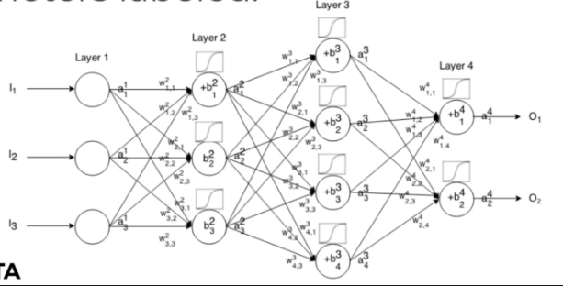

* That is a lot to calculate! How do we solve this?
  + In real case, this means we have some cost function **C** dependent lots of weights
    - **C(w1, w2, w3, …, wn)**
  + How do we figure out which weights lead us to the lowest cost?
  + For simplicity, let’s imagine we only had one weight in our cost function **w**
  + We want to **minimize** our loss/cost (overall error)
  + Which means we need to figure out what value of **w** result in the minimum of **C(w)**
  + Our ‘simple’ function **C(w)** – what value of **w** minimizes our cost?
  + Students of calculus know we could take a derivative and solve for 0

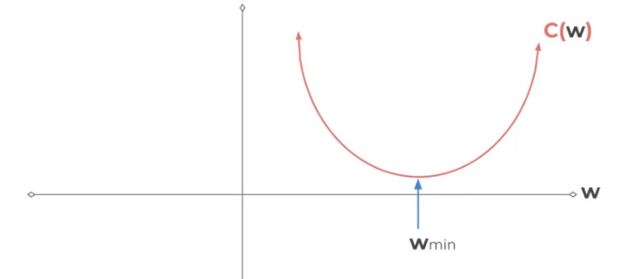

* + But recall our cost function will be very complex and it will be **n-dimensional**
    - And it will be **n-dimensional** since our networks will have 1000s weights
    - We can use **gradient descent** to solve this problem

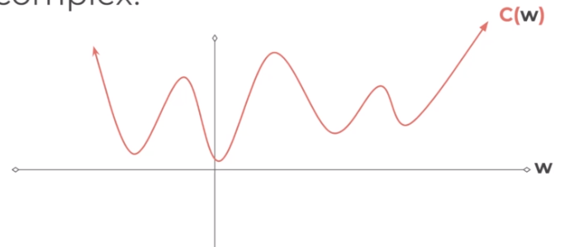

* + Let’s go back to our simplified version to see how this works
    - We can calculate the slope at the point
    - And we move in the downward direction of the slope

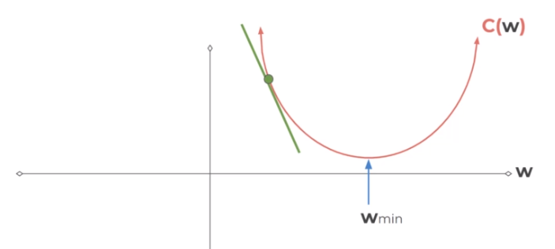

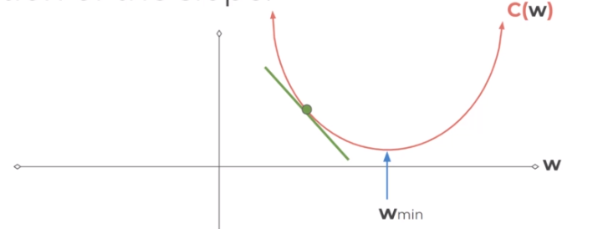

* + - Until we converge to zero, indicating a minimum

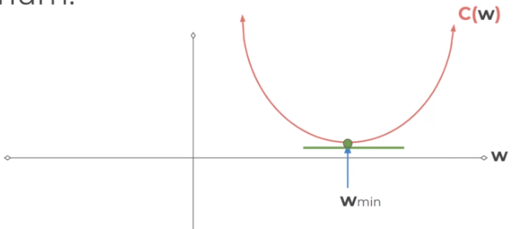

* + - We could have changed our step size to find the next point

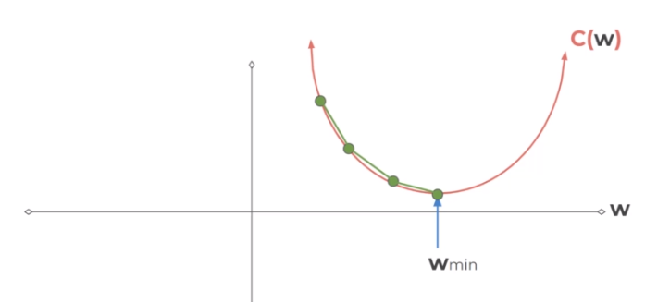

* + - Smaller step sizes take longer to find the minimum

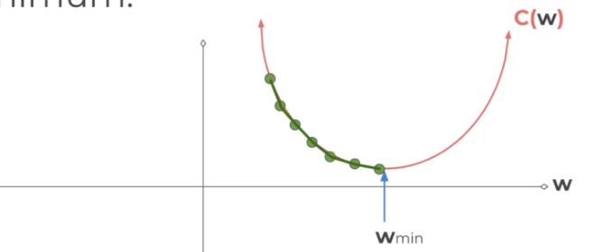

* + - Larger steps are faster, but we risk overshooting the minimum

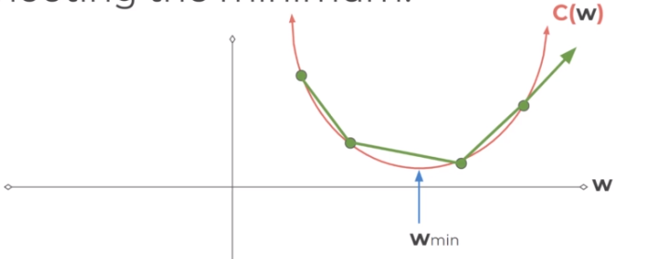

* + - The step size is known as the **learning rate**
  + The learning rate we showed in our illustrations was constants (each step size was equal), but we can be clever and adapt our steps size as we go along
    - We could start with larger steps, then go smaller as we realize the slope gets closer to zero
    - This is known as **adaptive gradient descent**
    - In 2015, Kingma and Ba published their paper ‘Adam: A method for Stochastic Optimization’
    - Adam is a much more efficient way of searching for these minimums, so you will see us use it for our code
    - Adam versus other gradient descent algorithms

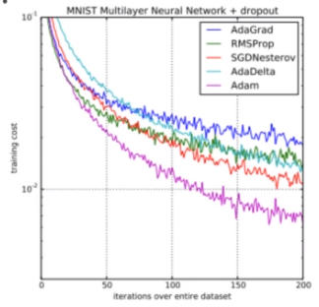

* + - Realistically we’re calculating this descent in an n-dimensional space for all our weights

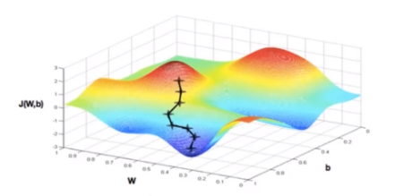

* + - When dealing with these N-dimensional vectors (tensors), the notation changes from **derivative** to **gradient**
    - This means we calculate **▽C(w1, w2, w3, …, wn)**
    - For classification problems, we often use the **cross entropy** loss function
    - The assumption is that your model predicts a probability distribution p(y=1) for each class i=1,2,…,C
    - For a binary classification this result in:

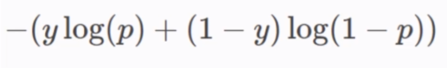

* + - For **M** number of classes >2

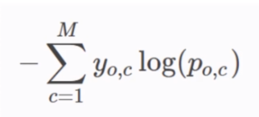

## Backpropagation

* We’ll start by building an intuition behind **backpropagation**, and then we’ll dive into the calculus and notation of backpropagation
* Fundamentally, we want to know how the cost function result changes with respect to the weights in the network, so we can update the weights to minimize the cost function
* Let’s begin with very simple network, where each layer only has 1 neuron
  + Each input will receive a weight and bias
  + This means we have: **C(w1, b1, w2, b2, w3, b3)**

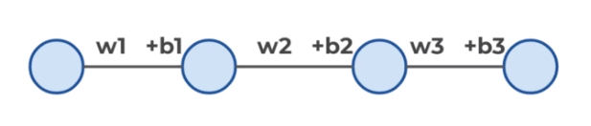

* + We’ve already seen how this process propagates forward
  + Let’s start the end to see the backpropagation
  + Let’s say we have **L** layers, then our notation becomes

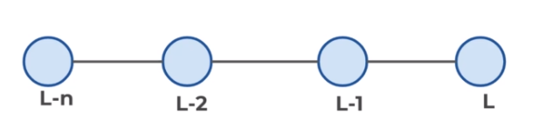

* + Focusing on these last two layers, let’s define **z = wx + b**
  + Then applying an activation function we’ll state **a = σ(z)**

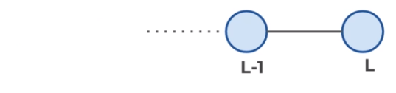

* + This means we have:
    - **zL = wLaL-1 + bL**
    - **aL = σ(zL)**
    - **C0 (...) = (aL – y)2**
  + We want to understand how sensitive is the cost function to changes in **w**
  + Using the relationships we already know along with the chain rule

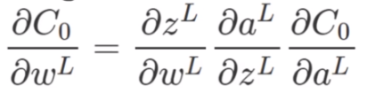

* + The main idea here is that we can use the gradient to go back through the network and adjust our weights and biases to minimize the output of the error vector on the last output layer
  + Using some calculus notation, we can expand this idea to networks with multiple neurons per layer
  + Hadamard Product

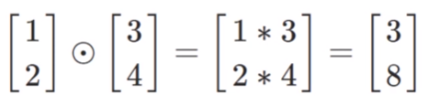

* + Given this notation and backpropagation, we have a few main steps to training neural networks
* Learning Process
  + Step 1
    - Using input **x** set the activation function **a** for the input layer
      * **z=w*x+b**
      * **a= σ(z)**
    - This resulting **a** then feeds into the next layer (and so on)
  + Step 2
    - For each layer, compute:
      * **zL = wLaL-1 + bL**
      * **aL = σ(zL)**
  + Step 3
    - We compute our error vector

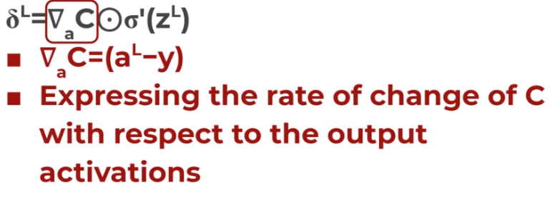

* + - Now let’s write out our error term for a layer in terms of the error of the next layer (since we’re moving backwards)
  + Step 4



* + - Backpropagate the error:
    - For each layer: L-1, L-2, … we compute:

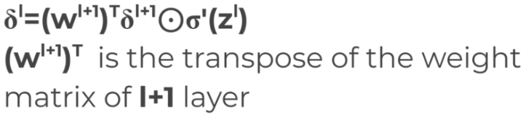

* + - When we apply the transpose weight matrix **(wl+1)T** we can think intuitively of this as moving the error backward through the network, giving us some sort of measure of the error at the output of the l-th layer
    - We then take the Hadamard product **Ꙩσl(zl)**. This moves the error backward through the activation function in layer **l**, giving us the error **δl** in the weighed input to layer **l**
    - The gradient of the cost function is given by
      * For each layer: L-1, L-2, … we compute

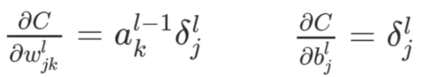

* + - * This then allows us o adjust the weights and biases to help minimize that cost function

## TensorFlow vs Keras

* **Tensor Flow**
  + TensorFlow is an open-source deep learning library developed by Google, with TF 20.0 being coding officially released in late 2019
  + TensorFlow has a large ecosystem of related components, including libraries like Tensorboard, Deployment and Production APIs, and support for various programming languages
  + TensorFlow 1.x had a complex python class system for building models, and due to the huge popularity of Keras, when TF 20.0 was released, TF adopted Keras as the Official API for TF
* **Keras**
  + Keras is a high-level python library that can use a variety of deep learning libraris underneath, such as: TensorFlow, CNTK or Theano
  + The Keras API as easy to use and builds models by simply adding layers on top models by simply adding layers on top of each other through simple calls
* While Keras still also remains as a separate library from TensorFlow, it can also now officially be imported through TF, so there is now need to additionally install it

Identify and deal with overfitting through Early Stopping Callbacks and Dropout Layers

* **Early Stopping**
  + Keras can automatically stop training based on a loss condition on the validation data passed during the model.fit() call
* **Dropout Layers**
  + Dropout can be added to layers to ‘turn off’ neurons during training to prevent overfitting
  + Each Dropout Lauer will ‘drop’ a user-defined percentage of neuron units in the previous layer every batch

Training

Below are some common definitions that are necessary to know and understand to correctly utilize Keras:

Sample: one element of a dataset.

Example: one image is a sample in a convolutional network

Example: one audio file is a sample for a speech recognition model

Batch: a set of N samples. The samples in a batch are processed independently, in parallel. If training, a batch results in only one update to the model.A batch generally approximates the distribution of the input data better than a single input. The larger the batch, the better the approximation; however, it is also true that the batch will take longer to process and will still result in only one update. For inference (evaluate/predict), it is recommended to pick a batch size that is as large as you can afford without going out of memory (since larger batches will usually result in faster evaluation/prediction).

Epoch: an arbitrary cutoff, generally defined as "one pass over the entire dataset", used to separate training into distinct phases, which is useful for logging and periodic evaluation.

When using validation_data or validation_split with the fit method of Keras models, evaluation will be run at the end of every epoch.

Within Keras, there is the ability to add callbacks specifically designed to be run at the end of an epoch. Examples of these are learning rate changes and model checkpointing (saving).'''

**Choosing an optimizer and loss**

**Keep in mind what kind of problem you are trying to solve:**

**# For a multi-class classification problem**

**model.compile(optimizer='rmsprop',**

**loss='categorical_crossentropy',**

**metrics=['accuracy'])**

**# For a binary classification problem**

**model.compile(optimizer='rmsprop',**

**loss='binary_crossentropy',**

**metrics=['accuracy'])**

**# For a mean squared error regression problem**

**model.compile(optimizer='rmsprop',**

**loss='mse')**

## TensorBoard

* Tensorboard is a visualization tool from Google designed to work in conjunction with TensorFlow to visualize various aspects of your model

## Code

### TF Syntax Basics - Part One - Preparing the Data

df=pd.read_csv('TensorFlow_FILES/DATA/fake_reg.csv')  
df

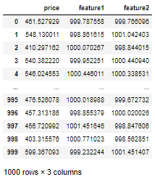

sns.pairplot(df)

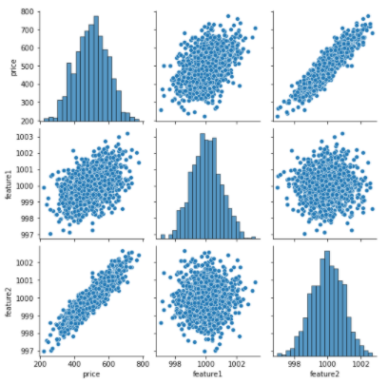

from sklearn.model_selection import train_test_split  
*# we need numpy array -> values*  
  
X=df[['feature1', 'feature2']].values  
y=df['price'].values  
  
X_train, X_test, y_train, y_test = train_test_split(X, y, test_size=0.3, random_state=101)  
  
X_train

array([[ 998.48889502, 1000.12658144],

[ 999.21210104, 999.55094486],

[ 999.82345446, 1000.64314664],

...,

[ 999.98167664, 997.68290688],

[1000.25556216, 999.90515693],

[1000.2413667 , 998.49108442]])

*# normalize and scale feature data*  
  
from sklearn.preprocessing import MinMaxScaler  
scaler=MinMaxScaler()  
scaler.fit(X_train)  
X_train=scaler.transform(X_train)  
X_test=scaler.transform(X_test)  
  
X_train

array([[0.22179862, 0.55212838],

[0.34106018, 0.45061693],

[0.44187649, 0.6432228 ],

...,

[0.4679684 , 0.12119512],

[0.51313398, 0.51308096],

[0.51079305, 0.26371433]])

print(X_train.min(), X_train.max())

0.0 1.0

### TF Syntax Basics - Part Two - Creating and Training the Model

from tensorflow.keras.models import Sequential  
from tensorflow.keras.layers import Dense  
*# 2 ways to create Keras Sequential Model*  
  
*# 1 way*  
model1=Sequential([Dense(4, activation='relu'),  
 Dense(4, activation='relu'),  
 Dense(4, activation='relu'),  
 Dense(1)])  
  
  
*# 2 way - preffered in that course*  
model=Sequential()  
  
model.add(Dense(4, activation='relu'))  
model.add(Dense(4, activation='relu'))  
model.add(Dense(4, activation='relu'))  
model.add(Dense(1))   
  
'''  
Choosing an optimizer and loss  
Keep in mind what kind of problem you are trying to solve:  
  
# For a multi-class classification problem  
model.compile(optimizer='rmsprop',  
 loss='categorical_crossentropy',  
 metrics=['accuracy'])  
  
# For a binary classification problem  
model.compile(optimizer='rmsprop',  
 loss='binary_crossentropy',  
 metrics=['accuracy'])  
  
# For a mean squared error regression problem  
model.compile(optimizer='rmsprop',  
 loss='mse')  
'''  
  
  
model.compile(optimizer='rmsprop', loss='mse')  
  
  
'''  
Training  
Below are some common definitions that are necessary to know and understand to correctly utilize Keras:  
  
Sample: one element of a dataset.  
Example: one image is a sample in a convolutional network  
Example: one audio file is a sample for a speech recognition model  
Batch: a set of N samples. The samples in a batch are processed independently, in parallel. If training, a batch results in only one update to the model.A batch generally approximates the distribution of the input data better than a single input. The larger the batch, the better the approximation; however, it is also true that the batch will take longer to process and will still result in only one update. For inference (evaluate/predict), it is recommended to pick a batch size that is as large as you can afford without going out of memory (since larger batches will usually result in faster evaluation/prediction).  
Epoch: an arbitrary cutoff, generally defined as "one pass over the entire dataset", used to separate training into distinct phases, which is useful for logging and periodic evaluation.  
When using validation_data or validation_split with the fit method of Keras models, evaluation will be run at the end of every epoch.  
Within Keras, there is the ability to add callbacks specifically designed to be run at the end of an epoch. Examples of these are learning rate changes and model checkpointing (saving).'''  
  
model.fit(X_train, y_train, epochs=250, verbose=1)

Epoch 1/250

22/22 [==============================] - 1s 1ms/step - loss: 258005.5944

Epoch 2/250

22/22 [==============================] - 0s 2ms/step - loss: 262430.3567

Epoch 3/250

22/22 [==============================] - 0s 1ms/step - loss: 259152.5510

...

loss_df=pd.DataFrame(model.history.history)  
loss_df.plot()

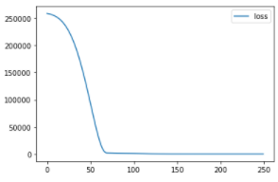

### TF Syntax Basics - Part Three - Model Evaluation

model.evaluate(X_test, y_test, verbose=0)

29.665605545043945

model.evaluate(X_train, y_train, verbose=0)

25.016708374023438

test_predictions=model.predict(X_test)  
test_predictions

array([[656.8613 ],

[514.2179 ],

[520.5068 ],

[487.06985],

[543.72034],

...

test_predictions=pd.Series(test_predictions.reshape(300,))  
  
pred_df=pd.DataFrame(y_test, columns=['Test True Y'])  
pred_df['predictions']=test_predictions  
  
pred_df

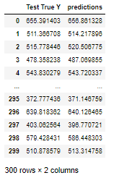

sns.scatterplot(x='Test True Y', y='predictions', data=pred_df)

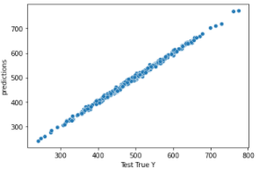

from sklearn.metrics import mean_absolute_error, mean_squared_error  
mean_absolute_error(pred_df['Test True Y'], pred_df['predictions'])

4.32480961972583

df.describe()

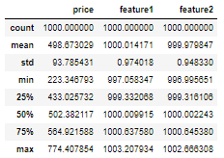

*# 4.23 dollars off mean 498,67 $*  
mean_squared_error(pred_df['Test True Y'], pred_df['predictions'])

29.66559083790996

new_gem=[[998, 1000]]  
  
new_gem=scaler.transform(new_gem)  
model.predict(new_gem)

array([[421.04175]], dtype=float32)

from tensorflow.keras.models import load_model  
model.save('my_gem_model.h5')  
later_model=load_model('my_gem_model.h5')  
later_model.predict(new_gem)

array([[421.04175]], dtype=float32)

# Code - Housing

### TF Regression Code Along - Exploratory Data Analysis

df=pd.read_csv('TensorFlow_FILES\DATA\kc_house_data.csv')  
df

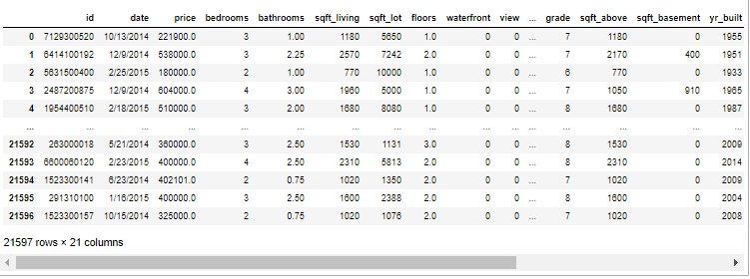

df.isnull().sum()

id 0

date 0

price 0

bedrooms 0

bathrooms 0

sqft_living 0

sqft_lot 0

floors 0

waterfront 0

view 0

condition 0

grade 0

sqft_above 0

sqft_basement 0

yr_built 0

yr_renovated 0

zipcode 0

lat 0

long 0

sqft_living15 0

sqft_lot15 0

dtype: int64

df.describe().transpose()

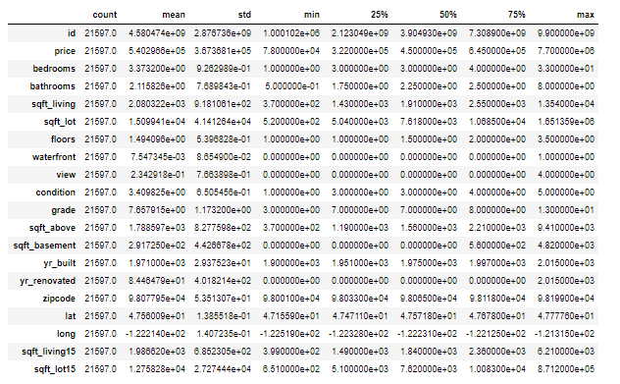

plt.figure(figsize=(18,8))  
sns.histplot(df['price'], kde=True)

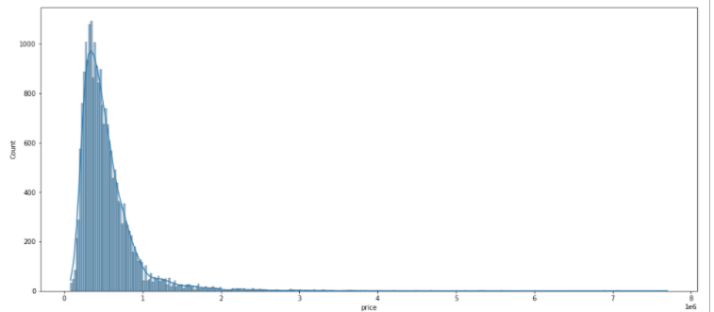

sns.countplot(data=df,x='bedrooms')

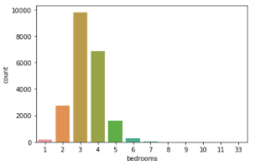

df[df['bedrooms']==33]

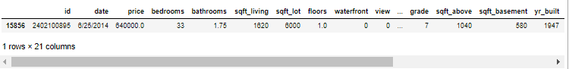

df.corr()

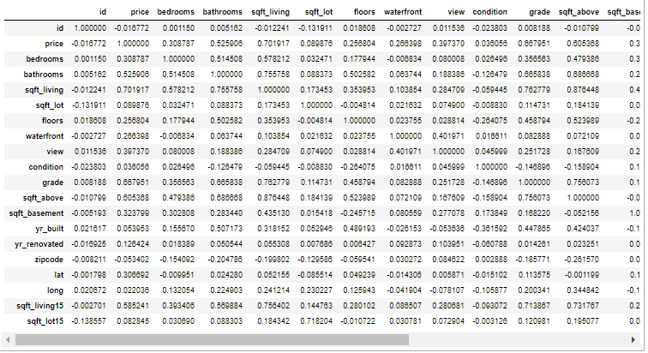

df.corr()['price'].sort_valuess()

zipcode -0.053402

id -0.016772

long 0.022036

condition 0.036056

yr_built 0.053953

sqft_lot15 0.082845

sqft_lot 0.089876

yr_renovated 0.126424

floors 0.256804

waterfront 0.266398

lat 0.306692

bedrooms 0.308787

sqft_basement 0.323799

view 0.397370

bathrooms 0.525906

sqft_living15 0.585241

sqft_above 0.605368

grade 0.667951

sqft_living 0.701917

price 1.000000

Name: price, dtype: float64

plt.figure(figsize=(12,8))  
sns.scatterplot(x='price', y='sqft_living', data=df)

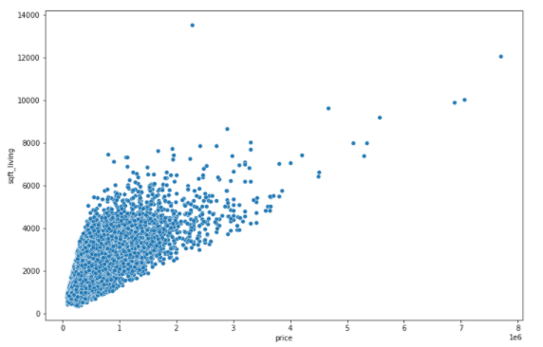

plt.figure(figsize=(12,8))  
sns.scatterplot(x='price', y='long', data=df)

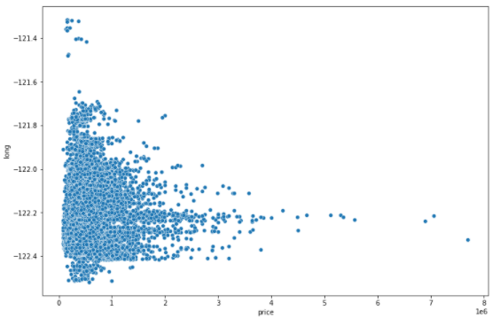

plt.figure(figsize=(12,8))  
sns.scatterplot(x='price', y='lat', data=df)

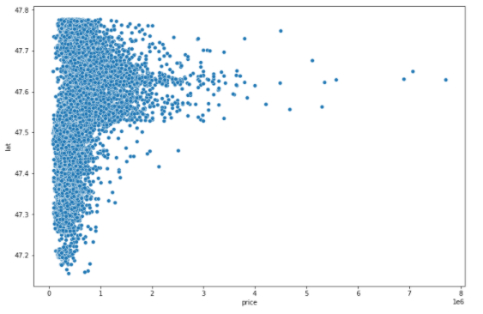

plt.figure(figsize=(12,12))  
sns.scatterplot(x='long', y='lat', data=df, hue='price', palette='plasma_r')

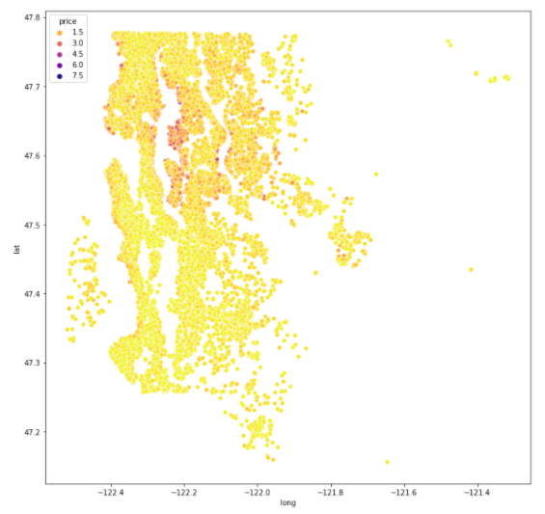

df.sort_values('price', ascending=False).head(20)

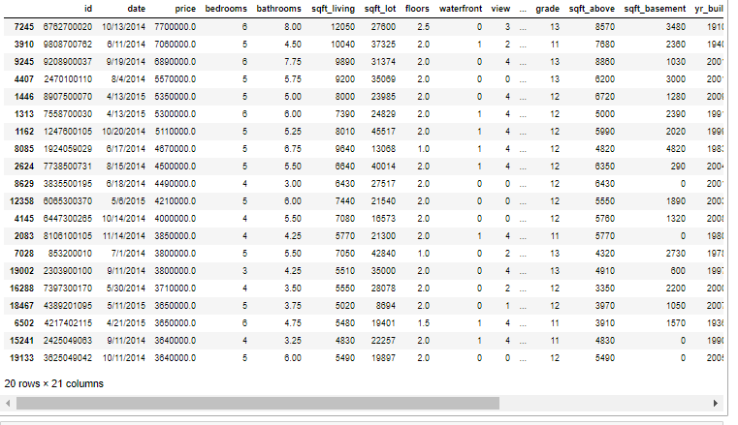

len(df)

21597

len(df)*0.01

215.97

*#remove 1%*  
non_top_1_perc=df.sort_values('price', ascending=False).iloc[216:]

plt.figure(figsize=(12,12))  
sns.scatterplot(x='long', y='lat', data=non_top_1_perc, hue='price', palette='plasma_r', edgecolor=None, alpha=0.6)

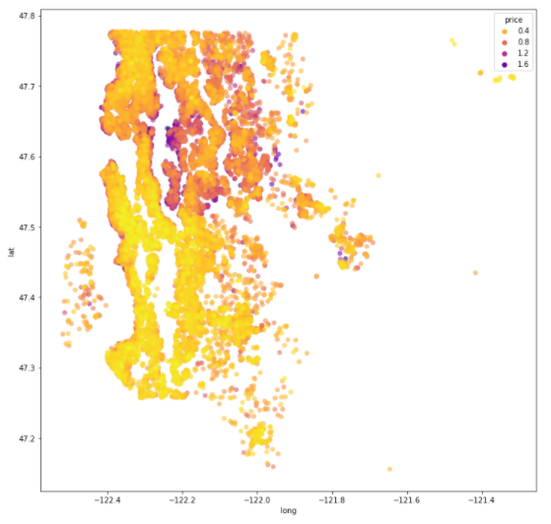

plt.figure(figsize=(12,12))  
sns.scatterplot(x='long', y='lat', data=non_top_1_perc, hue='zipcode', palette='viridis_r', edgecolor=None, alpha=0.6)

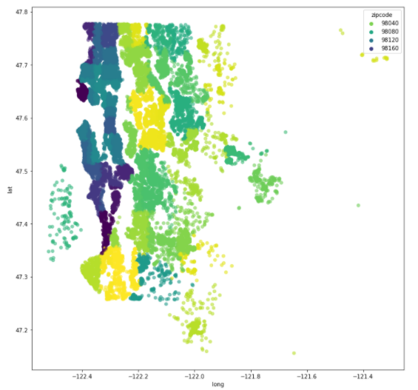

sns.boxplot(x='waterfront',y='price', data=df )

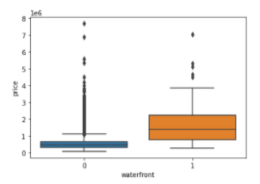

### TF Regression Code Along - Exploratory Data Analysis - Continued

df=df.drop('id', axis=1)  
df['date']=pd.to_datetime(df['date'])  
df

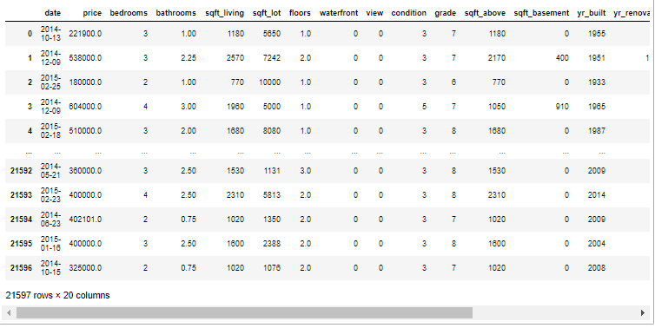

df['year']=df['date'].apply(lambda date: date.year)  
df['month']=df['date'].apply(lambda date: date.month)  
df

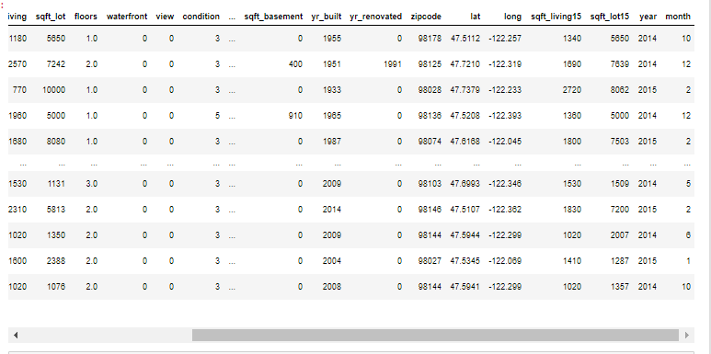

plt.figure(figsize=(12,8))  
sns.boxplot(x='month', y='price', data=df)

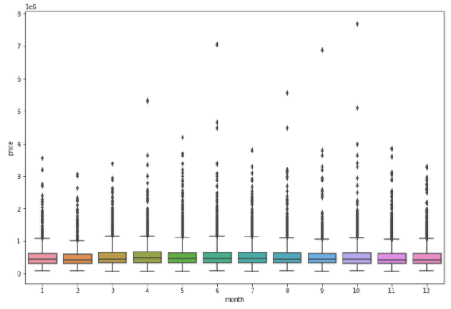

df.groupby('month').mean()['price'].plot()

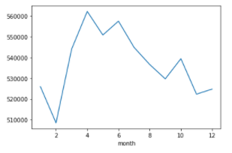

df.groupby('year').mean()['price'].plot()

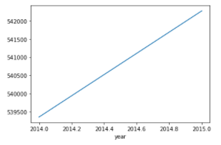

df=df.drop('date', axis=1)  
df=df.drop('zipcode', axis=1)  
df['yr_renovated'].value_counts()

0 20683

2014 91

2013 37

2003 36

2000 35

...

1934 1

1959 1

1951 1

1948 1

1944 1

Name: yr_renovated, Length: 70, dtype: int64

df['sqft_basement'].value_counts()

0 13110

600 221

700 218

500 214

800 206

...

792 1

2590 1

935 1

2390 1

248 1

Name: sqft_basement, Length: 306, dtype: int64

### TF Regression Code Along - Data Preprocessing and Creating a Model

from sklearn.model_selection import train_test_split  
X=df.drop('price', axis=1)  
y=df['price']  
  
  
X_train, X_test, y_train, y_test = train_test_split(X, y, test_size=0.3, random_state=101)  
from sklearn.preprocessing import MinMaxScaler  
scaler=MinMaxScaler()  
X_train=scaler.fit_transform(X_train)  
X_test=scaler.fit_transform(X_test)  
from tensorflow.keras.models import Sequential  
from tensorflow.keras.layers import Dense  
X_train.shape

(15117, 19)

model=Sequential()  
  
model.add(Dense(19, activation='relu'))  
*# copy several times*  
model.add(Dense(19, activation='relu'))  
model.add(Dense(19, activation='relu'))  
model.add(Dense(19, activation='relu'))  
  
model.add(Dense(1))  
  
model.compile(optimizer='adam', loss='mse')  
  
*# batch_size - smaller - longer train*  
  
model.fit(X_train, y_train,  
 validation_data=(X_test, y_test),  
 batch_size=128,  
 epochs=400)

Epoch 1/400

119/119 [==============================] - 1s 3ms/step - loss: 452554683187.2000 - val_loss: 418879930368.0000

Epoch 2/400

119/119 [==============================] - 0s 2ms/step - loss: 419409884228.2667 - val_loss: 413849485312.0000

Epoch 3/400

...

### TF Regression Code Along - Model Evaluation and Predictions

losses=pd.DataFrame(model.history.history)  
losses.plot(figsize=(12,8))

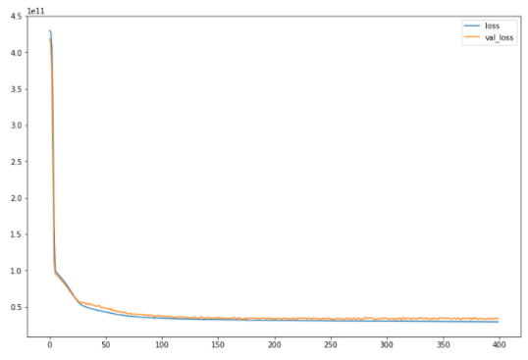

from sklearn.metrics import mean_squared_error, mean_absolute_error, explained_variance_score  
predictions=model.predict(X_test)

mean_absolute_error(y_test, predictions)

110518.74287229938

np.sqrt(mean_absolute_error(y_test, predictions))

332.44359351971184

mean_squared_error(y_test, predictions)

33509499068.862328

df['price'].mean()

540296.5735055795

*# mean: 540296.5735055795*  
*# error: 110518.74287229938*  
*# about 20% !!!*

explained_variance_score(y_test, predictions)

0.7837225198224652

plt.figure(figsize=(20,8))  
plt.scatter(y_test, predictions)  
  
plt.plot(y_test, y_test, 'r')

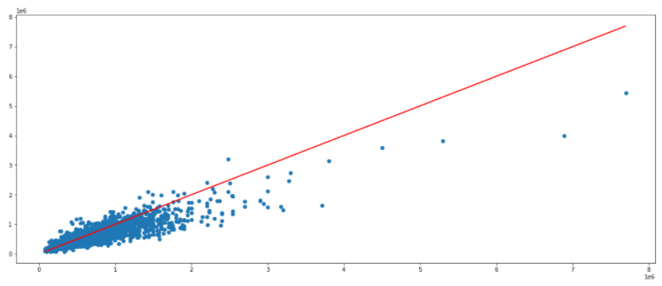

single_house=df.drop('price', axis=1).iloc[1]  
single_house

bedrooms 3.000

bathrooms 2.250

sqft_living 2570.000

sqft_lot 7242.000

floors 2.000

waterfront 0.000

view 0.000

condition 3.000

grade 7.000

sqft_above 2170.000

sqft_basement 400.000

yr_built 1951.000

yr_renovated 1991.000

lat 47.721

long -122.319

sqft_living15 1690.000

sqft_lot15 7639.000

year 2014.000

month 12.000

Name: 1, dtype: float64

single_house=scaler.transform(single_house.values.reshape(-1, 19))  
model.predict(single_house)

array([[495179.28]], dtype=float32)

df.iloc[1]

price 538000.000

bedrooms 3.000

bathrooms 2.250

sqft_living 2570.000

sqft_lot 7242.000

floors 2.000

waterfront 0.000

view 0.000

condition 3.000

grade 7.000

sqft_above 2170.000

sqft_basement 400.000

yr_built 1951.000

yr_renovated 1991.000

lat 47.721

long -122.319

sqft_living15 1690.000

sqft_lot15 7639.000

year 2014.000

month 12.000

Name: 1, dtype: float64

### TF Classification Code Along - EDA and Preprocessing

df=pd.read_csv('TensorFlow_FILES\DATA\cancer_classification.csv')  
df

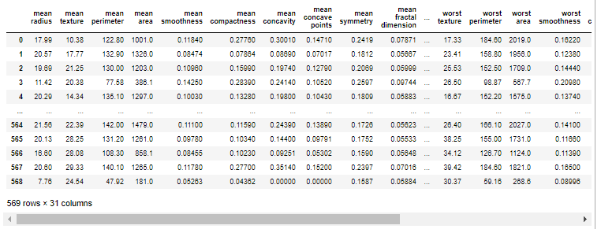

df.info()

<class 'pandas.core.frame.DataFrame'>

RangeIndex: 569 entries, 0 to 568

Data columns (total 31 columns):

# Column Non-Null Count Dtype

--- ------ -------------- -----

0 mean radius 569 non-null float64

1 mean texture 569 non-null float64

2 mean perimeter 569 non-null float64

3 mean area 569 non-null float64

4 mean smoothness 569 non-null float64

5 mean compactness 569 non-null float64

6 mean concavity 569 non-null float64

7 mean concave points 569 non-null float64

8 mean symmetry 569 non-null float64

9 mean fractal dimension 569 non-null float64

10 radius error 569 non-null float64

11 texture error 569 non-null float64

12 perimeter error 569 non-null float64

13 area error 569 non-null float64

14 smoothness error 569 non-null float64

15 compactness error 569 non-null float64

16 concavity error 569 non-null float64

17 concave points error 569 non-null float64

18 symmetry error 569 non-null float64

19 fractal dimension error 569 non-null float64

20 worst radius 569 non-null float64

21 worst texture 569 non-null float64

22 worst perimeter 569 non-null float64

23 worst area 569 non-null float64

24 worst smoothness 569 non-null float64

25 worst compactness 569 non-null float64

26 worst concavity 569 non-null float64

27 worst concave points 569 non-null float64

28 worst symmetry 569 non-null float64

29 worst fractal dimension 569 non-null float64

30 benign_0__mal_1 569 non-null int64

dtypes: float64(30), int64(1)

memory usage: 137.9 KB

df.describe().transpose()

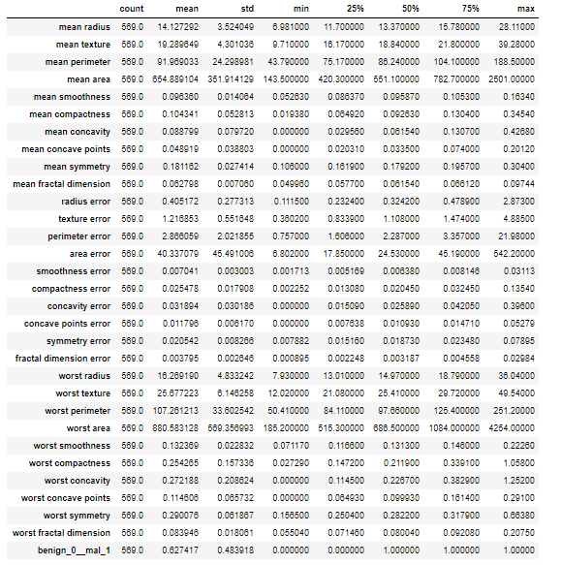

sns.countplot(x='benign_0__mal_1', data=df)

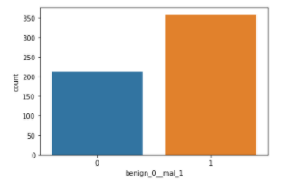

df.corr()

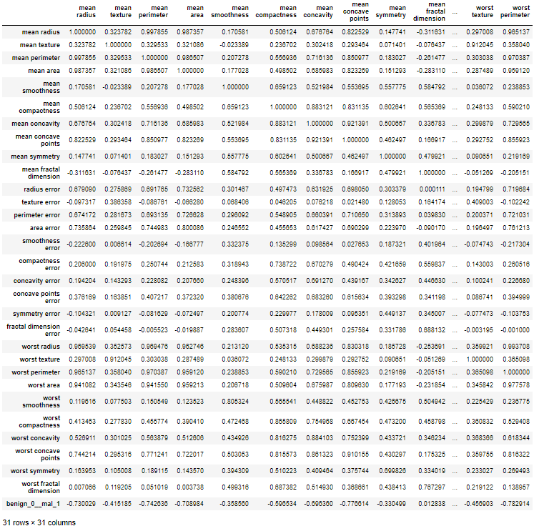

df.corr()['benign_0__mal_1'].sort_values()

worst concave points -0.793566

worst perimeter -0.782914

mean concave points -0.776614

worst radius -0.776454

mean perimeter -0.742636

worst area -0.733825

mean radius -0.730029

mean area -0.708984

mean concavity -0.696360

worst concavity -0.659610

mean compactness -0.596534

worst compactness -0.590998

radius error -0.567134

perimeter error -0.556141

area error -0.548236

worst texture -0.456903

worst smoothness -0.421465

worst symmetry -0.416294

mean texture -0.415185

concave points error -0.408042

mean smoothness -0.358560

mean symmetry -0.330499

worst fractal dimension -0.323872

compactness error -0.292999

concavity error -0.253730

fractal dimension error -0.077972

symmetry error 0.006522

texture error 0.008303

mean fractal dimension 0.012838

smoothness error 0.067016

benign_0__mal_1 1.000000

Name: benign_0__mal_1, dtype: float64

df.corr()['benign_0__mal_1'][:-1].sort_values().plot(kind='bar')

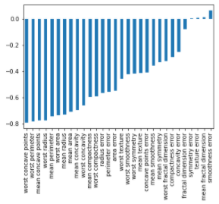

plt.figure(figsize=(12,12))  
sns.heatmap(df.corr(), cmap='plasma_r')

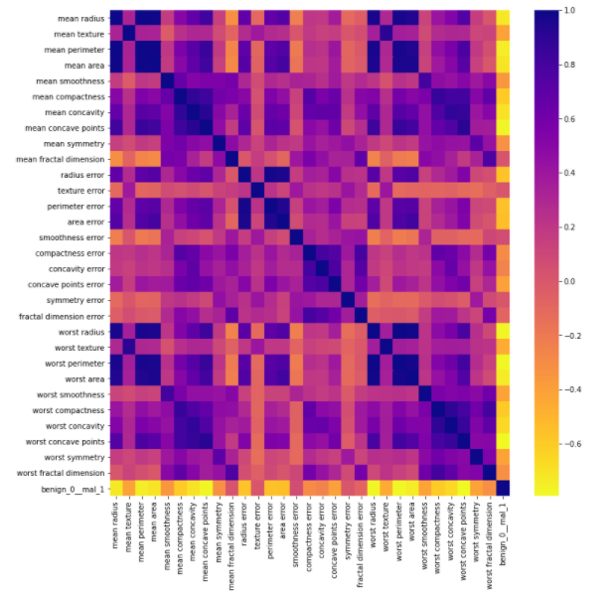

from sklearn.model_selection import train_test_split  
  
X=df.drop('benign_0__mal_1', axis=1).values  
y=df['benign_0__mal_1'].values  
  
  
X_train, X_test, y_train, y_test = train_test_split(X, y, test_size=0.25, random_state=101)  
from sklearn.preprocessing import MinMaxScaler  
  
scaler=MinMaxScaler()  
  
scaler.fit(X_train)  
  
X_train=scaler.transform(X_train)  
X_test=scaler.transform(X_test)

### TF Classification - Dealing with Overfitting and Evaluation

from tensorflow.keras.models import Sequential  
from tensorflow.keras.layers import Dense, Dropout  
  
X_train.shape

(426, 30)

model=Sequential()  
  
model.add(Dense(30, activation='relu'))  
model.add(Dense(15, activation='relu'))  
  
*# BINARY*  
model.add(Dense(1, activation='sigmoid'))  
  
model.compile(loss='binary_crossentropy', optimizer='adam')  
model.fit(x=X_train, y=y_train, epochs=600, validation_data=(X_test, y_test))

Epoch 1/600

14/14 [==============================] - 1s 16ms/step - loss: 0.6762 - val_loss: 0.6480

Epoch 2/600

14/14 [==============================] - 0s 5ms/step - loss: 0.6379 - val_loss: 0.6119

Epoch 3/600

…

losses=pd.DataFrame(model.history.history)  
  
plt.figure(figsize=(10,10))  
plt.plot(losses)

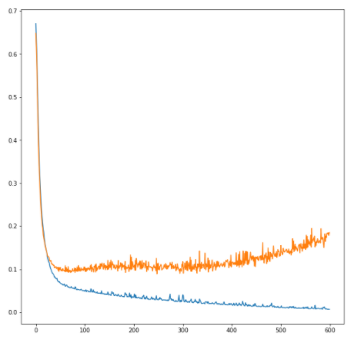

*# Second model with calbacks*  
  
from tensorflow.keras.callbacks import EarlyStopping  
help(EarlyStopping)

...

patience: Number of epochs with no improvement

| after which training will be stopped.

...

early_stop=EarlyStopping(monitor='val_loss', mode='min', verbose=1, patience=25)  
  
  
model=Sequential()  
  
model.add(Dense(30, activation='relu'))  
model.add(Dense(15, activation='relu'))  
  
*# BINARY*  
model.add(Dense(1, activation='sigmoid'))  
  
model.compile(loss='binary_crossentropy', optimizer='adam')  
  
  
model.fit(x=X_train, y=y_train, epochs=600, validation_data=(X_test, y_test),   
 callbacks=[early_stop])

Epoch 1/600

14/14 [==============================] - 1s 14ms/step - loss: 0.7073 - val_loss: 0.6813

Epoch 2/600

14/14 [==============================] - 0s 4ms/step - loss: 0.6701 - val_loss: 0.6454

Epoch 3/600

...

losses=pd.DataFrame(model.history.history)  
  
plt.plot(losses)

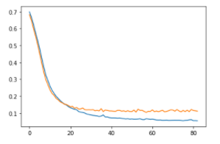

from tensorflow.keras.layers import Dropout  
*# dropout layers*  
  
early_stop=EarlyStopping(monitor='val_loss', mode='min', verbose=1, patience=25)  
  
  
model=Sequential()  
  
model.add(Dense(30, activation='relu'))  
model.add(Dropout(0.5))  
  
model.add(Dense(15, activation='relu'))  
model.add(Dropout(0.5))  
  
*# BINARY*  
model.add(Dense(1, activation='sigmoid'))  
  
model.compile(loss='binary_crossentropy', optimizer='adam')  
  
  
  
model.fit(x=X_train, y=y_train, epochs=600, validation_data=(X_test, y_test),   
 callbacks=[early_stop])

Epoch 1/600

14/14 [==============================] - 1s 15ms/step - loss: 0.6993 - val_loss: 0.6813

Epoch 2/600

14/14 [==============================] - 0s 5ms/step - loss: 0.6767 - val_loss: 0.6602

Epoch 3/600

...

losses=pd.DataFrame(model.history.history)  
  
plt.figure(figsize=(8,8))  
plt.plot(losses)

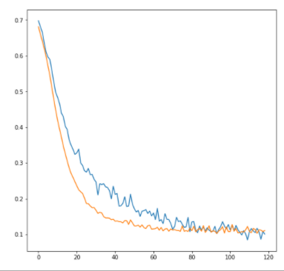

predictions=model.predict(X_test)  
predictions=np.where(predictions>0.5,1,0)  
predictions

array([[1],

[1],

[1],

[0],

...

from sklearn.metrics import classification_report, confusion_matrix  
  
print(classification_report(y_test, predictions))  
print(confusion_matrix(y_test, predictions))

precision recall f1-score support

0 0.95 0.98 0.96 55

1 0.99 0.97 0.98 88

accuracy 0.97 143

macro avg 0.97 0.97 0.97 143

weighted avg 0.97 0.97 0.97 143

[[54 1]

[ 3 85]]

### Tensorboard

import pandas as pd  
import numpy as np  
  
df = pd.read_csv('TensorFlow_FILES/DATA/cancer_classification.csv')  
  
X = df.drop('benign_0__mal_1',axis=1).values  
y = df['benign_0__mal_1'].values  
  
from sklearn.model_selection import train_test_split  
X_train, X_test, y_train, y_test = train_test_split(X,y,test_size=0.25,random_state=101)  
  
  
*# scaling data*  
from sklearn.preprocessing import MinMaxScaler  
scaler = MinMaxScaler()  
scaler.fit(X_train)  
  
X_train = scaler.transform(X_train)  
X_test = scaler.transform(X_test)  
  
*# creating a model*  
import tensorflow as tf  
from tensorflow.keras.models import Sequential  
from tensorflow.keras.layers import Dense, Activation,Dropout  
  
from tensorflow.keras.callbacks import EarlyStopping,TensorBoard  
  
early_stop = EarlyStopping(monitor='val_loss', mode='min', verbose=1, patience=25)  
from datetime import datetime  
datetime.now().strftime("%Y-%m-%d--%H%M")

'2021-02-17--2050'

*# WINDOWS: Use "logs\\fit"*  
*# MACOS/LINUX: Use "logs\fit"*  
  
log_directory = 'logs\\fit'  
  
*# OPTIONAL: ADD A TIMESTAMP FOR UNIQUE FOLDER*  
*# timestamp = datetime.now().strftime("%Y-%m-%d--%H%M")*  
*# log_directory = log_directory + '\\' + timestamp*  
  
  
board = TensorBoard(log_dir=log_directory,histogram_freq=1,  
 write_graph=True,  
 write_images=True,  
 update_freq='epoch',  
 profile_batch=2,  
 embeddings_freq=1)  
  
model = Sequential()  
model.add(Dense(units=30,activation='relu'))  
model.add(Dropout(0.5))  
model.add(Dense(units=15,activation='relu'))  
model.add(Dropout(0.5))  
model.add(Dense(units=1,activation='sigmoid'))  
model.compile(loss='binary_crossentropy', optimizer='adam')  
  
model.fit(x=X_train,   
 y=y_train,   
 epochs=600,  
 validation_data=(X_test, y_test), verbose=1,  
 callbacks=[early_stop,board]  
 )

Epoch 1/600

14/14 [==============================] - 9s 280ms/step - loss: 0.7295 - val_loss: 0.6756

Epoch 2/600

14/14 [==============================] - 0s 16ms/step - loss: 0.6983 - val_loss: 0.6590

Epoch 3/600

...

print(log_directory)

logs\fit

# Code – Breast cancer

df.info()

<class 'pandas.core.frame.DataFrame'>

RangeIndex: 569 entries, 0 to 568

Data columns (total 31 columns):

# Column Non-Null Count Dtype

--- ------ -------------- -----

0 mean radius 569 non-null float64

1 mean texture 569 non-null float64

2 mean perimeter 569 non-null float64

3 mean area 569 non-null float64

4 mean smoothness 569 non-null float64

5 mean compactness 569 non-null float64

6 mean concavity 569 non-null float64

7 mean concave points 569 non-null float64

8 mean symmetry 569 non-null float64

9 mean fractal dimension 569 non-null float64

10 radius error 569 non-null float64

11 texture error 569 non-null float64

12 perimeter error 569 non-null float64

13 area error 569 non-null float64

14 smoothness error 569 non-null float64

15 compactness error 569 non-null float64

16 concavity error 569 non-null float64

17 concave points error 569 non-null float64

18 symmetry error 569 non-null float64

19 fractal dimension error 569 non-null float64

20 worst radius 569 non-null float64

21 worst texture 569 non-null float64

22 worst perimeter 569 non-null float64

23 worst area 569 non-null float64

24 worst smoothness 569 non-null float64

25 worst compactness 569 non-null float64

26 worst concavity 569 non-null float64

27 worst concave points 569 non-null float64

28 worst symmetry 569 non-null float64

29 worst fractal dimension 569 non-null float64

30 benign_0__mal_1 569 non-null int64

dtypes: float64(30), int64(1)

memory usage: 137.9 KB

df.describe().transpose()

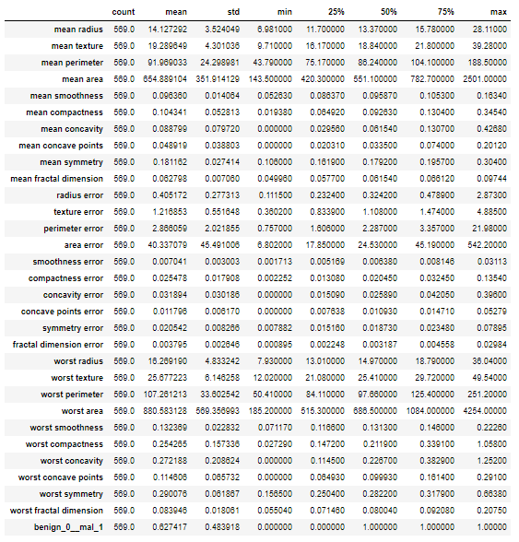

### EDA

sns.countplot(x='benign_0__mal_1',data=df)

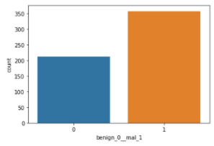

sns.heatmap(df.corr())

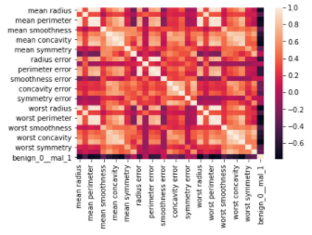

df.corr()['benign_0__mal_1'].sort_values()

worst concave points -0.793566

worst perimeter -0.782914

mean concave points -0.776614

worst radius -0.776454

mean perimeter -0.742636

worst area -0.733825

mean radius -0.730029

mean area -0.708984

mean concavity -0.696360

worst concavity -0.659610

mean compactness -0.596534

worst compactness -0.590998

radius error -0.567134

perimeter error -0.556141

area error -0.548236

worst texture -0.456903

worst smoothness -0.421465

worst symmetry -0.416294

mean texture -0.415185

concave points error -0.408042

mean smoothness -0.358560

mean symmetry -0.330499

worst fractal dimension -0.323872

compactness error -0.292999

concavity error -0.253730

fractal dimension error -0.077972

symmetry error 0.006522

texture error 0.008303

mean fractal dimension 0.012838

smoothness error 0.067016

benign_0__mal_1 1.000000

Name: benign_0__mal_1, dtype: float64

df.corr()['benign_0__mal_1'].sort_values().plot(kind='bar')

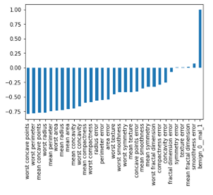

df.corr()['benign_0__mal_1'][:-1].sort_values().plot(kind='bar')

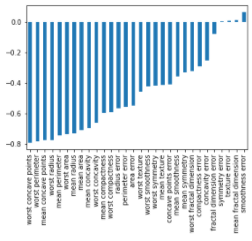

### Train test split

X = df.drop('benign_0__mal_1',axis=1).values  
y = df['benign_0__mal_1'].values  
from sklearn.model_selection import train_test_split  
X_train, X_test, y_train, y_test = train_test_split(X,y,test_size=0.25,random_state=101)

### Scaling data

from sklearn.preprocessing import MinMaxScaler  
scaler = MinMaxScaler()  
scaler.fit(X_train)  
X_train = scaler.transform(X_train)  
X_test = scaler.transform(X_test)

### Creating the Model

*# For a binary classification problem*  
*# model.compile(optimizer='rmsprop',*  
*# loss='binary_crossentropy',*  
*# metrics=['accuracy'])*  
import tensorflow as tf  
from tensorflow.keras.models import Sequential  
from tensorflow.keras.layers import Dense, Activation,Dropout  
X_train.shape

(426, 30)

model = Sequential()  
model.add(Dense(units=30,activation='relu'))  
model.add(Dense(units=15,activation='relu'))  
  
model.add(Dense(units=1,activation='sigmoid'))  
  
*# For a binary classification problem*  
model.compile(loss='binary_crossentropy', optimizer='adam')

### Example One: Choosing too many epochs and overfitting!

model.fit(x=X_train,   
 y=y_train,   
 epochs=600,  
 validation_data=(X_test, y_test), verbose=1  
 )

Epoch 1/600

14/14 [==============================] - 2s 81ms/step - loss: 0.7084 - val_loss: 0.6736

Epoch 2/600

14/14 [==============================] - 0s 5ms/step - loss: 0.6664 - val_loss: 0.6337

Epoch 3/600

...

*# model.history.history*  
model_loss = pd.DataFrame(model.history.history)  
*# model_loss*  
model_loss.plot()

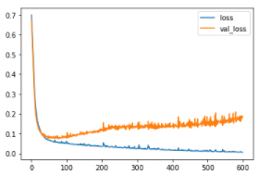

### Example two: Early stopping

model = Sequential()  
model.add(Dense(units=30,activation='relu'))  
model.add(Dense(units=15,activation='relu'))  
model.add(Dense(units=1,activation='sigmoid'))  
model.compile(loss='binary_crossentropy', optimizer='adam')  
from tensorflow.keras.callbacks import EarlyStopping  
‘’’  
Stop training when a monitored quantity has stopped improving.  
Arguments:  
 monitor: Quantity to be monitored.  
 min_delta: Minimum change in the monitored quantity  
 to qualify as an improvement, i.e. an absolute  
 change of less than min_delta, will count as no  
 improvement.  
 patience: Number of epochs with no improvement  
 after which training will be stopped.  
 verbose: verbosity mode.  
 mode: One of `{"auto", "min", "max"}`. In `min` mode,  
 training will stop when the quantity  
 monitored has stopped decreasing; in `max`  
 mode it will stop when the quantity  
 monitored has stopped increasing; in `auto`  
 mode, the direction is automatically inferred  
 from the name of the monitored quantity.  
‘’’  
early_stop = EarlyStopping(monitor='val_loss', mode='min', verbose=1, patience=25)  
model.fit(x=X_train,   
 y=y_train,   
 epochs=600,  
 validation_data=(X_test, y_test), verbose=1,  
 callbacks=[early_stop]  
 )

Train on 426 samples, validate on 143 samples

Epoch 1/600

426/426 [==============================] - 0s 967us/sample - loss: 0.6927 - val_loss: 0.6778

Epoch 2/600

426/426 [==============================] - 0s 103us/sample - loss: 0.6653 - val_loss: 0.6505

Epoch 3/600

…

model_loss = pd.DataFrame(model.history.history)  
model_loss.plot()

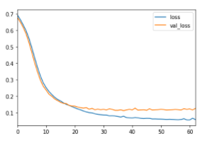

### Example Three: DropOut Layers

from tensorflow.keras.layers import Dropout  
model = Sequential()  
model.add(Dense(units=30,activation='relu'))  
model.add(Dropout(0.5))  
  
model.add(Dense(units=15,activation='relu'))  
model.add(Dropout(0.5))  
  
model.add(Dense(units=1,activation='sigmoid'))  
model.compile(loss='binary_crossentropy', optimizer='adam')  
  
model.fit(x=X_train,   
 y=y_train,   
 epochs=600,  
 validation_data=(X_test, y_test), verbose=1,  
 callbacks=[early_stop]  
 )

Train on 426 samples, validate on 143 samples

Epoch 1/600

426/426 [==============================] - 0s 1ms/sample - loss: 0.6894 - val_loss: 0.6833

Epoch 2/600

426/426 [==============================] - 0s 101us/sample - loss: 0.6828 - val_loss: 0.6722

Epoch 3/600

...

model_loss = pd.DataFrame(model.history.history)  
model_loss.plot()

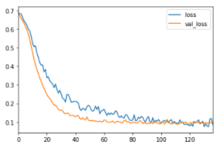

### Model evaluation

predictions = model.predict_classes(X_test)  
from sklearn.metrics import classification_report,confusion_matrix  
print(classification_report(y_test,predictions))  
print(confusion_matrix(y_test,predictions))

precision recall f1-score support

0 0.96 0.98 0.97 55

1 0.99 0.98 0.98 88

accuracy 0.98 143

macro avg 0.98 0.98 0.98 143

weighted avg 0.98 0.98 0.98 143

[[54 1]

[ 2 86]]

## Code – Lending Club

### Data overview

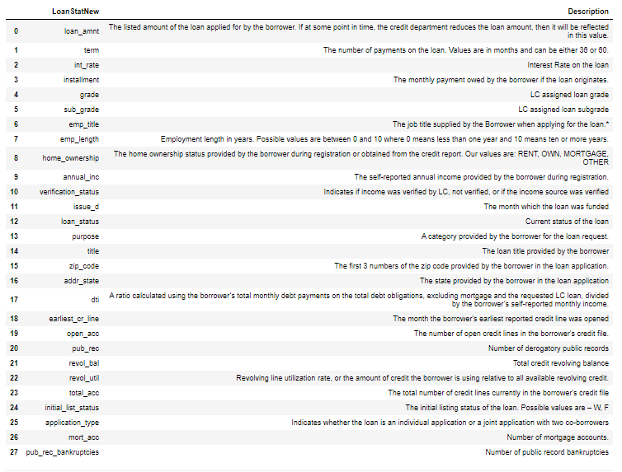

data_info = pd.read_csv('../DATA/lending_club_info.csv',index_col='LoanStatNew')  
print(data_info.loc['revol_util']['Description'])

Revolving line utilization rate, or the amount of credit the borrower is using relative to all available revolving credit.

def feat_info(col_name):  
 print(data_info.loc[col_name]['Description'])  
feat_info('mort_acc')

Number of mortgage accounts.

df = pd.read_csv('../DATA/lending_club_loan_two.csv')  
df.info()

<class 'pandas.core.frame.DataFrame'>

RangeIndex: 396030 entries, 0 to 396029

Data columns (total 27 columns):

# Column Non-Null Count Dtype

--- ------ -------------- -----

0 loan_amnt 396030 non-null float64

1 term 396030 non-null object

2 int_rate 396030 non-null float64

3 installment 396030 non-null float64

4 grade 396030 non-null object

5 sub_grade 396030 non-null object

6 emp_title 373103 non-null object

7 emp_length 377729 non-null object

8 home_ownership 396030 non-null object

9 annual_inc 396030 non-null float64

10 verification_status 396030 non-null object

11 issue_d 396030 non-null object

12 loan_status 396030 non-null object

13 purpose 396030 non-null object

14 title 394275 non-null object

15 dti 396030 non-null float64

16 earliest_cr_line 396030 non-null object

17 open_acc 396030 non-null float64

18 pub_rec 396030 non-null float64

19 revol_bal 396030 non-null float64

20 revol_util 395754 non-null float64

21 total_acc 396030 non-null float64

22 initial_list_status 396030 non-null object

23 application_type 396030 non-null object

24 mort_acc 358235 non-null float64

25 pub_rec_bankruptcies 395495 non-null float64

26 address 396030 non-null object

dtypes: float64(12), object(15)

memory usage: 81.6+ MB

df

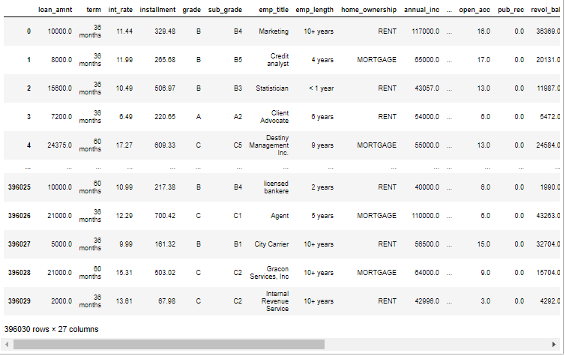

### Exploratory data analysis

sns.countplot(x='loan_status', data=df)

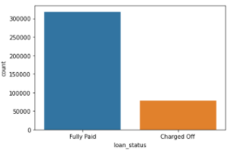

plt.figure(figsize=(16,4))  
sns.histplot(x='loan_amnt', data=df, bins=50)

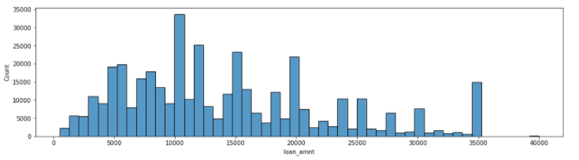

plt.figure(figsize=(16,10))  
sns.heatmap(df.corr(), cmap='viridis', annot=True)

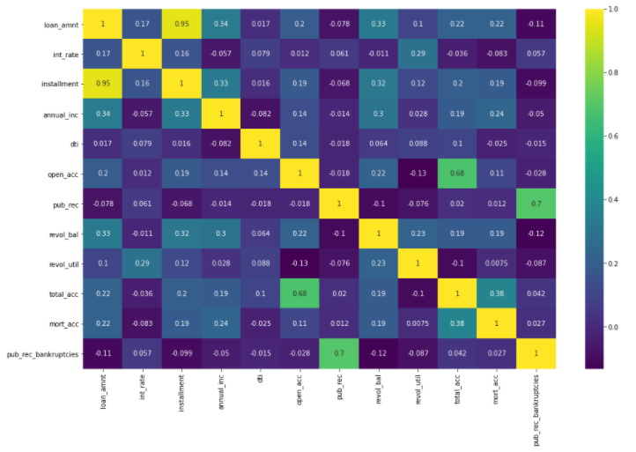

plt.figure(figsize=(16,8))  
sns.scatterplot(x='installment', y='loan_amnt', data=df)

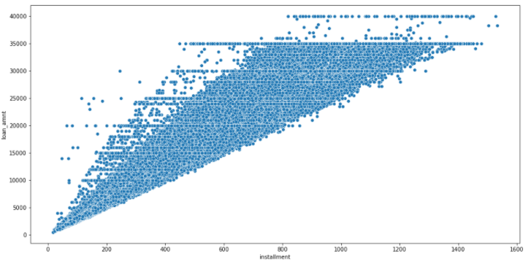

sns.boxplot(x='loan_status', y='loan_amnt', data=df)

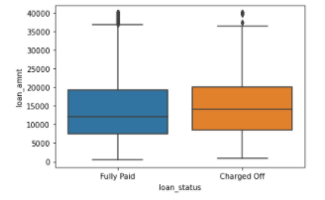

df.groupby('loan_status')['loan_amnt'].describe()

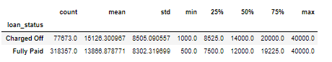

df['grade'].unique()

array(['B4', 'B5', 'B3', 'A2', 'C5', 'C3', 'A1', 'B2', 'C1', 'A5', 'E4',

'A4', 'A3', 'D1', 'C2', 'B1', 'D3', 'D5', 'D2', 'E1', 'E2', 'E5',

'F4', 'E3', 'D4', 'G1', 'F5', 'G2', 'C4', 'F1', 'F3', 'G5', 'G4',

'F2', 'G3'], dtype=object)

sns.countplot(x='grade', data=df, hue='loan_status')

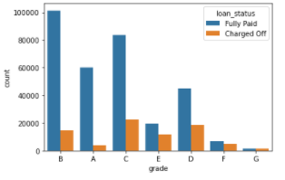

plt.figure(figsize=(12,4))  
sns.countplot(x='sub_grade', data=df.sort_values('sub_grade'), palette='plasma')

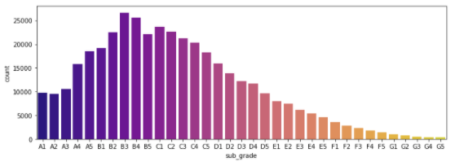

plt.figure(figsize=(12,4))  
sns.countplot(x='sub_grade', data=df.sort_values('sub_grade'), hue=('loan_status'), palette='plasma')

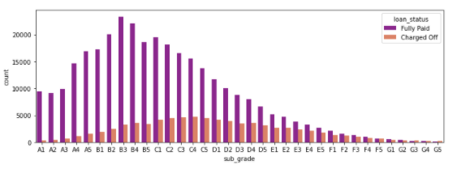

plt.figure(figsize=(12,4))  
sns.countplot(x='sub_grade', data=df[(df['grade']=='F') | (df['grade']=='G')].sort_values('sub_grade'), hue='loan_status', palette='plasma')

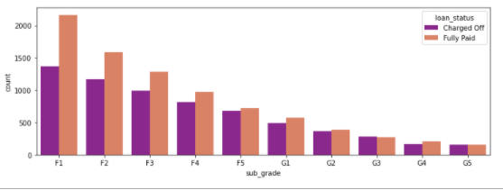

df['loan_repaid']=df['loan_status'].map({'Fully Paid': 1, 'Charged Off':0})  
df

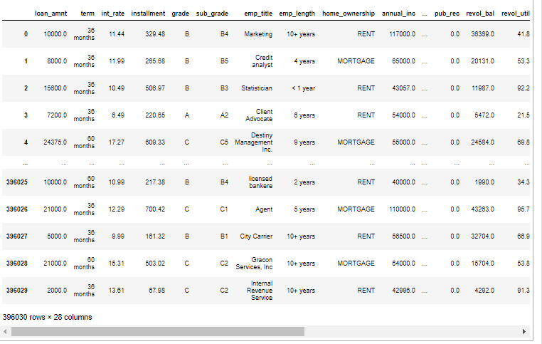

df['loan_status'].unique()

array(['Fully Paid', 'Charged Off'], dtype=object)

df[['loan_status', 'loan_repaid']]

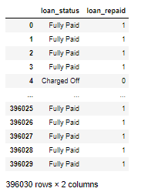

df.corr()['loan_repaid'].sort_values()[:-1].plot(kind='bar')

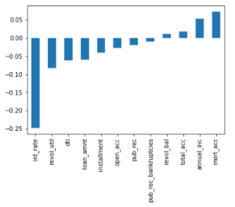

### Data preprocessing – Missing data

df.isnull().sum()

loan_amnt 0

term 0

int_rate 0

installment 0

grade 0

sub_grade 0

emp_title 22927

emp_length 18301

home_ownership 0

annual_inc 0

verification_status 0

issue_d 0

loan_status 0

purpose 0

title 1755

dti 0

earliest_cr_line 0

open_acc 0

pub_rec 0

revol_bal 0

revol_util 276

total_acc 0

initial_list_status 0

application_type 0

mort_acc 37795

pub_rec_bankruptcies 535

address 0

loan_repaid 0

dtype: int64

df.isnull().sum()/len(df)

loan_amnt 0.000000

term 0.000000

int_rate 0.000000

installment 0.000000

grade 0.000000

sub_grade 0.000000

emp_title 0.057892

emp_length 0.046211

home_ownership 0.000000

annual_inc 0.000000

verification_status 0.000000

issue_d 0.000000

loan_status 0.000000

purpose 0.000000

title 0.004431

dti 0.000000

earliest_cr_line 0.000000

open_acc 0.000000

pub_rec 0.000000

revol_bal 0.000000

revol_util 0.000697

total_acc 0.000000

initial_list_status 0.000000

application_type 0.000000

mort_acc 0.095435

pub_rec_bankruptcies 0.001351

address 0.000000

loan_repaid 0.000000

dtype: float64

df['emp_title'].nunique()

173105

df['emp_title'].value_counts()

Teacher 4389

Manager 4250

Registered Nurse 1856

RN 1846

Supervisor 1830

...

Catholic Life Insurance 1

City of Lancaster Fire Dept 1

KTLM-TV 1

Englobal 1

Night crew manager 1

Name: emp_title, Length: 173105, dtype: int64

df.drop('emp_title', axis=1, inplace=True)

sorted(df['emp_length'].dropna().unique())

['1 year',

'10+ years',

'2 years',

'3 years',

'4 years',

'5 years',

'6 years',

'7 years',

'8 years',

'9 years',

'< 1 year']

emp_length_order=[ '< 1 year',  
 '1 year',  
 '2 years',  
 '3 years',  
 '4 years',  
 '5 years',  
 '6 years',  
 '7 years',  
 '8 years',  
 '9 years',  
'10+ years'  
]

plt.figure(figsize=(12,4))  
sns.countplot(x='emp_length', data=df, order=emp_length_order)

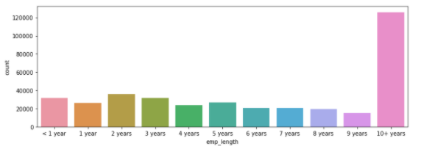

plt.figure(figsize=(12,4))  
sns.countplot(x='emp_length', data=df, order=emp_length_order, hue='loan_status')

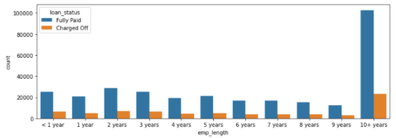

emp_co=df[df['loan_status']=='Charged Off'].groupby('emp_length').count()['loan_status']  
emp_fp=df[df['loan_status']=='Fully Paid'].groupby('emp_length').count()['loan_status']  
emp_co

emp_length

1 year 5154

10+ years 23215

2 years 6924

3 years 6182

4 years 4608

5 years 5092

6 years 3943

7 years 4055

8 years 3829

9 years 3070

< 1 year 6563

Name: loan_status, dtype: int64

emp_fp

emp_length

1 year 20728

10+ years 102826

2 years 28903

3 years 25483

4 years 19344

5 years 21403

6 years 16898

7 years 16764

8 years 15339

9 years 12244

< 1 year 25162

Name: loan_status, dtype: int64

emp_co/emp_fp

emp_length

1 year 0.248649

10+ years 0.225770

2 years 0.239560

3 years 0.242593

4 years 0.238213

5 years 0.237911

6 years 0.233341

7 years 0.241887

8 years 0.249625

9 years 0.250735

< 1 year 0.260830

Name: loan_status, dtype: float64

(emp_co/emp_fp).plot(kind='bar')

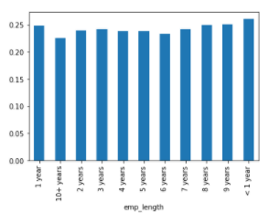

df.drop('emp_length', axis=1, inplace=True)

df.isnull().sum()

loan_amnt 0

term 0

int_rate 0

installment 0

grade 0

sub_grade 0

home_ownership 0

annual_inc 0

verification_status 0

issue_d 0

loan_status 0

purpose 0

title 1755

dti 0

earliest_cr_line 0

open_acc 0

pub_rec 0

revol_bal 0

revol_util 276

total_acc 0

initial_list_status 0

application_type 0

mort_acc 37795

pub_rec_bankruptcies 535

address 0

loan_repaid 0

dtype: int64

df['purpose'].unique()

array(['vacation', 'debt_consolidation', 'credit_card',

'home_improvement', 'small_business', 'major_purchase', 'other',

'medical', 'wedding', 'car', 'moving', 'house', 'educational',

'renewable_energy'], dtype=object)

df['title'].unique()

array(['Vacation', 'Debt consolidation', 'Credit card refinancing', ...,

'Credit buster ', 'Loanforpayoff', 'Toxic Debt Payoff'],

dtype=object)

df.drop('title', axis=1, inplace=True)

df['mort_acc'].value_counts()

0.0 139777

1.0 60416

2.0 49948

3.0 38049

4.0 27887

5.0 18194

6.0 11069

7.0 6052

8.0 3121

9.0 1656

10.0 865

11.0 479

12.0 264

13.0 146

14.0 107

15.0 61

16.0 37

17.0 22

18.0 18

19.0 15

20.0 13

24.0 10

22.0 7

21.0 4

25.0 4

27.0 3

23.0 2

32.0 2

26.0 2

31.0 2

30.0 1

28.0 1

34.0 1

Name: mort_acc, dtype: int64

df.corr()['mort_acc']

loan_amnt 0.222315

int_rate -0.082583

installment 0.193694

annual_inc 0.236320

dti -0.025439

open_acc 0.109205

pub_rec 0.011552

revol_bal 0.194925

revol_util 0.007514

total_acc 0.381072

mort_acc 1.000000

pub_rec_bankruptcies 0.027239

loan_repaid 0.073111

Name: mort_acc, dtype: float64

total_acc_avg=df.groupby('total_acc').mean()['mort_acc']  
total_acc_avg

total_acc

2.0 0.000000

3.0 0.052023

4.0 0.066743

5.0 0.103289

6.0 0.151293

...

124.0 1.000000

129.0 1.000000

135.0 3.000000

150.0 2.000000

151.0 0.000000

Name: mort_acc, Length: 118, dtype: float64

def fill_mort_acc(total_acc, mort_acc):  
 if np.isnan(mort_acc):  
 return total_acc_avg[total_acc]  
 else:  
 return mort_acc  
df['mort_acc']=df.apply(lambda x: fill_mort_acc(x['total_acc'], x['mort_acc']), axis=1)  
df['mort_acc'].isnull().sum()

0

df.isnull().sum()

loan_amnt 0

term 0

int_rate 0

installment 0

grade 0

sub_grade 0

home_ownership 0

annual_inc 0

verification_status 0

issue_d 0

loan_status 0

purpose 0

dti 0

earliest_cr_line 0

open_acc 0

pub_rec 0

revol_bal 0

revol_util 276

total_acc 0

initial_list_status 0

application_type 0

mort_acc 0

pub_rec_bankruptcies 535

address 0

loan_repaid 0

dtype: int64

df.dropna(inplace=True)  
df.isnull().sum()

loan_amnt 0

term 0

int_rate 0

installment 0

grade 0

sub_grade 0

home_ownership 0

annual_inc 0

verification_status 0

issue_d 0

loan_status 0

purpose 0

dti 0

earliest_cr_line 0

open_acc 0

pub_rec 0

revol_bal 0

revol_util 0

total_acc 0

initial_list_status 0

application_type 0

mort_acc 0

pub_rec_bankruptcies 0

address 0

loan_repaid 0

dtype: int64

### Data preprocessing – Categorical variables and dummy variables

df.select_dtypes(['object']).columns  
  
df['term'].value_counts()

36 months 301247

60 months 93972

Name: term, dtype: int64

df['term']=df['term'].apply(lambda term: int(term[:3]))

df['grade'].value_counts()

B 115812

C 105775

A 64056

D 63364

E 31427

F 11740

G 3045

Name: grade, dtype: int64

df.drop('grade', axis=1, inplace=True)  
dummies=pd.get_dummies(df['sub_grade'], drop_first=True) *#drop_first because if row isn't any sub_class, itst the first*  
dummies

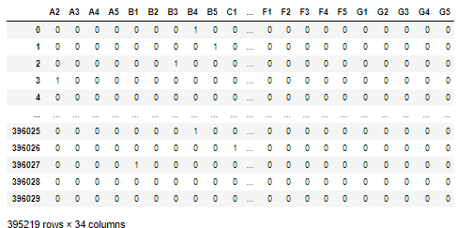

df=pd.concat([df.drop('sub_grade', axis=1), dummies], axis=1)  
dummies=pd.get_dummies(df[['verification_status', 'application_type','initial_list_status','purpose']], drop_first=True) *#drop_first because if row isn't any sub_class, itst the first*  
dummies

df=pd.concat([df.drop(['verification_status', 'application_type','initial_list_status','purpose'], axis=1), dummies], axis=1)  
df

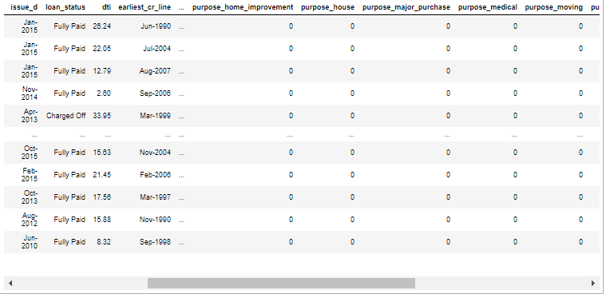

df['home_ownership'].value_counts()

MORTGAGE 198022

RENT 159395

OWN 37660

OTHER 110

NONE 29

ANY 3

Name: home_ownership, dtype: int64

df['home_ownership'].replace(['NONE', 'ANY'], 'OTHER', inplace=True)  
df['home_ownership'].value_counts()

MORTGAGE 198022

RENT 159395

OWN 37660

OTHER 142

Name: home_ownership, dtype: int64

dummies=pd.get_dummies(df['home_ownership'], drop_first=True) *#drop_first because if row isn't any sub_class, itst the first*  
df=pd.concat([df.drop('home_ownership', axis=1), dummies], axis=1)  
df['zip_code']=df['address'].apply(lambda zipcode: zipcode[-5:])  
df['zip_code'].value_counts()

70466 56880

22690 56413

30723 56402

48052 55811

00813 45725

29597 45393

05113 45300

11650 11210

93700 11126

86630 10959

Name: zip_code, dtype: int64

dummies=pd.get_dummies(df['zip_code'], drop_first=True) *#drop_first because if row isn't any sub_class, itst the first*  
df=pd.concat([df.drop('zip_code', axis=1), dummies], axis=1)

df.drop('address', axis=1, inplace=True)  
df=df.drop('issue_d', axis=1)

df['earliest_cr_line']

0 Jun-1990

1 Jul-2004

2 Aug-2007

3 Sep-2006

4 Mar-1999

...

396025 Nov-2004

396026 Feb-2006

396027 Mar-1997

396028 Nov-1990

396029 Sep-1998

Name: earliest_cr_line, Length: 395219, dtype: object

df['earliest_cr_line']=df['earliest_cr_line'].apply(lambda date:int(date[-4:]))

### Train test split

from sklearn.model_selection import train_test_split  
df.drop('loan_status', axis=1, inplace=True)  
X=df.drop('loan_repaid', axis=1)  
y=df['loan_repaid']  
  
X_train, X_test, y_train, y_test = train_test_split(X, y, test_size=0.2, random_state=101)

### Normalizing data

from sklearn.preprocessing import MinMaxScaler  
scaler=MinMaxScaler()  
  
X_train=scaler.fit_transform(X_train)  
X_test=scaler.transform(X_test)

### Creating model

import tensorflow as tf  
from tensorflow.keras.models import Sequential  
from tensorflow.keras.layers import Dense,Dropout  
  
X_train.shape

(316175, 78)

model = Sequential()  
  
model.add(Dense(78, activation='relu'))  
model.add(Dropout(0.2))  
  
model.add(Dense(39, activation='relu'))  
model.add(Dropout(0.2))  
  
model.add(Dense(19, activation='relu'))  
model.add(Dropout(0.2))  
  
model.add(Dense(1, activation='sigmoid'))  
  
model.compile(loss='binary_crossentropy', optimizer='adam')  
*# Choose whatever number of layers/neurons you want.*  
*# Remember to compile()*  
  
model.fit(x=X_train, y=y_train, epochs=25, batch_size=265,  
 validation_data=(X_test, y_test))

Epoch 1/25

1194/1194 [==============================] - 8s 6ms/step - loss: 0.3737 - val_loss: 0.2647

Epoch 2/25

1194/1194 [==============================] - 4s 3ms/step - loss: 0.2690 - val_loss: 0.2633

Epoch 3/25

...

### Save model

from tensorflow.keras.models import load_model  
model.save('loan_model.h5')

### Evaluating Model Performance

losses=pd.DataFrame(model.history.history)  
losses

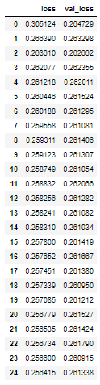

losses.plot()

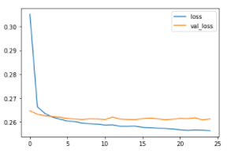

from sklearn.metrics import classification_report, confusion_matrix  
predictions=model.predict(X_test)  
predictions=np.where(predictions>0.5, 1, 0)  
predictions

array([[1],

[1],

[1],

...,

[1],

[1],

[0]])

print(classification_report(y_test, predictions))  
print(confusion_matrix(y_test, predictions))

precision recall f1-score support

0 0.98 0.44 0.61 15658

1 0.88 1.00 0.93 63386

accuracy 0.89 79044

macro avg 0.93 0.72 0.77 79044

weighted avg 0.90 0.89 0.87 79044

[[ 6916 8742]

[ 161 63225]]

import random  
random.seed(101)  
random_ind = random.randint(0,len(df))  
  
new_customer = df.drop('loan_repaid',axis=1).iloc[random_ind]  
new_customer

loan_amnt 25000.00

term 60.00

int_rate 18.24

installment 638.11

annual_inc 61665.00

...

30723 1.00

48052 0.00

70466 0.00

86630 0.00

93700 0.00

Name: 305323, Length: 78, dtype: float64

new_customer=scaler.transform(new_customer.values.reshape(1,78))  
predict_new_customer=model.predict(new_customer)  
  
predict_new_customer=np.where(predict_new_customer>0.5, 1, 0)  
predict_new_customer

array([[1]])

df.iloc[random_ind]['loan_repaid']

1.0

# Big Data and Spark with Python

## Overview

* Topics:
  + Explanation of Hadoop, MapReduces, Spark, PySpark
  + Local vs Distributed Systems
  + Overview of Hadoop Ecosystem
  + Detailed overview of Spark
  + Set-up on Amazon Web Services
  + Resources on other Spark Options
  + Jupyter Notebook hands-on code with PySpark and RDDs
* What can we do if we have a larger set of fata?
  + Try to using a SQL database to move storage onto hard drive instead of RAM
  + Or use a distributed system, that distributes the data to multiple machines/computers

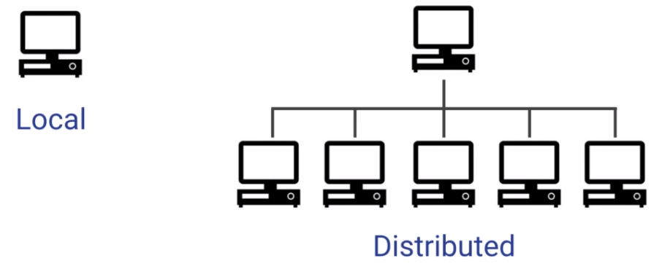

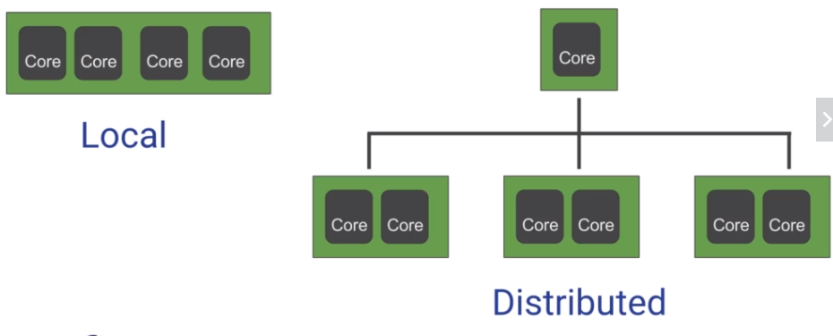

* A local process will use the computation resources of a single machine
* A distributed process has access to the computational resources across a number of machines connected through network
* After a certain point, it is easier to scale out many lower CPU machines, than to try to scale up to a single machine with high a CPU
* Distributed machines also have the advantage of easily scaling you can just add more machines
* They also include fault tolerance, if one machine fails, the whole network can still go on
* **Hadoop**
  + Hadoop is a way to distribute very large files across multiple machines
  + It uses the Hadoop Distributed File System (HDFS)
  + HDFS allows a user to work with large data sets
  + HDFS also duplicate blocks of data for fault tolerance
  + It also then uses MapReduce
  + MapReduce allows computations on that data

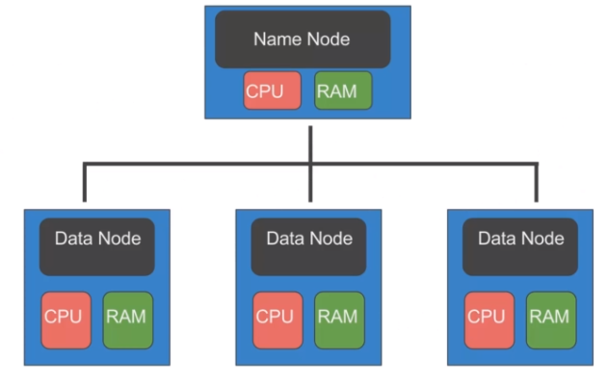

* + HDFS will use blocks of data, with a size of 128 MB by default
  + Each of these blocks is replicated 3 times
  + The blocks are distributed in a way to support fault tolerance
  + Smaller blocks provide more parallelization during processing
  + Multiple copies of a block prevent loss of data due to a failure of a node
  + MapReduce is a way of splitting a computation task to a distributed set of files (such as HDFS)
  + It consists of a Job Tracker and multiple Task Trackers

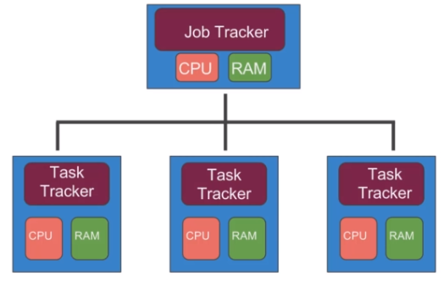

* + The Job Tracker sends code to run on the Task Trackers
  + The Task Trackers allocate CPU and memory for the tasks and monitor the tasks on the worker nodes

## Spark

* Topics:
  + Spark
  + Spark vs MapReduce
  + Spark RDDs
  + RDDs Operations
* Spark is one of the latest technologies being used to quickly and easily handle Big Data
* It was first released in February 2013 and has exploded in popularity due to it’s ease of use and speed
* It was created at the AMPLab at UC Barkeley
* You can think of Spark as s flexible alternative to MapReduce
* Spark can use data stored in a variety of formats
  + Cassandra
  + AWS S3
  + HDFS
  + And more …
* MapReduce requires files to be stored in HDFS, Spark does not!
* Spark also can perform operations up to 100x faster than MapReduce
  + MapReduce writes most data to dick after each map and reduce operation
  + Spark keeps most of the data in memory after each transformation
  + Spark can spill over to disk if the memory is filled
* At the core of Spark is the idea of a Resilient Distributed Dataset (RDD)
* Resilient Distributed Dataset (RDD) has 4 main features:
  + Distributed Collection of Data
  + Fault-tolerant
  + Parallel operation – portioned
  + Ability to use many data sources

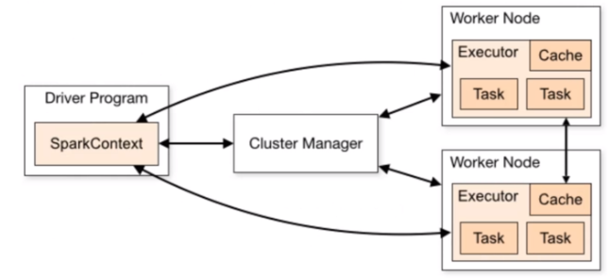

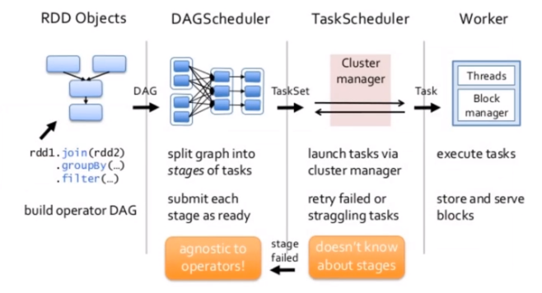

* RDDs are immutable, lazily evaluated, and cacheable
* There are two types of RDD operations:
  + **Transformations**
    - Basic Transformations
      * **Filter** – RDD.filter() – applies a function to each element and returns elements that evaluate to true

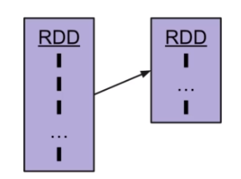

* + - * **Map** – RDD. Map() – transforms each element and preserves # of elements, very similar idea to pandas .apply() (grabbing first letter of a list of names)

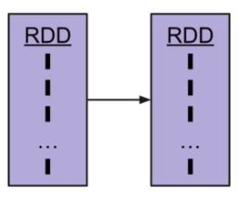

* + - * **FlatMap** – RDD.flatMap() – transforms each element into 0-N elements and changes # of elements (transforming a corpus of text into a list of words)

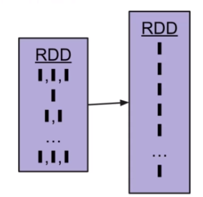

* + **Actions**
    - Basic Actions
      * **First** – Return the first element in the RDD
      * **Collect** – Return all the elements of the RDD as an array at the driver program
      * **Count** – Return the number of elements in the RDD
      * **Take** – Return an array with the first n elements of the RDD
* Pair RDDs
  + Often RDDs will be holding their values in tuples (key, values)
  + This offers better portioning of data and leads to functionality based on reduction
* Reduce and ReduceByKey
  + **Reduce()** – an action that will aggregate RDD elements using a function that returns a single element
  + **ReduceByKey()** – an action that will aggregate Pair RDD elements using a function that returns a Pair RDD
  + These are similar to a Group By operation
* Spark is being continually developed and new releases come out often
* The Spark Ecosystem now includes:
  + Spark SQL
  + Spark DataFrames
  + MLlib
  + GraphX
  + SparkStreaming

## EC2 Instance Set-Up

* Amazon Elastic Compute Cloud (Amazon EC2) is a web service that provides resizable compute capacity in the cloud
* We can basically think of it as a virtual computer we can access through the internet
* Here is our plan
  + Create EC2 Instance on AWS
  + Use SSH to connect to EC2 over internet
  + Set-up Spark and Jupyter on EC2 Instance



* SSH (Secure Shell Connection) – out goal is to remotely connect to the command line of our virtual machine on Amazon EC2

## Lambda Revision

even = lambda num: num%2==0  
first = lambda s: s[0]  
rev = lambda s: s[::-1]  
adder = lambda x, y: x+y

## PySpark Setup

As here: <https://medium.com/@josemarcialportilla/getting-spark-python-and-jupyter-notebook-running-on-amazon-ec2-dec599e1c297>

Bash An  
bash Anaconda3–4.1.1-Linux-x86_64.sh

→ bash Ana + Tab!!!

Be carefull and type:

yes  
yes

*# Configuration file for jupyter-notebook.*  
c = get_config()  
  
*# Notebook config this is where you saved your pem cert*  
c.NotebookApp.certfile = u'/home/ubuntu/certs/mycert.pem'  
*# listen on all IPs*  
c.NotebookApp.ip = '0.0.0.0'  
*# Allow all origins*  
c.NotebookApp.allow_origin = '*'  
*# Don't open browser by default*  
c.NotebookApp.open_browser = False  
*# Fix port to 8888*  
c.NotebookApp.port = 8888

## RDD Transformations and Actions

from pyspark import SparkContext  
sc=SparkContext()  
%%writefile example.txt  
first  
second line  
the third line  
then a fourth line

Overwriting example.txt

textFile=sc.textFile('example.txt')

*# Actions*  
textFile.count()

4

textFile.first()

'first'

secfind =textFile.filter(lambda line: 'second' in line)  
secfind

PythonRDD[11] at RDD at PythonRDD.scala:48

secfind.collect()

['second line']

words=textFile.map(lambda line: line.split())  
words.collect()

[['first'],

['second', 'line'],

['the', 'third', 'line'],

['then', 'a', 'fourth', 'line']]

textFile.collect()

['first', 'second line', 'the third line', 'then a fourth line']

textFile.flatMap(lambda line: line.split()).collect()

['first',

'second',

'line',

'the',

'third',

'line',

'then',

'a',

'fourth',

'line']

%%writefile services.txt  
*#EventId Timestamp Customer State ServiceID Amount*  
201 10/13/2017 100 NY 131 100.00  
204 10/18/2017 700 TX 129 450.00  
202 10/15/2017 203 CA 121 200.00  
206 10/19/2017 202 CA 131 500.00  
203 10/17/2017 101 NY 173 750.00  
205 10/19/2017 202 TX 121 200.00

Writing services.txt

services=sc.textFile('services.txt')

services.take(3)

['#EventId Timestamp Customer State ServiceID Amount',

'201 10/13/2017 100 NY 131 100.00',

'204 10/18/2017 700 TX 129 450.00']

services.map(lambda line: line.split()).take(3)

[['#EventId', 'Timestamp', 'Customer', 'State', 'ServiceID', 'Amount'],

['201', '10/13/2017', '100', 'NY', '131', '100.00'],

['204', '10/18/2017', '700', 'TX', '129', '450.00']]

services.map(lambda line: line[1:] if line[0]=='#' else line).collect()

['EventId Timestamp Customer State ServiceID Amount',

'201 10/13/2017 100 NY 131 100.00',

'204 10/18/2017 700 TX 129 450.00',

'202 10/15/2017 203 CA 121 200.00',

'206 10/19/2017 202 CA 131 500.00',

'203 10/17/2017 101 NY 173 750.00',

'205 10/19/2017 202 TX 121 200.00']

clean=services.map(lambda line: line[1:] if line[0]=='#' else line)  
clean=clean.map(lambda line: line.split())  
clean.collect()

[['EventId', 'Timestamp', 'Customer', 'State', 'ServiceID', 'Amount'],

['201', '10/13/2017', '100', 'NY', '131', '100.00'],

['204', '10/18/2017', '700', 'TX', '129', '450.00'],

['202', '10/15/2017', '203', 'CA', '121', '200.00'],

['206', '10/19/2017', '202', 'CA', '131', '500.00'],

['203', '10/17/2017', '101', 'NY', '173', '750.00'],

['205', '10/19/2017', '202', 'TX', '121', '200.00']]

clean.map(lambda lst: (lst[3], lst[-1])).collect()

[('State', 'Amount'),

('NY', '100.00'),

('TX', '450.00'),

('CA', '200.00'),

('CA', '500.00'),

('NY', '750.00'),

('TX', '200.00')]

pairs=clean.map(lambda lst: (lst[3], lst[-1]))  
rekey=pairs.reduceByKey(lambda amnt1, amnt2: float(amnt1)+float(amnt2))  
rekey.collect()

[('State', 'Amount'), ('NY', 850.0), ('TX', 650.0), ('CA', 700.0)]

clean.collect()

[['EventId', 'Timestamp', 'Customer', 'State', 'ServiceID', 'Amount'],

['201', '10/13/2017', '100', 'NY', '131', '100.00'],

['204', '10/18/2017', '700', 'TX', '129', '450.00'],

['202', '10/15/2017', '203', 'CA', '121', '200.00'],

['206', '10/19/2017', '202', 'CA', '131', '500.00'],

['203', '10/17/2017', '101', 'NY', '173', '750.00'],

['205', '10/19/2017', '202', 'TX', '121', '200.00']]

*# Grab (State, Amount)*  
step1=clean.map(lambda lst: (lst[3], lst[-1]))  
  
*# Reduce by Key*  
step2=step1.reduceByKey(lambda amnt1, amnt2: float(amnt1)+float(amnt2))  
  
*# Get rid of State, Amount titles*  
step3=step2.filter(lambda x: not x[0]=='State')  
  
*#Sort Results by Amount*  
step4=step3.sortBy(lambda stAmount: stAmount[1], ascending=False)  
  
*# ACTION*  
step4.collect()

[('NY', 850.0), ('CA', 700.0), ('TX', 650.0)]

x=['ID', 'State', 'Amount']  
  
def func1(lst):  
 return lst[-1]  
  
*# Tuple unpacking*  
def func2(id_st_amnt):  
 *#unpack values*  
 (Id,st,amt)=id_st_amnt  
 return amt

func1(x)

'Amount'

func2(x)

'Amount'

# My Notes

## Clear Data – Fill Nulls

housing.dropna(subset=["total_bedrooms"])

housing.drop("total_bedrooms", axis=1)

median = housing["total_bedrooms"].median()   
housing["total_bedrooms"].fillna(median, inplace=True)

from sklearn.impute import SimpleImputer  
imputer = SimpleImputer(strategy="median")  
housing_num = housing.drop("ocean_proximity", axis=1) *#drop non-numeric values*  
imputer.fit(housing_num)  
imputer.statistics_

array([ -118.51 , 34.26 , 29. , 2119.5 , 433. , 1164. , 408. , 3.5409])

housing_num.median().values

array([ -118.51 , 34.26 , 29. , 2119.5 , 433. , 1164. , 408. , 3.5409])

housing_tr = pd.DataFrame(X, columns=housing_num.columns, index=housing_num.index)

## Feature scaling – MinMaxScaling and Standarization

from sklearn.preprocessing import MinMaxScaler  
scaler=MinMaxScaler()  
scaler.fit(X_train)  
X_train=scaler.transform(X_train)  
X_test=scaler.transform(X_test)

from sklearn.preprocessing import StandardScaler  
  
scaler=StandardScaler()  
scaler.fit(df)  
  
scaled_data=scaler.transform(df)

## Transform Categories

dummies=pd.get_dummies(df['sub_grade'], drop_first=True) *#drop_first because if row isn't any sub_class, itst the first*  
df=pd.concat([df.drop('sub_grade', axis=1), dummies], axis=1)

## Saving Models

import joblib  
joblib.dump(my_model, "my_model.pkl")  
my_model_loaded = joblib.load("my_model.pkl")